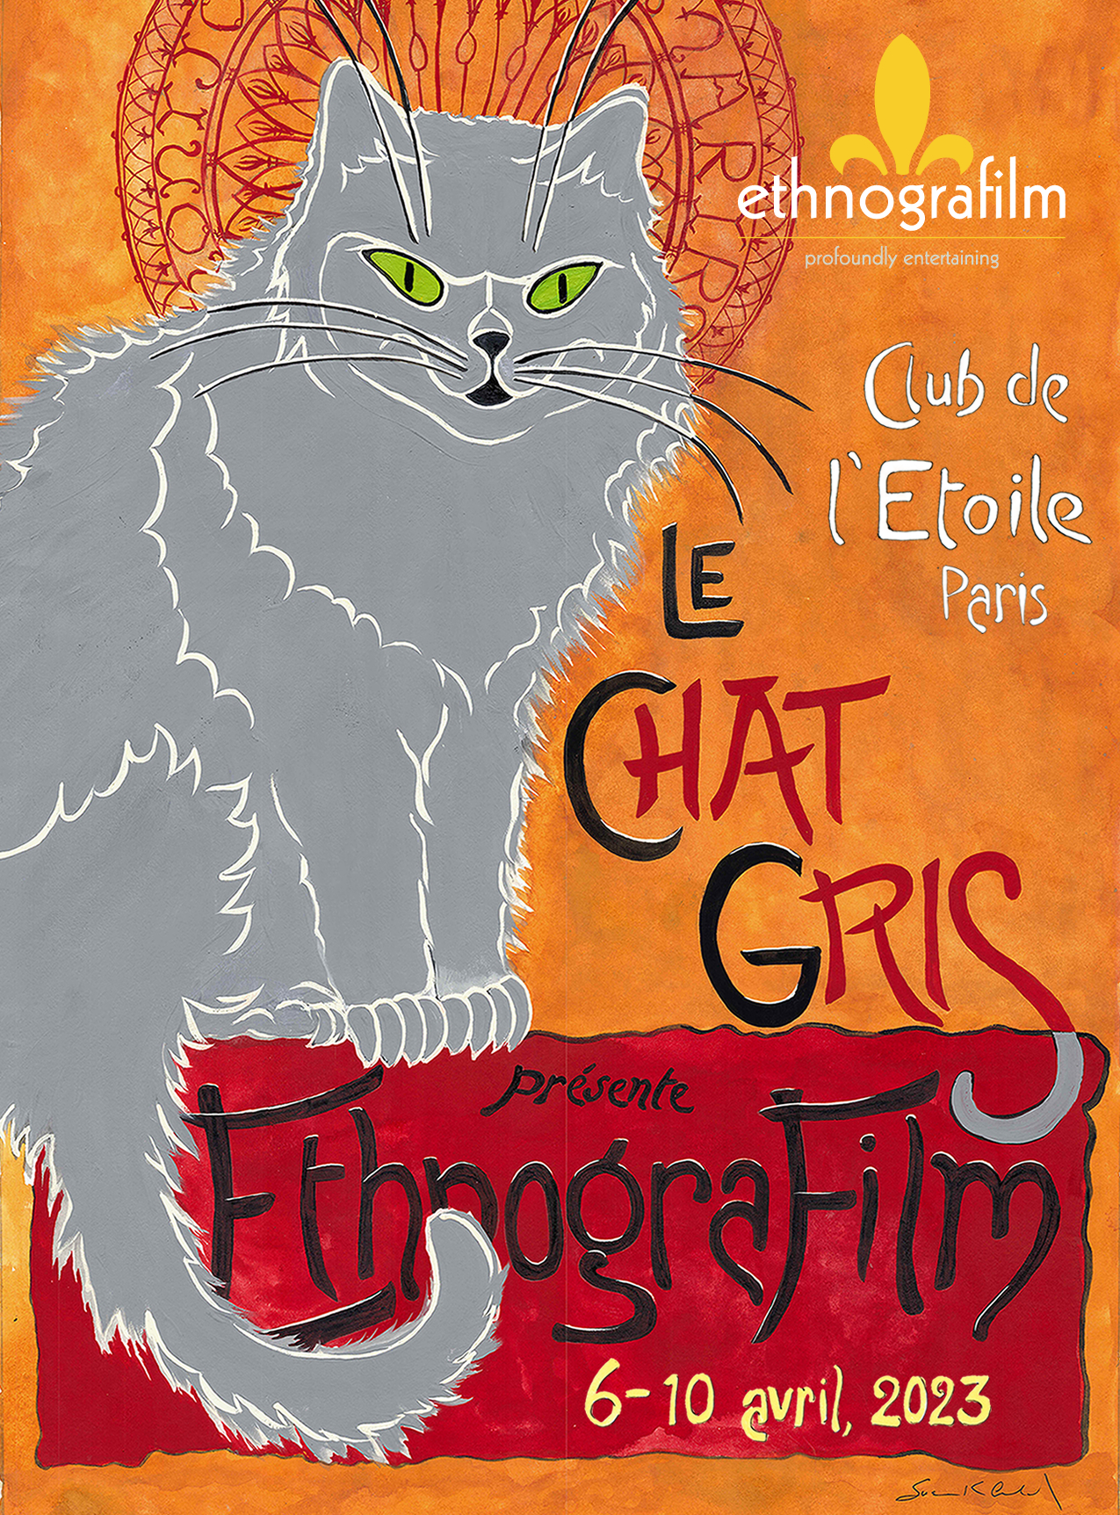

Ethnografilm seeks to enhance our understanding of the social world through film. From the 6rd through the 10th of April 2023 in Paris, France, the festival features over 100 works by documentary and academic filmmakers.

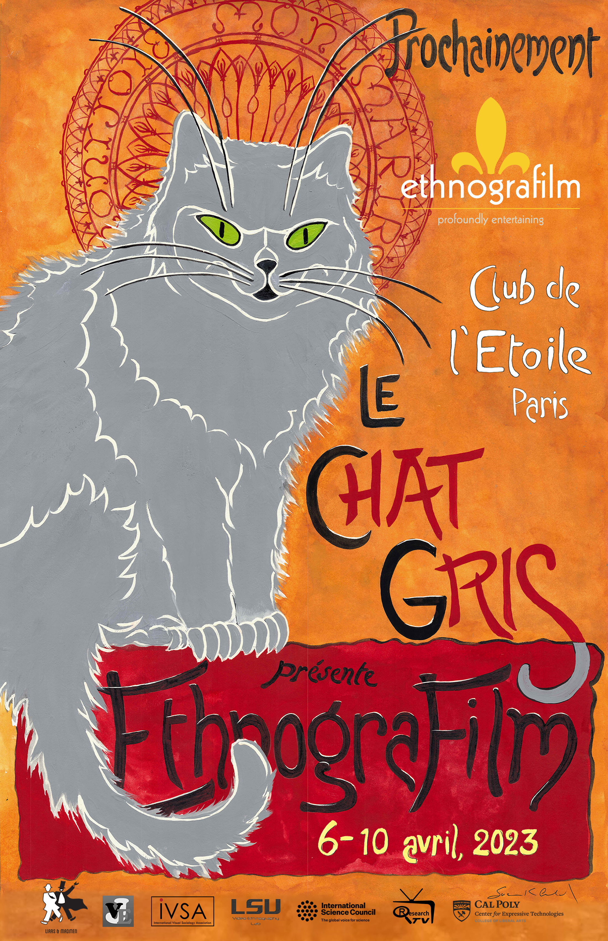

About the Cover
Our cover and 2023 poster feature Le Chat Gris, known in real life as Prudence the Cat, a feral cat who is
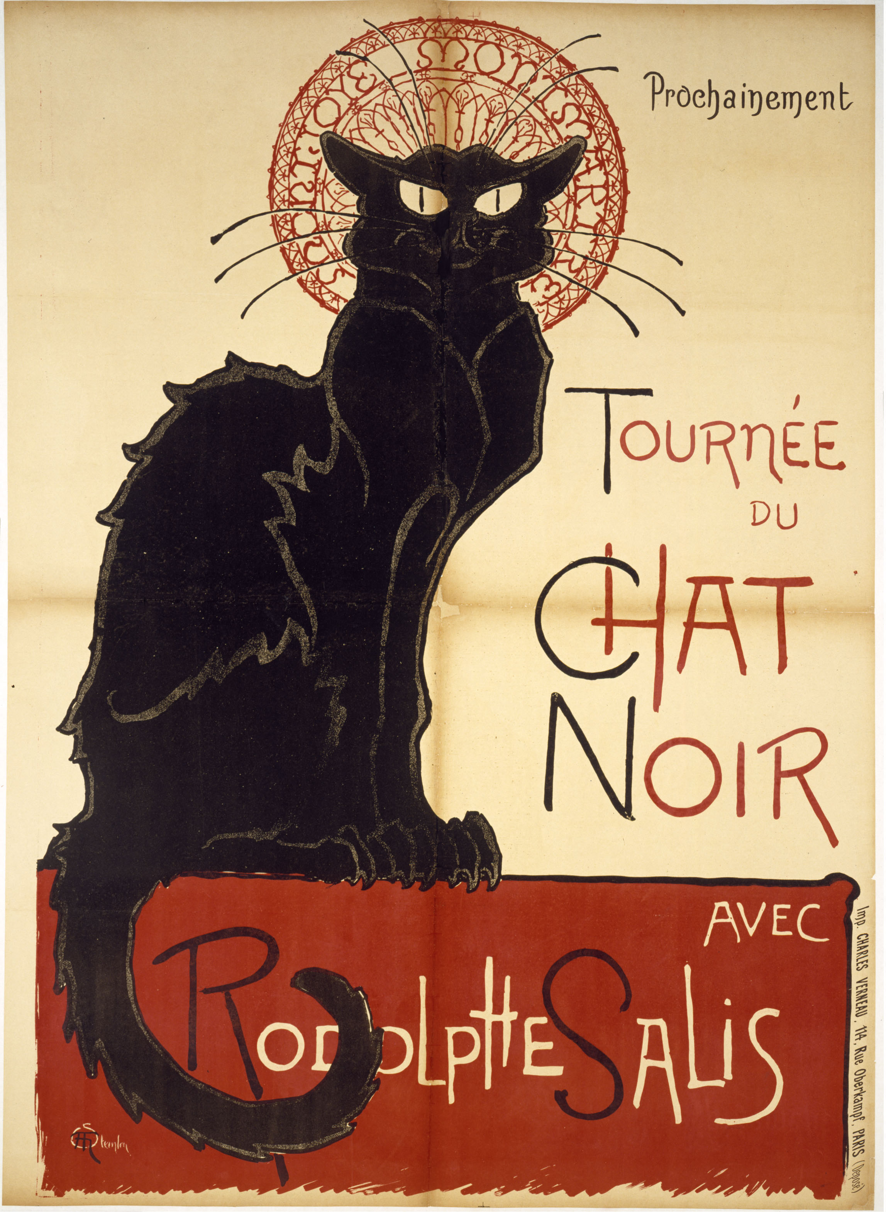

Le Chat Noir was the original Montmartre cabaret, opened in 1881 by Rodolphe Salis. Many are surprised to learn it was famous for shadow plays—cutout figures behind a screen and backlit to project their images on a screen. But the most famous contribution was Theodore Steinlen’s poster of 1896. Le Chat Noir became one of the most enduring images in Paris, now the model for Le Chat Gris, our poster for 2023!

Director’s Welcome

Ethnografilm is a moment to cherish for filmmakers, scholars, and all those who brought this diverse group to Paris. The International Science Council has been instrumental in implementing the vision of a festival to celebrate excellence in movies that enhance our understanding of the social world.
Ethnographic film—“ethnografilm” in Greg Scott’s coinage—has been broadly defined, yielding a huge variety of styles, formats, and themes.
We have a classic fringe theatre near the center of Paris! We have a community of filmmakers and scholars gathered for present inspiration and collaborations yet to come. What could be better?
Wes Shrum

Organization

Executive Director: Wesley Shrum, Louisiana State University
Artistic Director: Susan Arnold
Associate Director: Gregory Scott, DePaul University
Assistant Director: Matthew Harsh, California Polytechnic
Local Production: International Science Council
Alison Meston, Lea Nacache, Mathieu Denis,
Nick Perkins, Anne Thieme
Festival Production and Information Tech: Jewell Simon
Publicity and Design: Steve Coffee
Co-Founders: Wes Shrum and Greg Scott

Executive Committee
Ron Harpelle, Professor of History, Lakehead University, Canada
Kelly Saxberg, Independent Filmmaker, Thunder Bay, Canada
Molly Merryman, Kent State University
Kathryn Kasic, Montana State University
Michael Frierson, University of North Carolina, Greensboro
Sylvie Jacquemin, Cinematographer and Director, Paris
Robin Starbuck, Sarah Lawrence College
C S Venkiteswaran, Festival Director, Kerala, India
B. Paige Miller, University of Wisconsin, River Falls
Sreevasudeva Bhattathiri, Graphic Designer, Thiruvananthapuram
Antony Palackal, Loyola College of Social Science, Kerala, India
Andrew Persily, National Institute of Standards and Technology
Simon Luling, Paris Filmmaker
Kiril Kirkov, American University of Bulgaria
Lisa Pasold, Author
Roger Barnes, Film Critic
William Shewbridge, University of Maryland, Baltimore County

Ethnografilm Partners




The Video Ethnography Laboratory was established at LSU as a resource for graduate teaching and video ethnographic research.


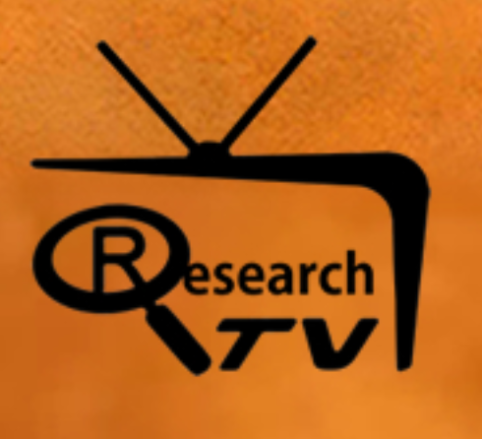  Journal of Video Ethnography




International Visual Sociology Association

2940 N Campbell
Jacob Kessler / United States / 00:04:11


A Satanic holiday is celebrated at a queer DIY space in Chicago. As police raid and permanently shut down the venue, excess pleasures persist to the musicality of a malfunctioning police radio. In the onslaught of lights and noises, audience members find a curious indifference to their source.

A Better Place
Jennifer Fearnley / Belize, India, Kenya, Seychelles, Singapore, United Kingdom / 00:32:44
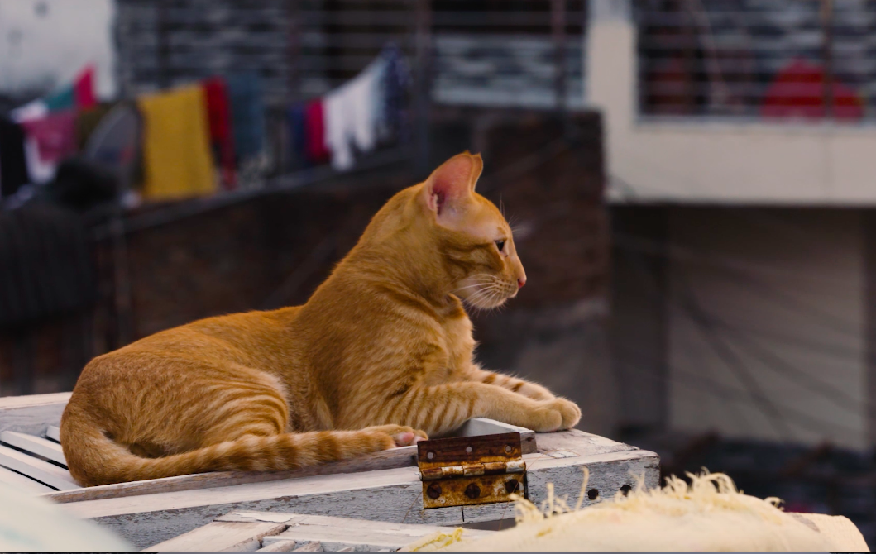
A Better Place is an in depth look at the toxic legacy of British colonial-era laws, which criminalise consensual same-sex love, while at the same time allowing perpetrators of sexual violence to go unpunished. More than 70 countries still criminalise gay sex. Meet the global network of activists, lawyers and legislators striving for equality and justice for everyone. Together, these courageous survivors and reformers are working to eradicate these laws, which blight the lives of millions.

a small bird then another small bird
Christine Rogers / United Kingdom / 00:05:41


When I moved from Australia to Belfast, Northern Ireland, in 2021, too much was hidden from me. People behind masks of politeness, small birds in trees. I installed a wildlife camera in my backyard and was drawn into the hidden life of local birds. But Donna Haraway calls for a 'subject forming entanglement' with the nonhuman. How can I do this through the lens?

Aents: Identity and territory
Ricardo Reátegui Marchesi / Peru / 00:20:02
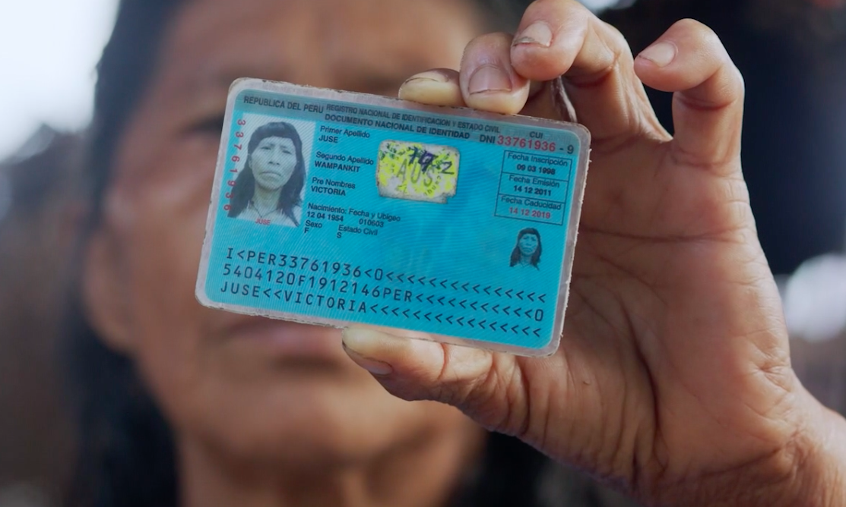
It took Mr. Espejo several years to get his Identity Document (ID); Elvis has to live with the wrong picture on his ID until he´s finally eligible to renew it; Dante wishes he could have the awajun “ornaments” on his ID picture, but the government doesn’t allow it. In this short documentary we learn the stories of delays, tribulations, and confusion involved in getting a Peruvian ID as told by members of the ancient Awajun community in the Peruvian Amazon. The testimonies reflect their feelings about identities and the different ways of being Peruvian in a country with around 45 different languages.

Ait Atta: Nomads of the High Atlas
Inanc Tekguc, Eda Elif Tibet / Morocco / 01:17:00
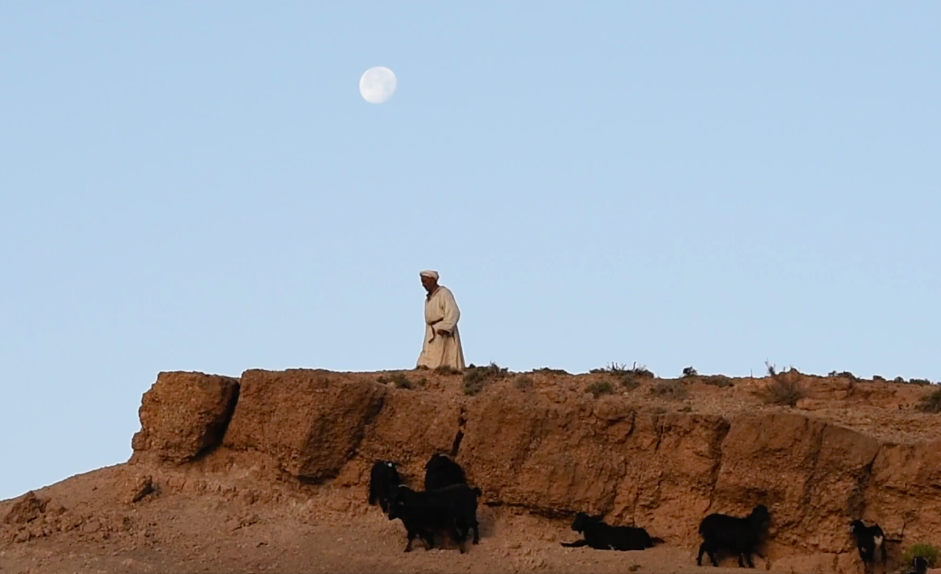
The Ait Atta tribe preserves their ancestral right of access to the agdal, a communal land management system that dates back hundreds of years in Morocco. The film follows Ben Youssef family’s arduous transhumant journey from the desert-like landscape of Nkob to the green pastures of Agdal Igourdane, through uneven terrain of steep climbs and descents of the High Atlas mountains. A sensorial ethnographic story on the incredible movement and (im)mobilities of the family and their herd, the film juxtaposes the hopes and constraints, obligations and sacrifices of a family torn apart between their traditions and their need to adapt to modern life.

Anicca
YOUSEF AZHARI / Malaysia / 13”
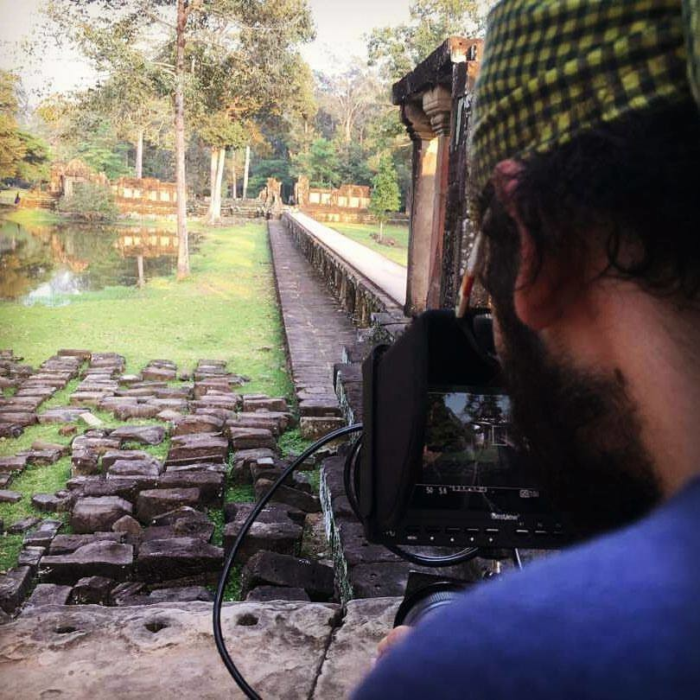

Human life interactions and its relativity to religion and historical traditions, how are the people connected to the beliefs of a specific piece of land, but are eventually interconnected with all other humans on the planet.

Art and Pep
MERCEDES KANE / U.S. / 88”

A Art Johnston took Pepe Peña home one night in 1972 and he never left. Together, they opened Sidetrack, a small bar that’s become a 16,000-foot pillar of Chicago’s gay business district. At Sidetrack, the community sings show tunes on a Sunday and helps elect progressives on a Tuesday. From being on the frontlines of the AIDS crisis to co-founding Equality Illinois, Art and Pep have been leading the fight all along, making Illinois one of the most progressive protectors of LGBTQ+ rights in the country. ART AND PEP is a look back at the long struggle for equality and their fight to love freely - and a look ahead at the work being carried on by a new generation of activists.

Ballad for the Robbery of the Sacrament
ANTONIO LLAMS / / 8”
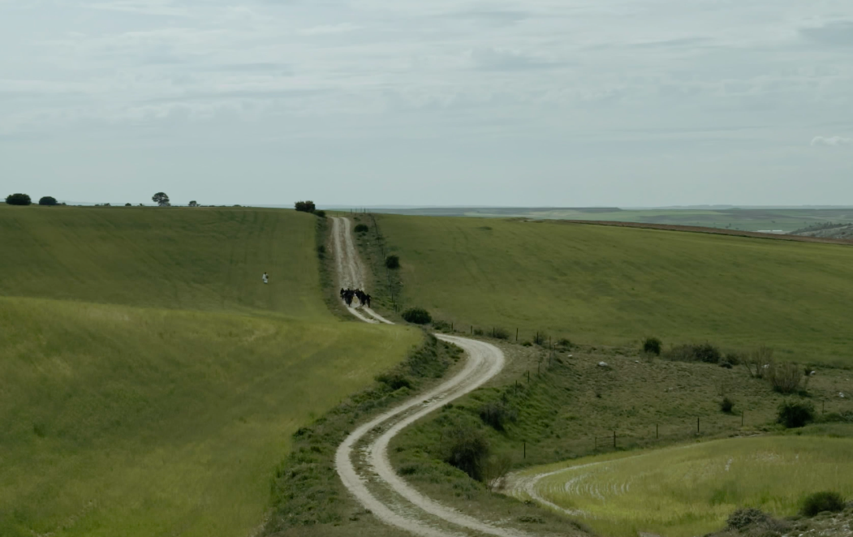

Black Action Figures
Dave Steck / United States / 00:06:55
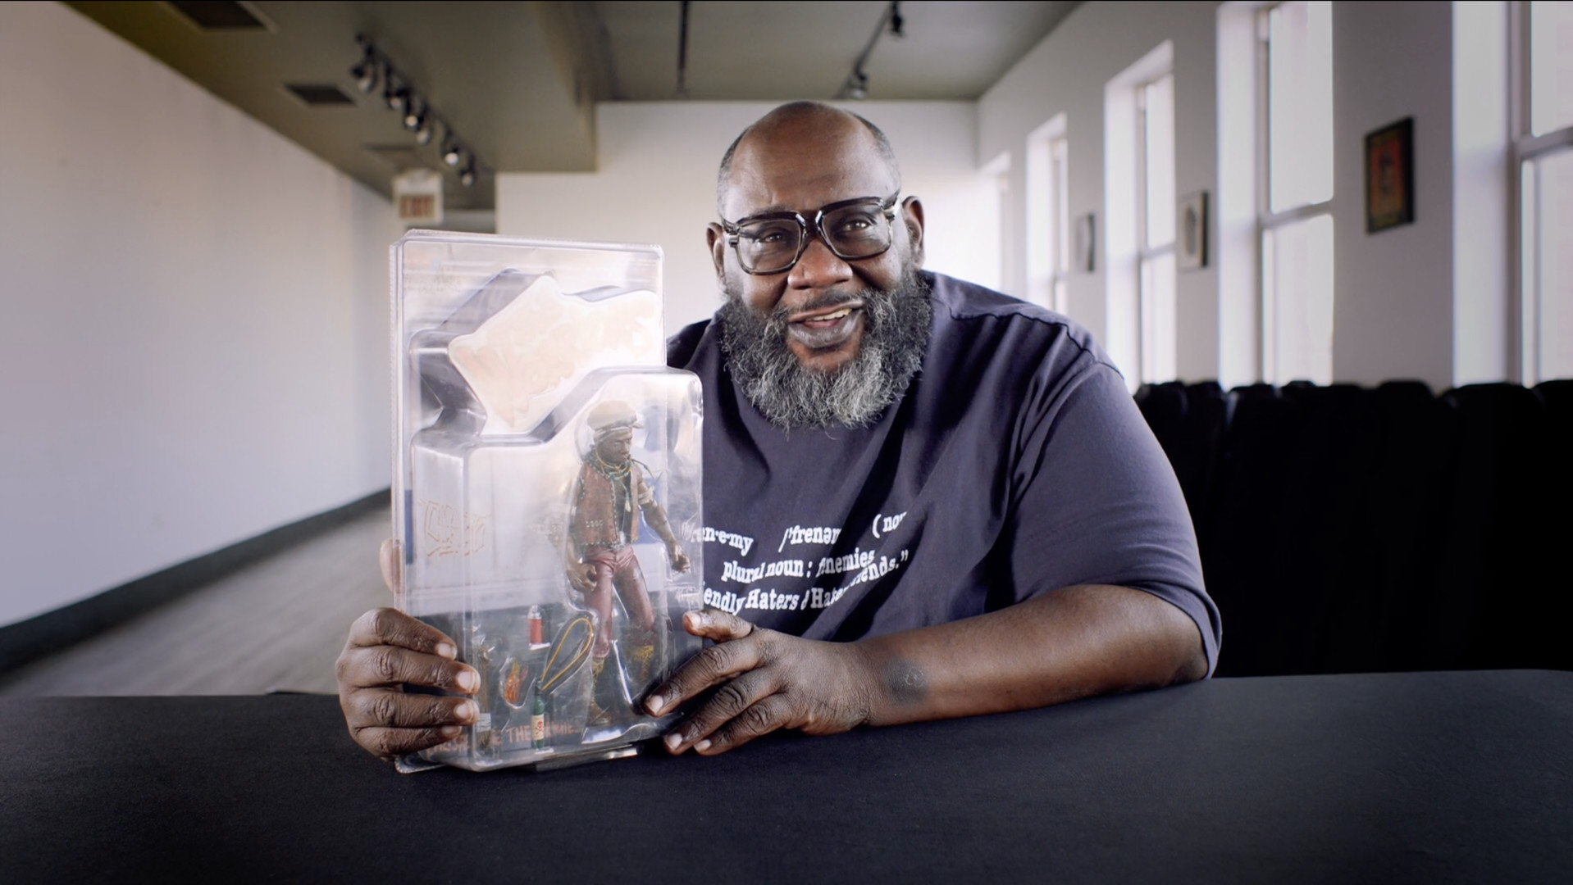

A short documentary about representation, connection and the power of seeing yourself reflected in popular culture. It features Duro Wicks sharing some of his personal doll collection and talking about his motivation, process and passion to find and collect Black action figures.

Brick Mule
Michael Brown / Nepal / 01:06:00
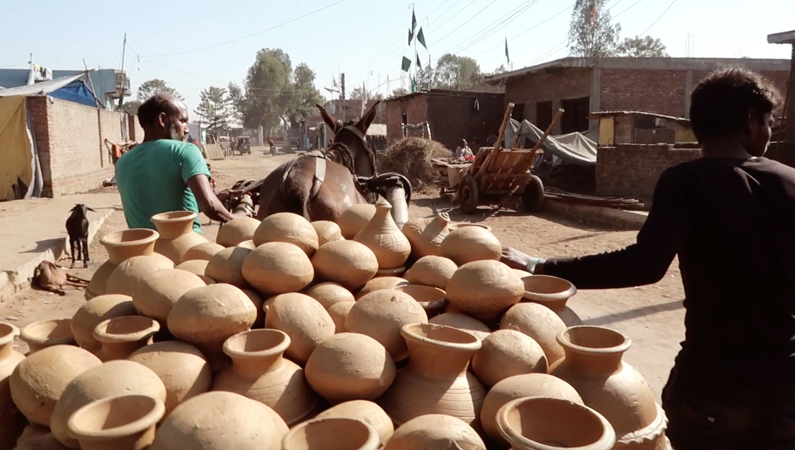

This Direct Cinema anthrozoological ethnographic film documents the lives of Nepal's working mules. The film finds a closeness with the mules; their sale in India, their journey to Nepal and their work in the huge brick factories of the Kathmandu valley and portering goods into the high Himalayas. Stunning cinematography and a crafted soundscape paint a moving portrait of Nepal's brick mules and the people who make their living with them.

Brother Rick
Elton Hubner / Canada / 00:14:30
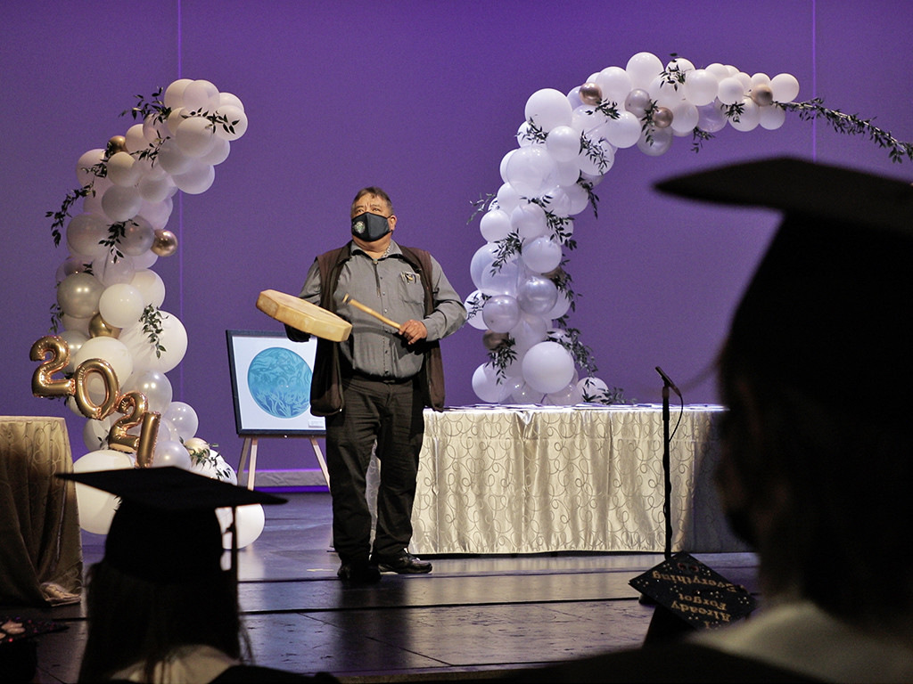

How a member of the Quw’utsun First Nation is bringing people of different backgrounds and generations together as brothers and sisters.

Cai Lun's Key: How the Kam People Preserved the Earliest Papermaking
Marie Anna Lee / China / 00:15:30
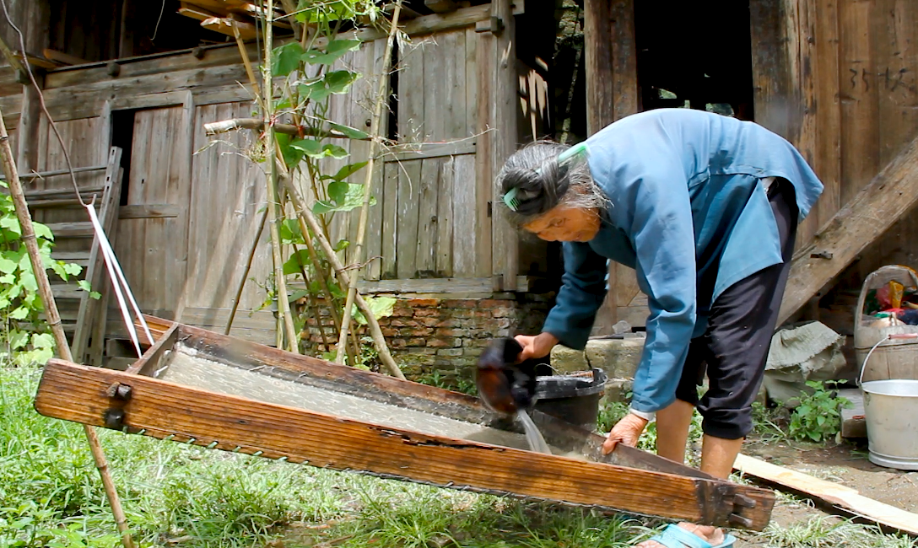
An art professor and her students apprentice with Kam minority artisans deep in the mountains of southwest China to learn early papermaking technology. The Kam have lived secluded from the rest of the world for centuries. Their papermaking tradition can be traced directly to the Chinese official Cai Lun, who is credited with inventing paper over 2000 years ago. Kam artisans adopted his technique after the addition of mulberry bark to the pulp mixture but before he invented the dipping method of forming paper.

Dafa Metti (Difficult)
Tal Amiran / France / 00:14:36
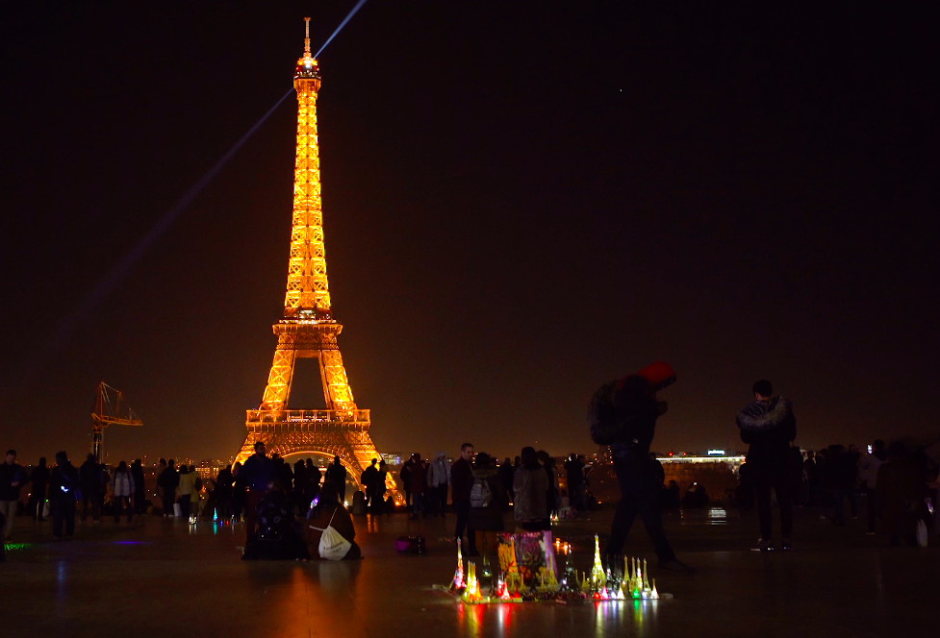
Under Paris' glittering Eiffel Tower, undocumented Senegalese migrants sell miniature souvenirs of the monument, to support their families back home. Far from their loved ones and hounded by the police, each day is a struggle through darkness in the City of Lights.

Deep Clean Water
Kevin Rumley / Switzerland / 00:20:00
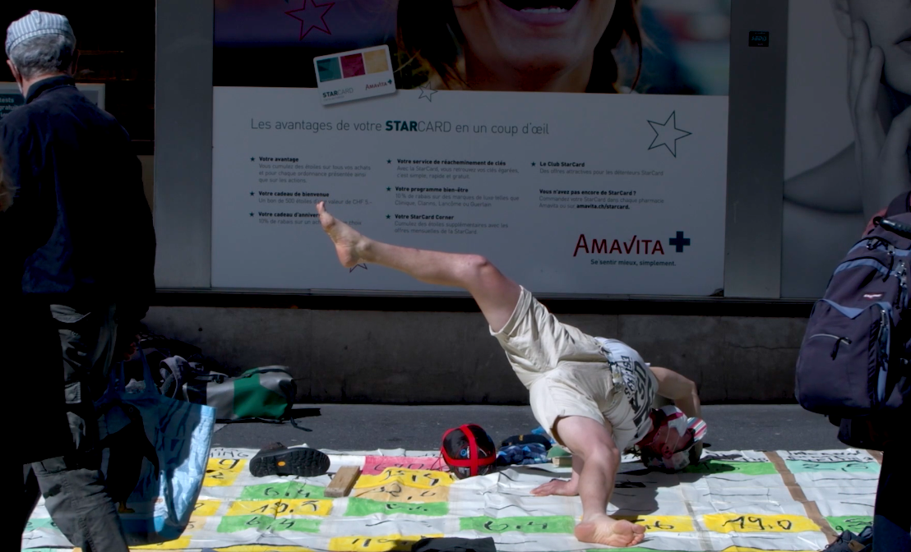
Jacob (30) is a Lithuanian artist who hitchhiked from Kaunas (Lithuania) to Lausanne (Switzerland) to meet Howey Ou, the Chinese Greta Thunberg. He is writing a master's thesis on Chinese climate change policy. He would like to have Howey's point of view. In Switzerland, he discovers that she is on a hunger strike and decides to do the same to support her.

Destiny
Yaser Talebi / / 00:53:00
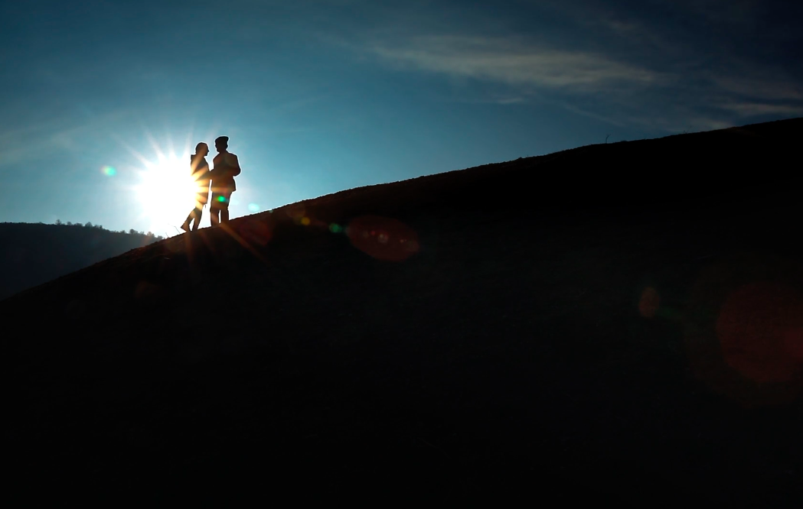
While her family insist that she stay home after high school to fulfill her duties, an 18-year-old Iranian girl cannot ignore the burning desire to pursue her dream of becoming a doctor. Standing before a heartbreaking crossroads, she must do all it takes to challenge the confinements forced upon women and girls in her society.

Detached
Vladimir Krivov / Russian Federation / 01:04:00
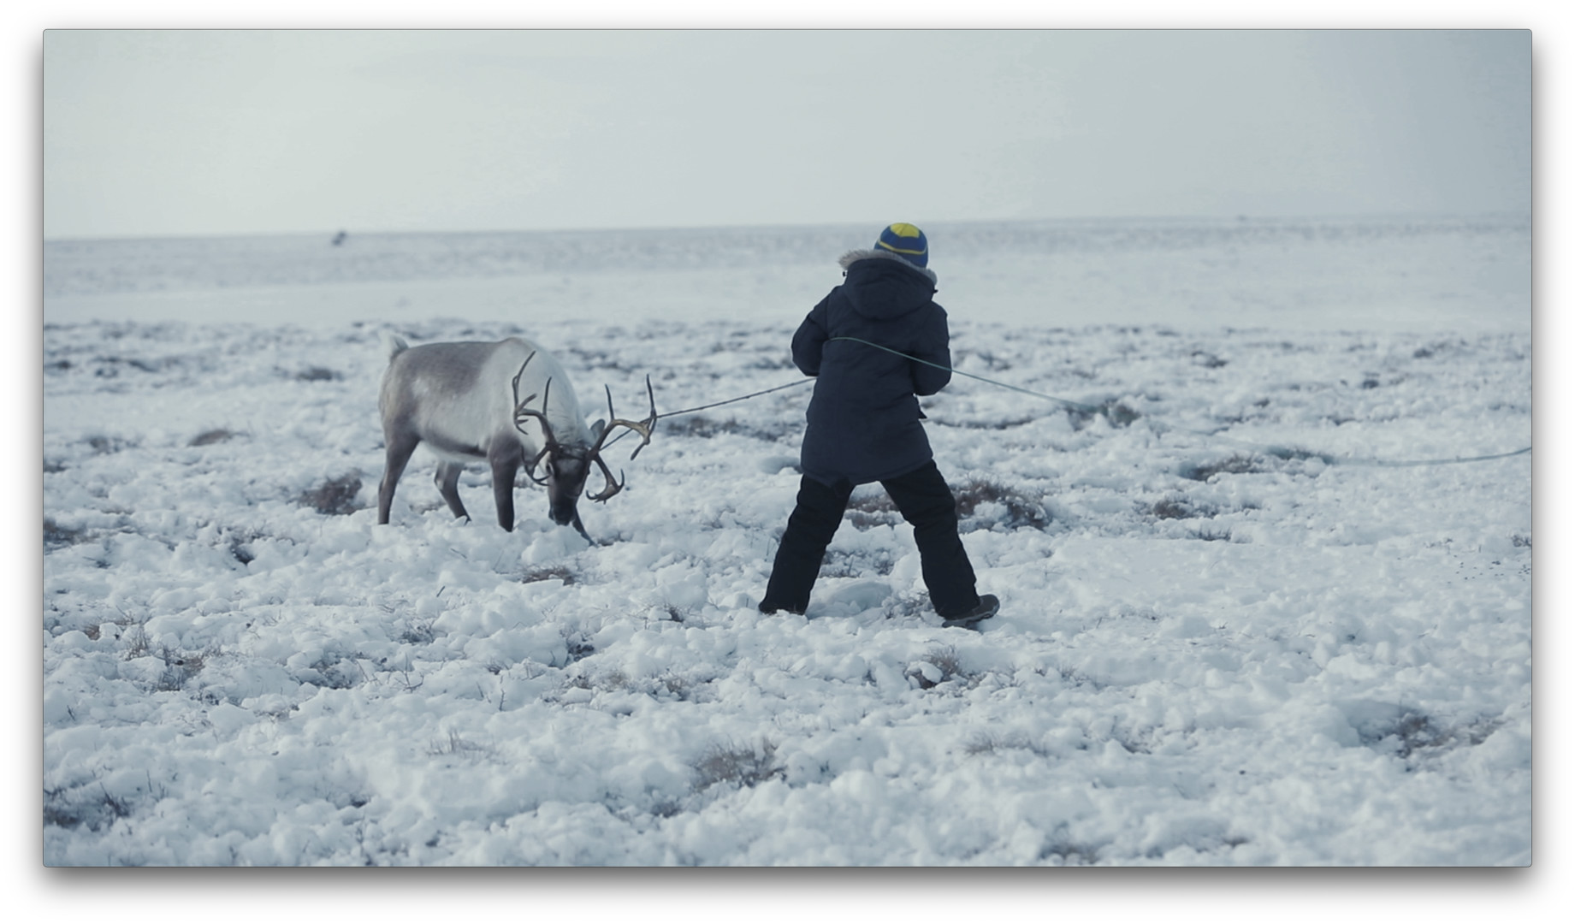
“The Detached” is a monologue of one Chukchi man and of the whole ethnic group at the same time. It’s a story of their life, Motherland, and also of the things that cause the Chukchi to break away from their roots. This film is a possible projection of our future, as by choosing the blessings of civilization, we risk losing ourselves. Is there a way to get out of the "blizzard"? It seems that the Chukchi know the answer..

Digital Energy Futures
Sarah Pink / Australia / 00:23:21
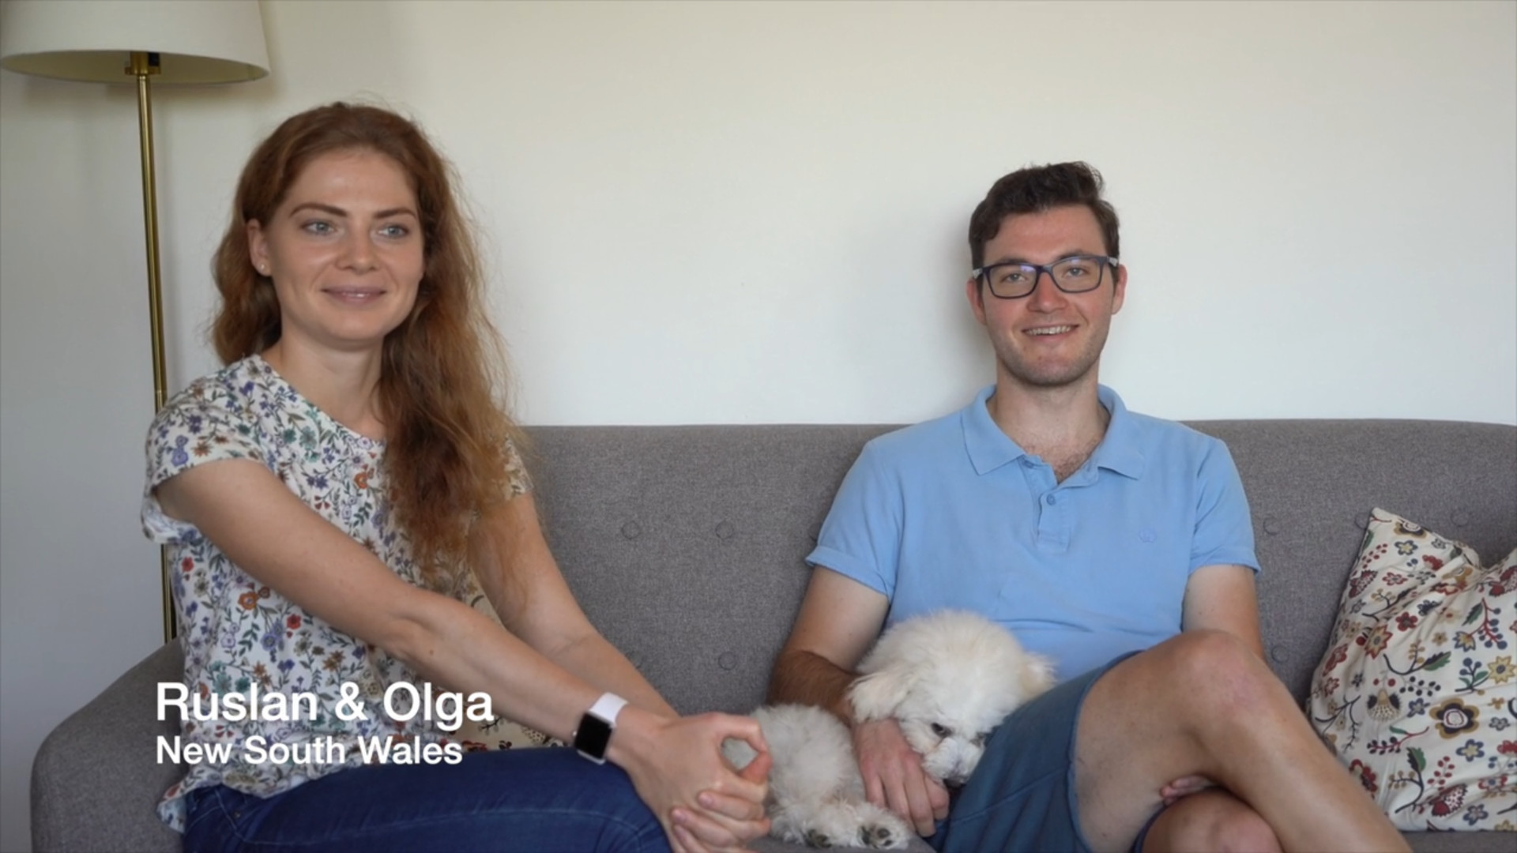
Imagine a future life where your smartphone, watch, airpods and your electric car were automatically charged without you even knowing. What would it be like to give up control to an external system which optimises your energy use, decides when a robotic vacuum cleans your home and even when your electricity is available. Or are these even realistic or desirable futures? This film explores how people living in Australia see their future lives in a country where increasingly extreme weather, concerns about public health, growing levels of technological automation, and a society dependent on digital media are set to create uncertainty about demand for electricity in the future.

Displaced. Small Acts of Survival
Andrés Ribagorda, Anthony Barlos, Charlotte Burck / Greece / 00:29:40
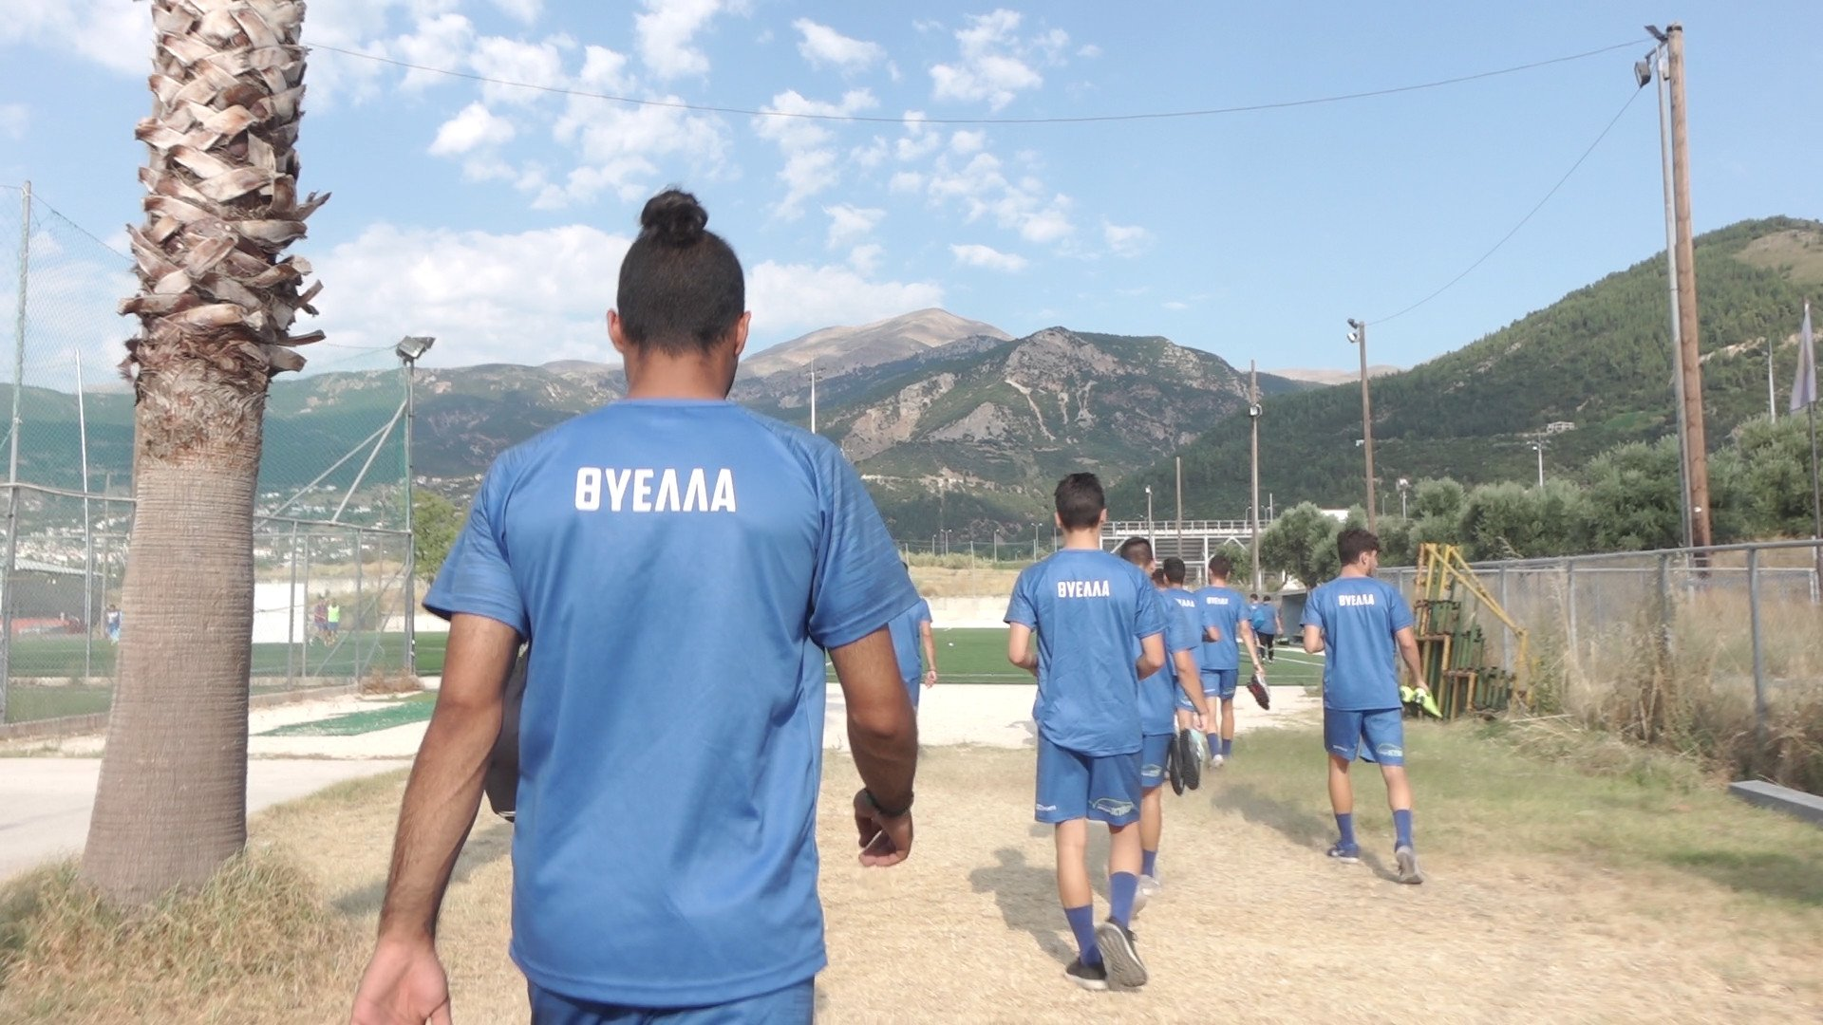
Two Iranian migrants are suspended in limbo in Patras, Greece, a port suffering high levels of unemployment and economic hardship. This atmospheric documentary traces their small acts of survival alongside those of two unemployed Greek builders coping with poverty.

Donkey Music
Morana Schulz, Karolina Malinowska / Croatia / 00:16:56
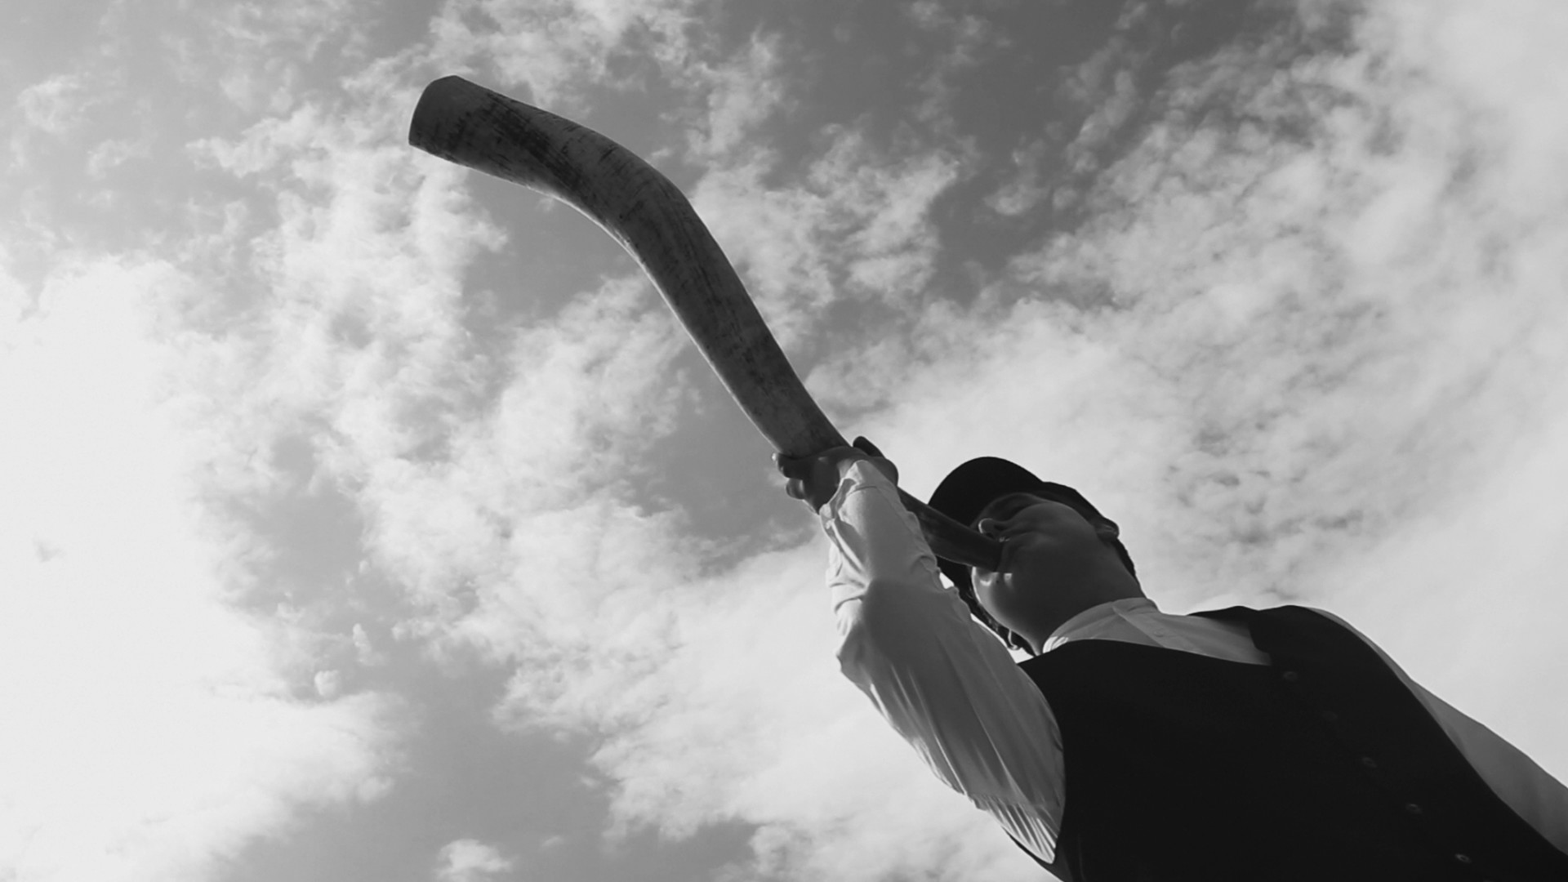
Every summer on a distant Croatian island, a parade of young men occupies the village Sali for several days. While they blow the oxen horns and strike up rhythm with old flat-irons, we sail with them through hell and dive with them into the sea, only to re-emerge among the living in the parade's grand finale.

Don' t break my stones
Katerina Patroni / Greece / 00:17:26
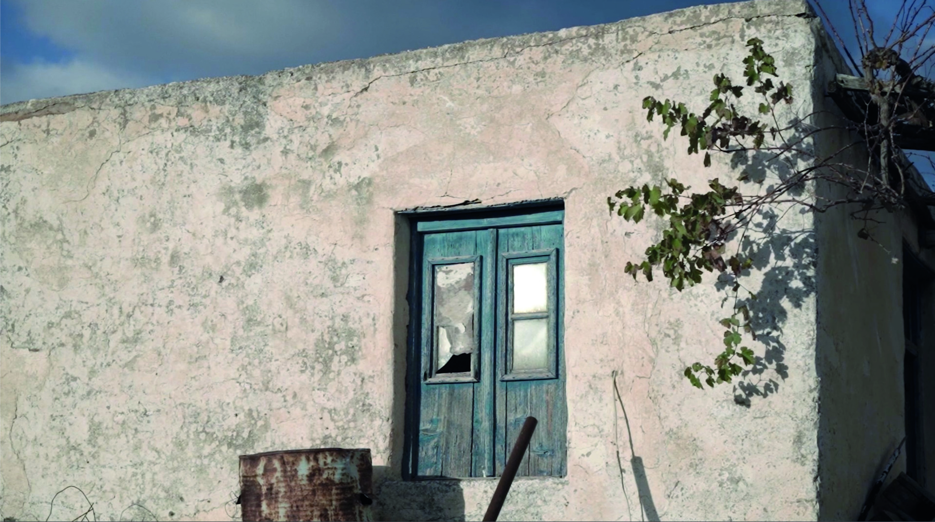
A Documentary about the katikés* of Paros island, Cyclades, Greece. Four people share their stories and memories from their katikés; the residences outside the main island settlements, around which Parians housed their productive agricultural activities and livestock farming.

El Ojo de Agua de los Gálvez
Jose Luis Figueroa, Ana Paola Rodriguez / Mexico / 01:30:00
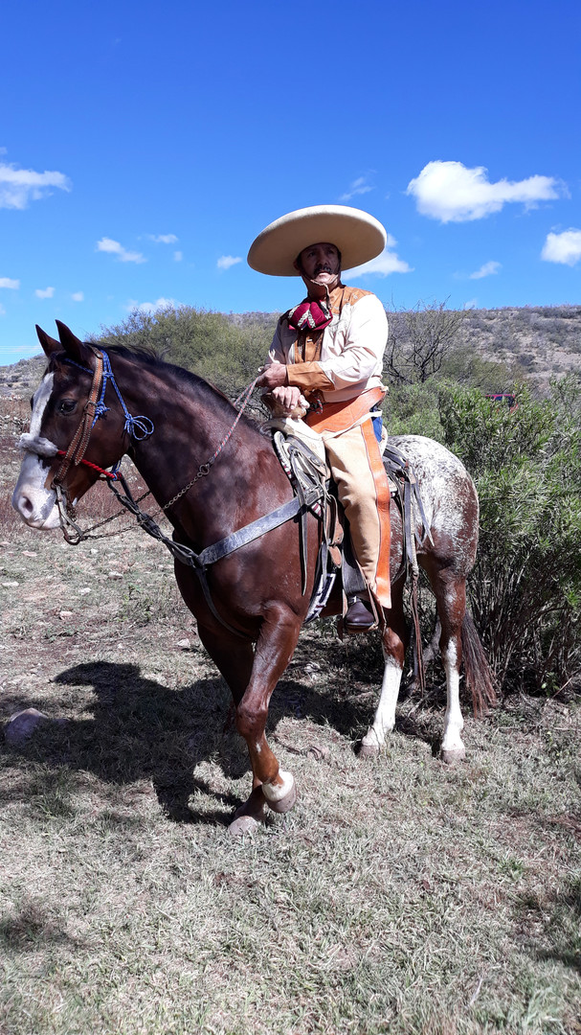
Despite living in Los Angeles, California, José Gálvez has decided not to leave his almost uninhabited El Ojo de Agua ranch in Mexico. There lies the history of his ancestors, his most beloved memories and most intense experiences. Such is his determination that he has motivated others to follow in his footsteps. The documentary expresses the love that this man feels for his personal and family history, and the dignity with which he refuses to let it vanish.

Electronic Knowings: A visual discussion with David and Judith MacDougall
Catherine Gough-Brady / Australia, Indonesia / 00:08:11
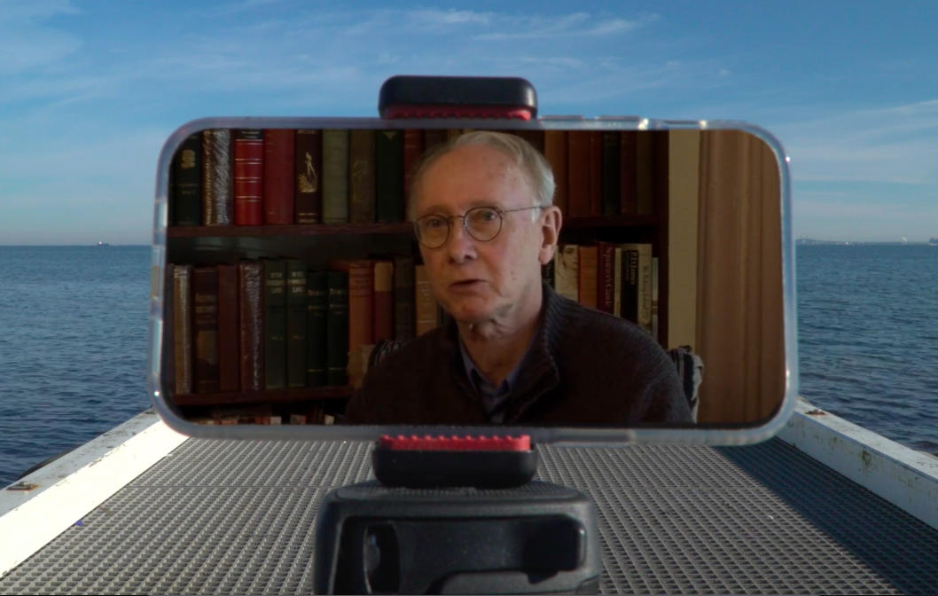
In this short essay film Catherine Gough-Brady creates a visual dialogue with David and Judith MacDougall’s views on observational filmmaking, expressed in archive interviews.

Elefsis
Takis George Bardakos / Greece / 00:19:23
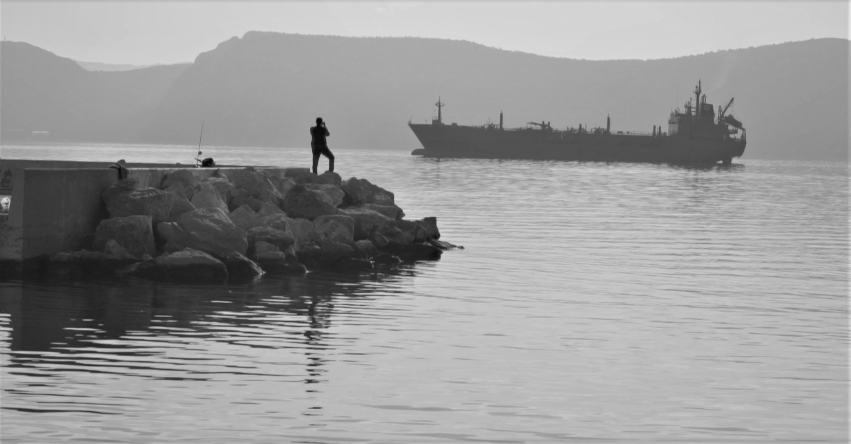
SYNOPSIS A collection of still shots, of the inhabitants of the port of Eleusis. People have reach their destination in front of the Sea of Eleusis scenary, against the horizon lines, resembling a kind of purification process. Time stops here and it is becoming of abstract meaning: There is no "past", no "future", just "eternal present".

Everywhere West
Mark Neumann / United States / 9”
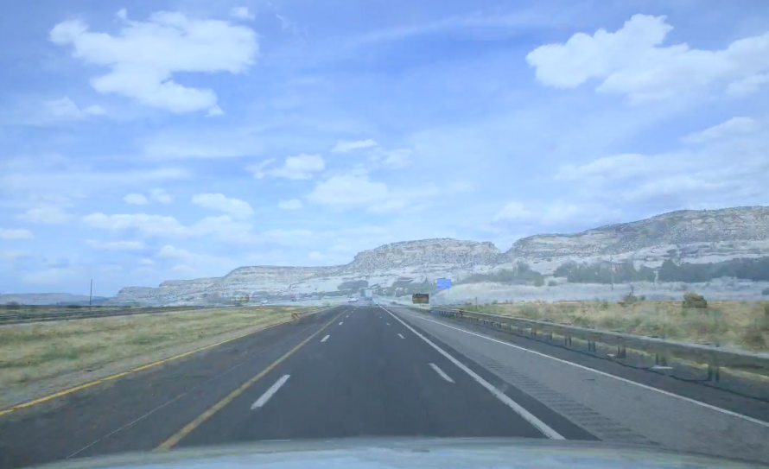

"Everywhere West" is a film-poem that puts viewers in the driver's seat on a high-speed journey across America, from Arizona to Maine, in less than 9 minutes. This is "cine-poetry," a rhapsodic, panoramic vision of America's highways and backroads, and a high-velocity search for self and country.

Exiled Hopes
Cihan Aydiner / United States / 00:14:56
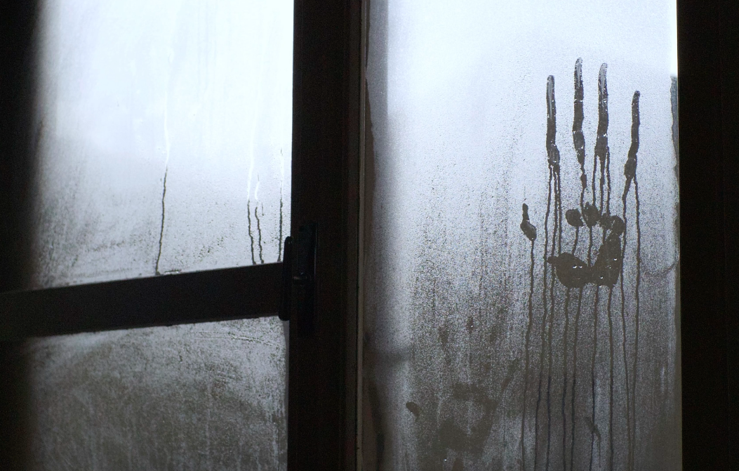
The Turkish emigration following the 2016 coup-like event is unique, given that they were forced to flee relatively stable lives to seek safety. In acknowledgment of the dire factors of the immigration process, many Turkish immigrants had high human capital with regard to education and their profession. Despite their high education and professional status, the forced aspect of their migration complicated their ability to secure stability and regain their former professional status.

Eye Witness
Lenore Rinder / United States / 00:19:48
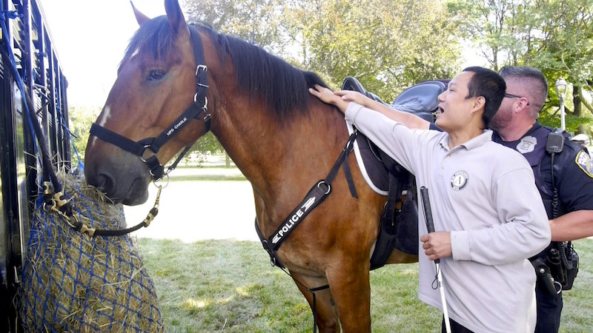
“Eye Witness” is a documentary video that follows six blind Karen refugees from Burma who are adapting to a new culture in Milwaukee, Wisconsin, USA. Aided by caring ESL teachers, family and community, they learn to navigate the challenges of becoming American citizens, find work, and live in a new world.

Fat Tuesday
Aleksandrija Ajdukovic / Serbia / 00:08:00
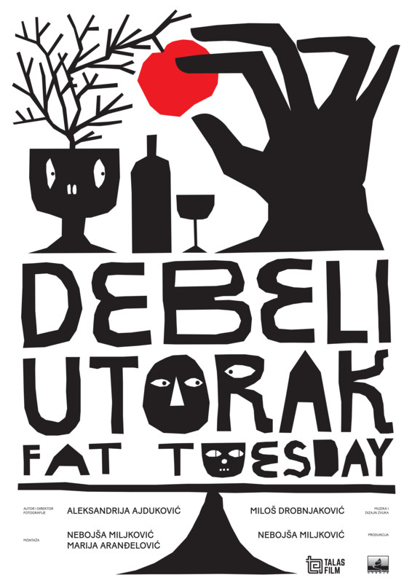
Film "Fat Tuesday", shot with Lomography cameras, is an illustration of three carnivals taking place in different parts of Serbia. Film is trying to find balance between established ritual dynamics and random whimsies of those taking part in it, all the while raising questions about our relation to culture, tradition, nature and society.

Fiddly Bits
Kodi Roberts / United States / 00:07:10
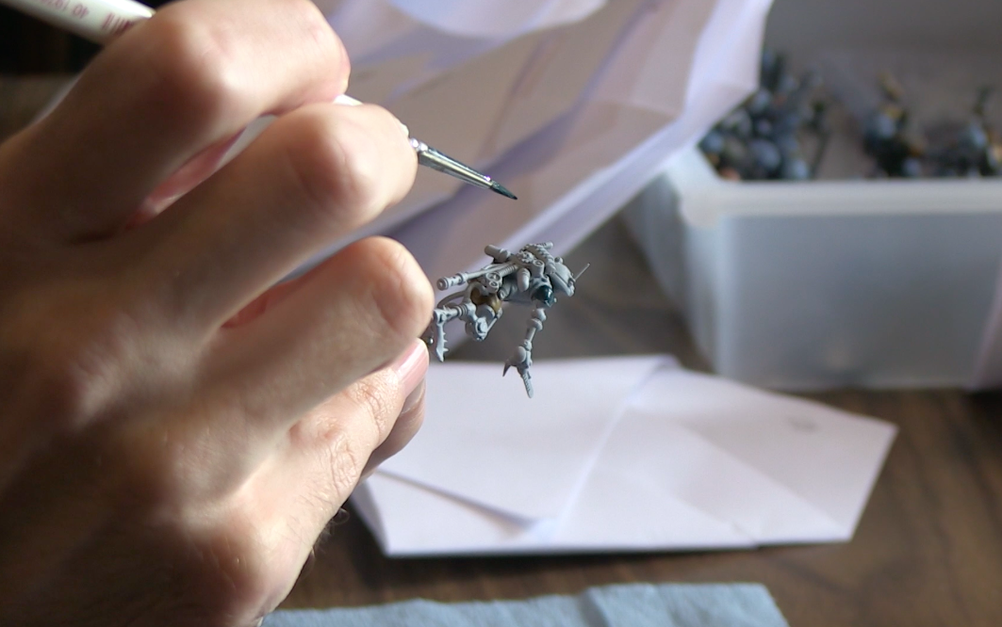
“Fiddly Bits” is a short ethnographic documentary about hobbyists who play the table-top miniature wargame Warhammer 40,000. The film focuses on three hobbyists and their conversation as they assemble and paint miniature figurines for use in the table-top game. How is identity navigated, negotiated, and constituted through the medium of miniature wargame figurines? Topics discussed include political geographies of the local wargaming community, and gender stereotypes and counternarratives among hobbyists.

First Saké Brewery in New York
Xiaoying Su / / 00:10:24
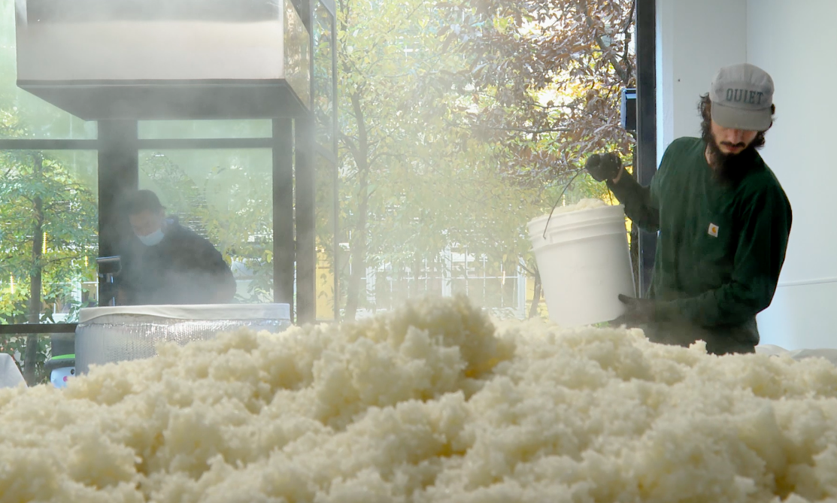
This documentary reveals the story of the passion and love of saké-makers and what it takes to make a world-class saké at Brooklyn Kura, the first saké brewery in New York. Dave Gustine is a previous photographer and currently one brewer of the brewery, obsessed with exploring the aesthetic and poetic connection between fermentation and photography. This short documentary is a journey of the experimental image without an interview.

40 Steps
Gad Aisen, Manor Birman / Israel / 01:17:51
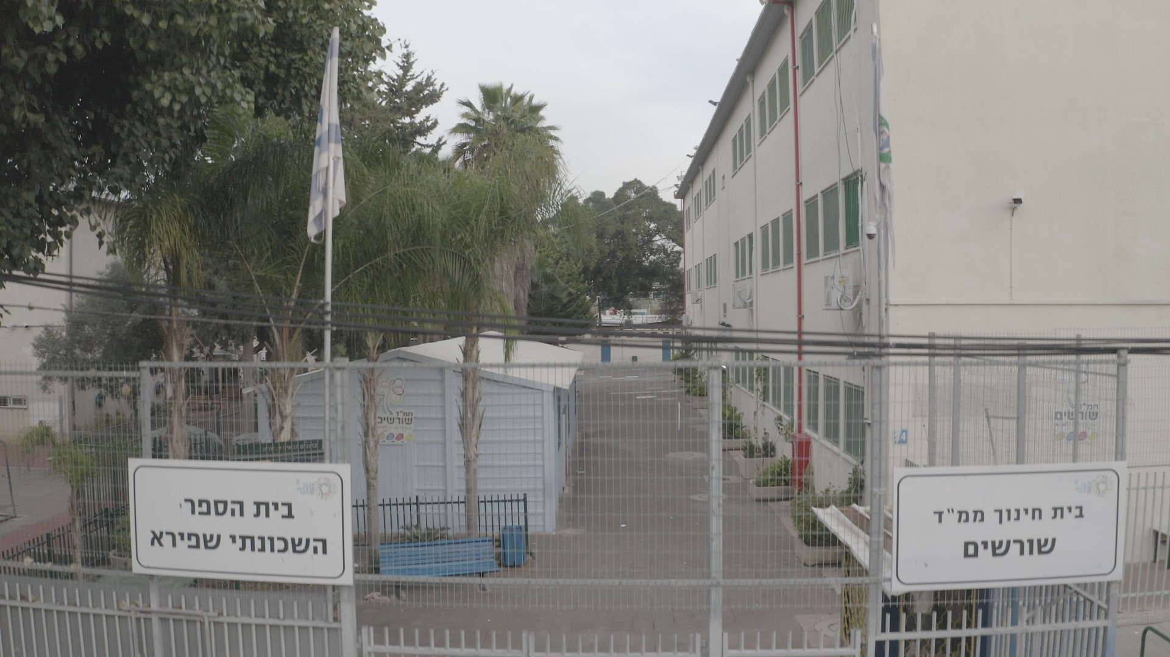
An orthodox school in south Tel Aviv is divided into half for a new secular elementary school. In a shared playground, both schools must coexist, while the identity of different communities are put to the test.

Fred Chappell: I am One of You Forever
Michael Frierson / United States / 01:00:18
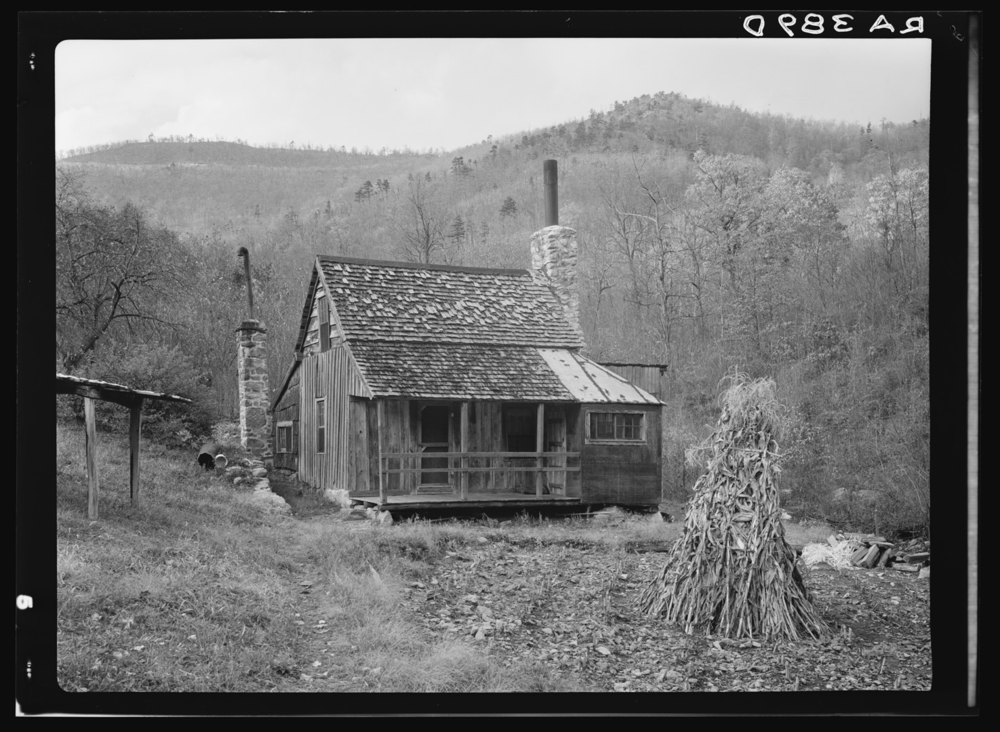
Fred Chappell is one of our most important Southern writers, but no one is really surprised if you have never heard of him. Fred grew up on farm in Great Smokey Mountains. His early life was marked by the struggle between the old ways of Appalachia that lingered due to the region’s isolation, and the new ways of modern industry. In his hometown of Canton, North Carolina, a mill town dominated by the Champion Paper and Fiber Company, Fred read pulp magazines as a kid and wrote science fiction as a teenager. Chappell went on to help create one of the nation’s first graduate creative writing programs.

Freedom Squared
Anastasia Zverkova / Russian Federation / 01:05:55

The plot is centered around two scientific experiments that simulate a long-distance space flight. Physiologist Nikolai Osetsky goes to Antarctica to study human vision in conditions closely resembling those of the Moon. Meanwhile, a group of testers from Russia and the United States are locked in a replica of a spaceship to test the effects of isolation on themselves. Both experiments led participants into a state of severe loneliness. It raises the question: is a human being ready for a long-distance spaceflight not only physically, but also spiritually?

Getting That Note Out
Francesca Soans / United States / 00:56:37
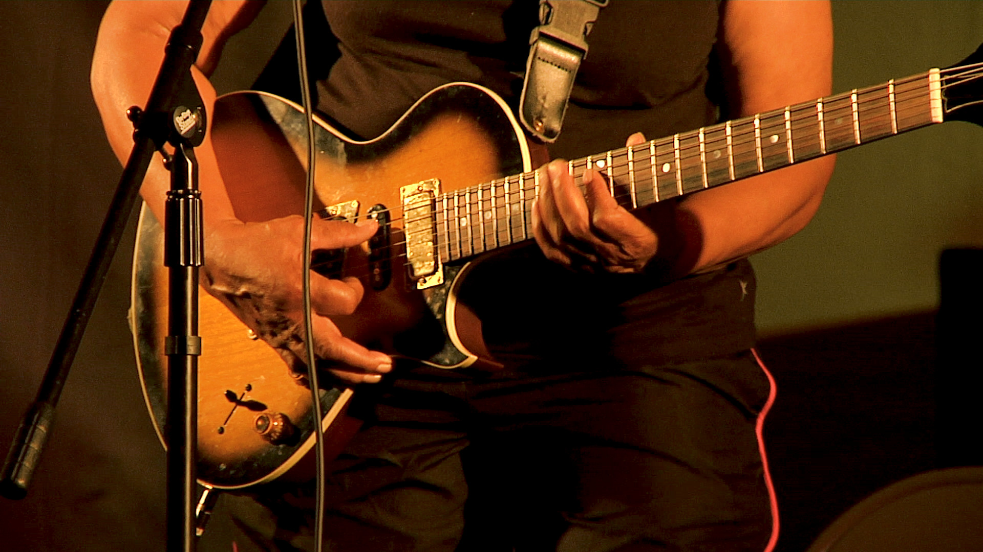
LOGLINE: An aging blues guitarist re-connects with her music, revealing the power and resilience of the creative spirit. SYNOPSIS: Past collides with present in this intimate slow cinema documentary about aging blues guitarist Etheleen Wright as she re-connects with band members to perform at a local music festival. As she visits abandoned buildings and plucks remembered strings, Etheleen’s memories reveal a story of struggle, loss, and resilience. Getting That Note Out is a story about the power of creativity in all of us.

Girose My Love
Sandrine Loncke / France / 00:12:30
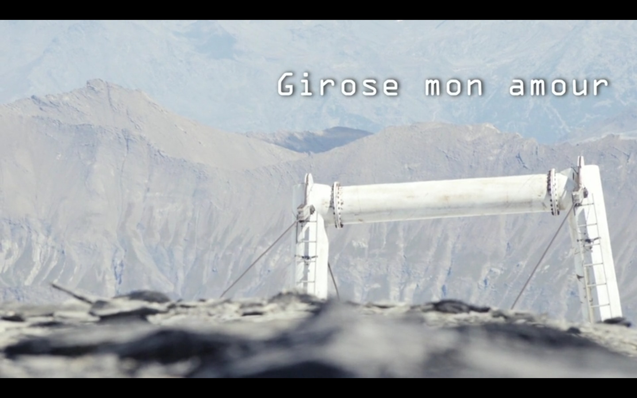
While a tourist development company is planning the installation on the glacier La Girose of a new section of cable car which will link, at 3600 meters above sea level, the last great ice cap of the Écrins massif to the immense ski area of Les Deux-Alpes, a collective of artists decides to settle in residence on the glacier to think about our relationship to these territories of ice, doomed to disappear.

Hantush - a fairytale
Alexia Tsouni / Palestine, State of, Spain / 00:06:12
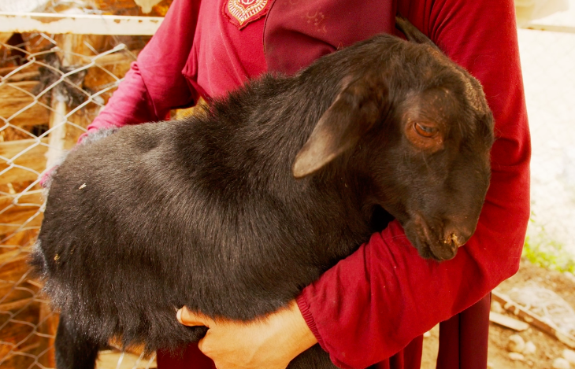
When Israeli bulldozers arrived at her Bedouin village to demolish her home, 14-year-old Palestine refugee girl Salha called on her flying lamb Hantush to take her somewhere far away...

Home: A Himalayan Portrait
Jane Dyson, Ross Harrison / India / 00:08:11
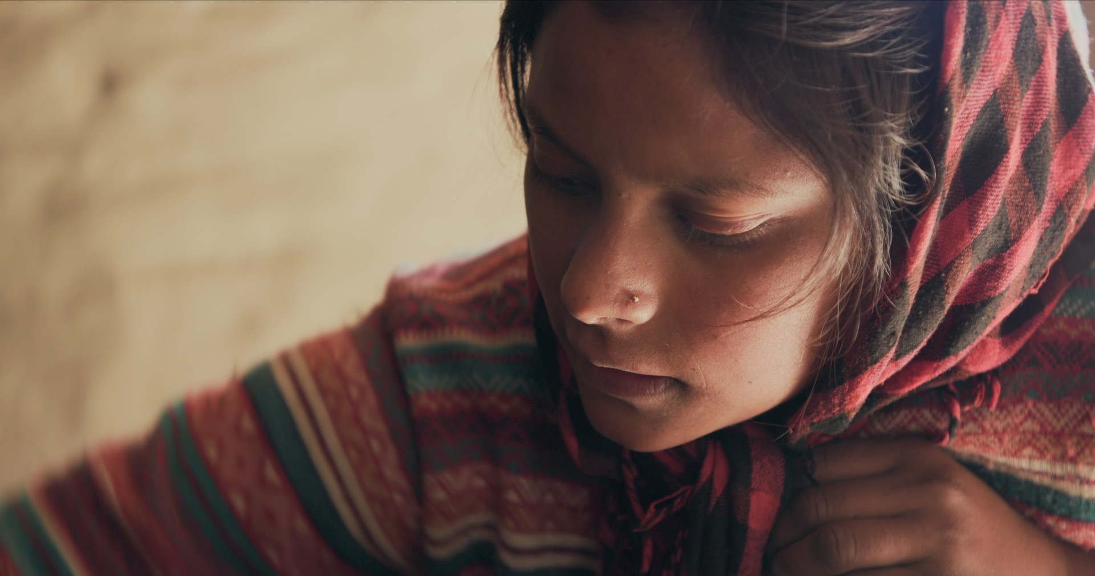
In the months before her inevitable arranged marriage, Munni contemplates her home in the Indian Himalayas. She reflects on her ties to family and the land, her ambivalent pursuit for an education outside the village and the delicate dance between continuity and change. Based on ethnographic research in the village over two decades, 'Home' is a portrait of love and loyalty, and of simmering unease for what might lie ahead.

Homeboys
Tamar Goren / Uganda / 00:60:00
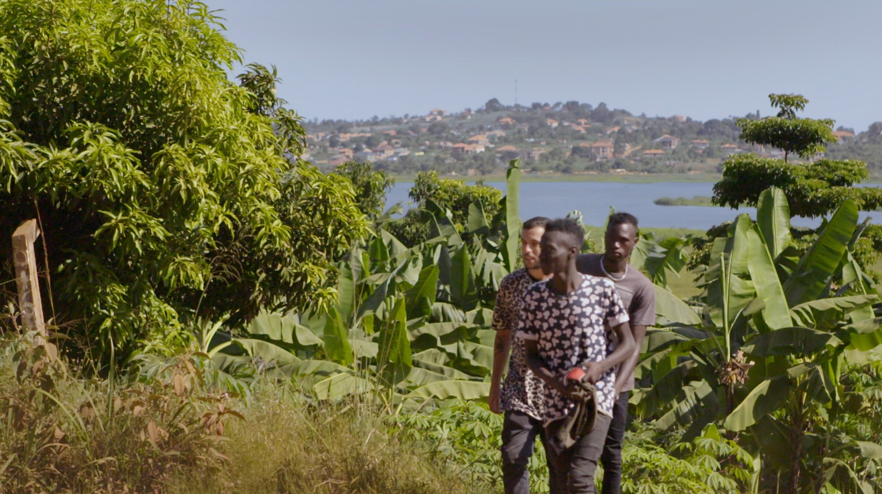
Samuel and Isaac are South Sudanese teenage refugees, who grew up in Israel but were deported. They now live in Uganda, and dream of making their musical talent known to the world. Amir, an Israeli musician, arrives to work with them, to try to make their dreams come true, within this complex reality.

Impresario
Lauretta Molitor / United States / 01:01:00
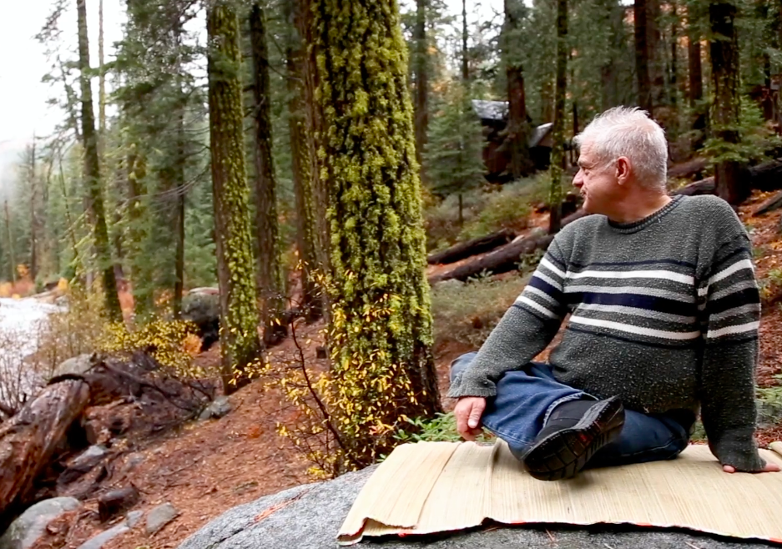
An intimate portrait of Frameline founder, force of nature, filmmaker and producer, Marc Huestis; this longtime HIV survivor story is one of humor, pathos and liberation.

In a Lion’s Clothes
Elina Seye, Karoliina Halsti Ndiaye / Senegal / 00:30:20
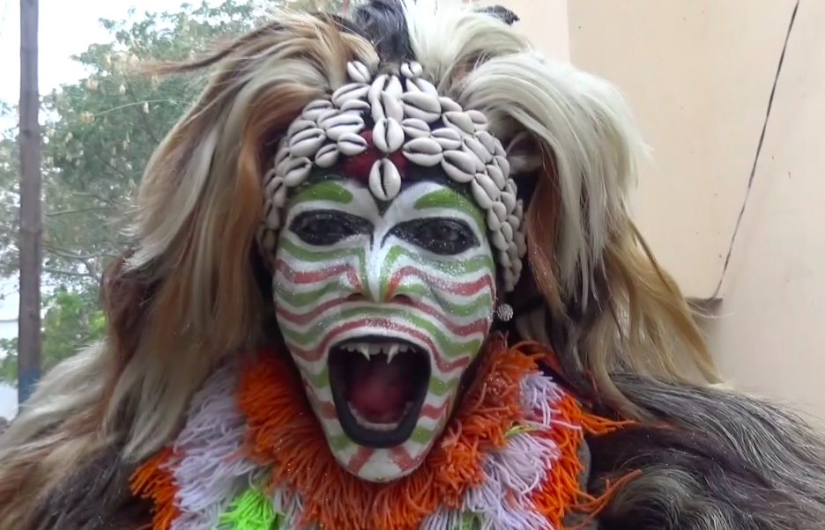
The documentary gives an impression of simb lion dance performances in Dakar, Senegal, and introduces a young generation of simb performers. We encounter the lion dancers in the streets near the performance space where musicians are already performing songs accompanied by the sabar drums. Especially children are eager to see the show but if you sneak in without buying a ticket, you will be punished by the lions. The performance climaxes with the dances of the lions and their companions.

Infinite Blue
Christian Schultz / United States / 00:08:54
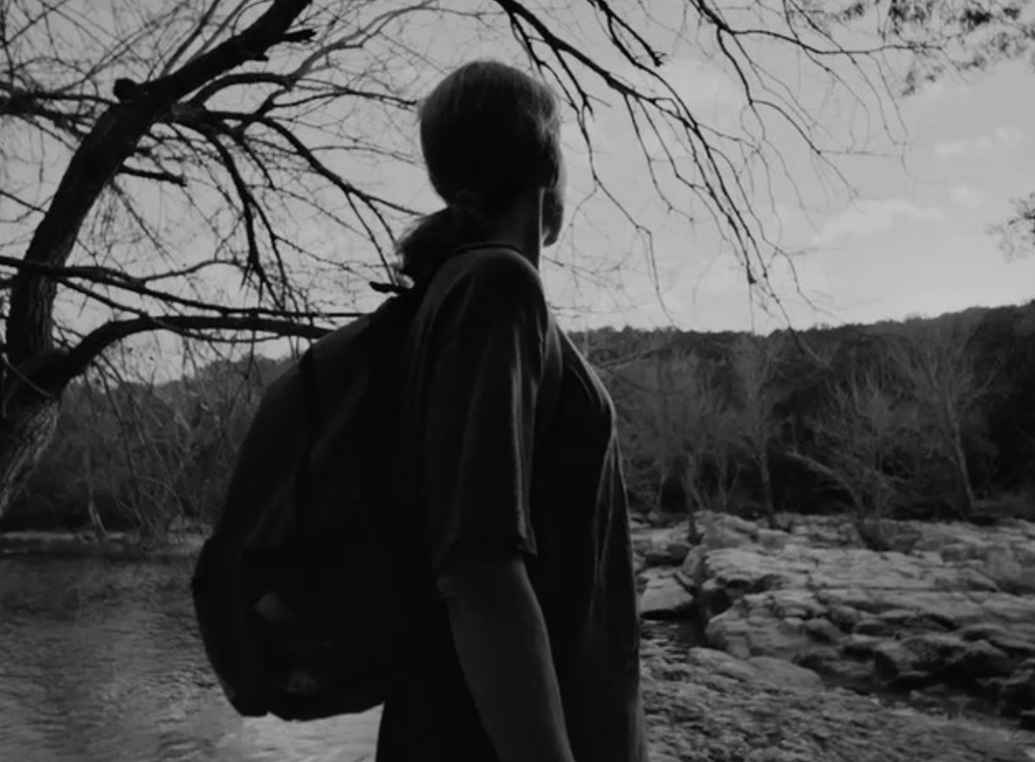
Infinite Blue is a brief, reverent look at the lives of three unhoused people living in Austin, Texas. Lyrical in tone, this short film bridges the distance between those with housing and those without as Scott, Amber, and Montrell share their stories.

Into the Land of Ice and Fire
Dimitra ZIROU / Greece, Norway, Serbia / 01:35:00
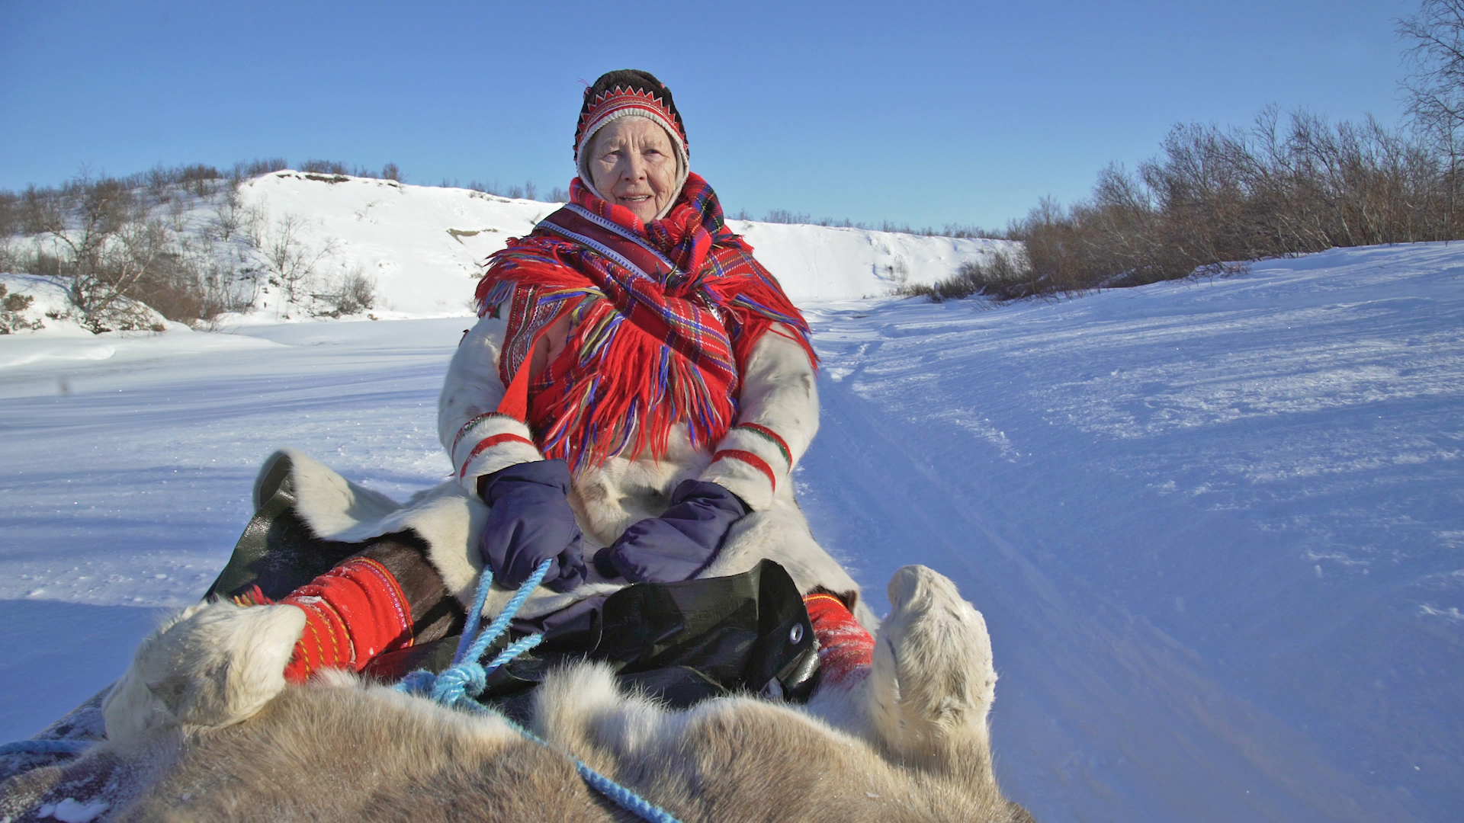
The film is inspired by the contemporary life of the indigenous people inhabiting the European arctic region, the Sámi. Two parallel stories, are gradually unfolding the everyday life of two very different persons: 86 year - old Sara and Mihka, a 7 year-old Sámi boy, both living in a remote small town in the middle of the Norwegian arctic tundra.

Iorram (Boat Song)
Alastair Cole / United Kingdom / 01:36:35
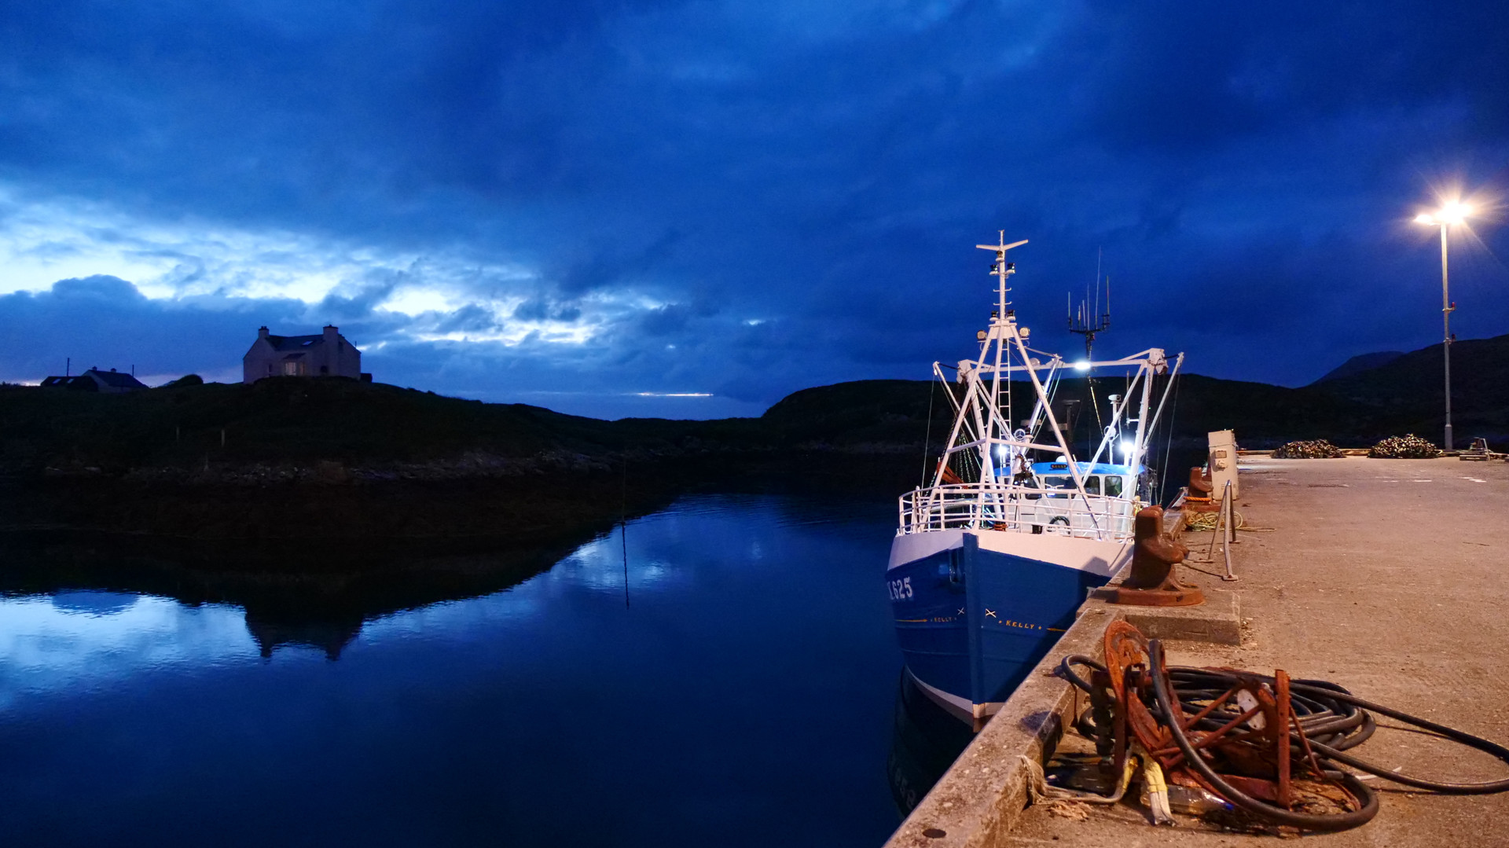
The first-ever cinema documentary in Scottish Gaelic, Iorram (Boat Song) is an immersive portrait of the fishing community in the Outer Hebrides, as it faces an uncertain future. Director Alastair Cole layers breath-taking footage of island life today with archive sound recordings of voices, stories and songs from the mid-20th century, woven together with a original folk score by Aidan O'Rourke to create a poetic dialogue between past and present, about a culture and language fighting to survive in the modern globalized world. The film is available with subtitles in English, Gaelic, Italian, French, German, Spanish.

It's about Time
Harald Scherz / / 00:08:57

Exploring the human perception of Time.

Kallawayas
Alvaro Mercado / Bolivia, Plurinational State of / 00:14:18
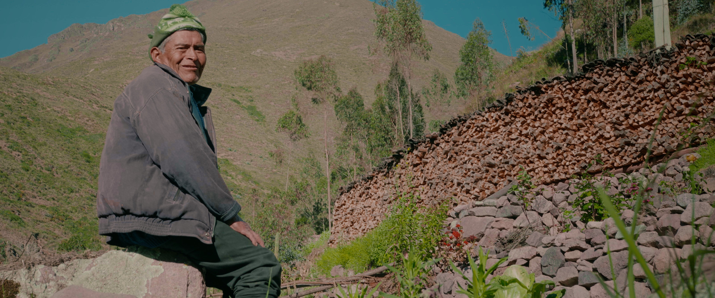
A tiny small comunity hiden in the heart of Charazani, Bolivia. is an antiq group of non traditional old medics who heal people throug rituals and herbs. Afraid of cameras and in path of losing their language will now be shown.

Kopacabana
Marcos Bonisson, Khalil Charif / Brazil / 00:13:33
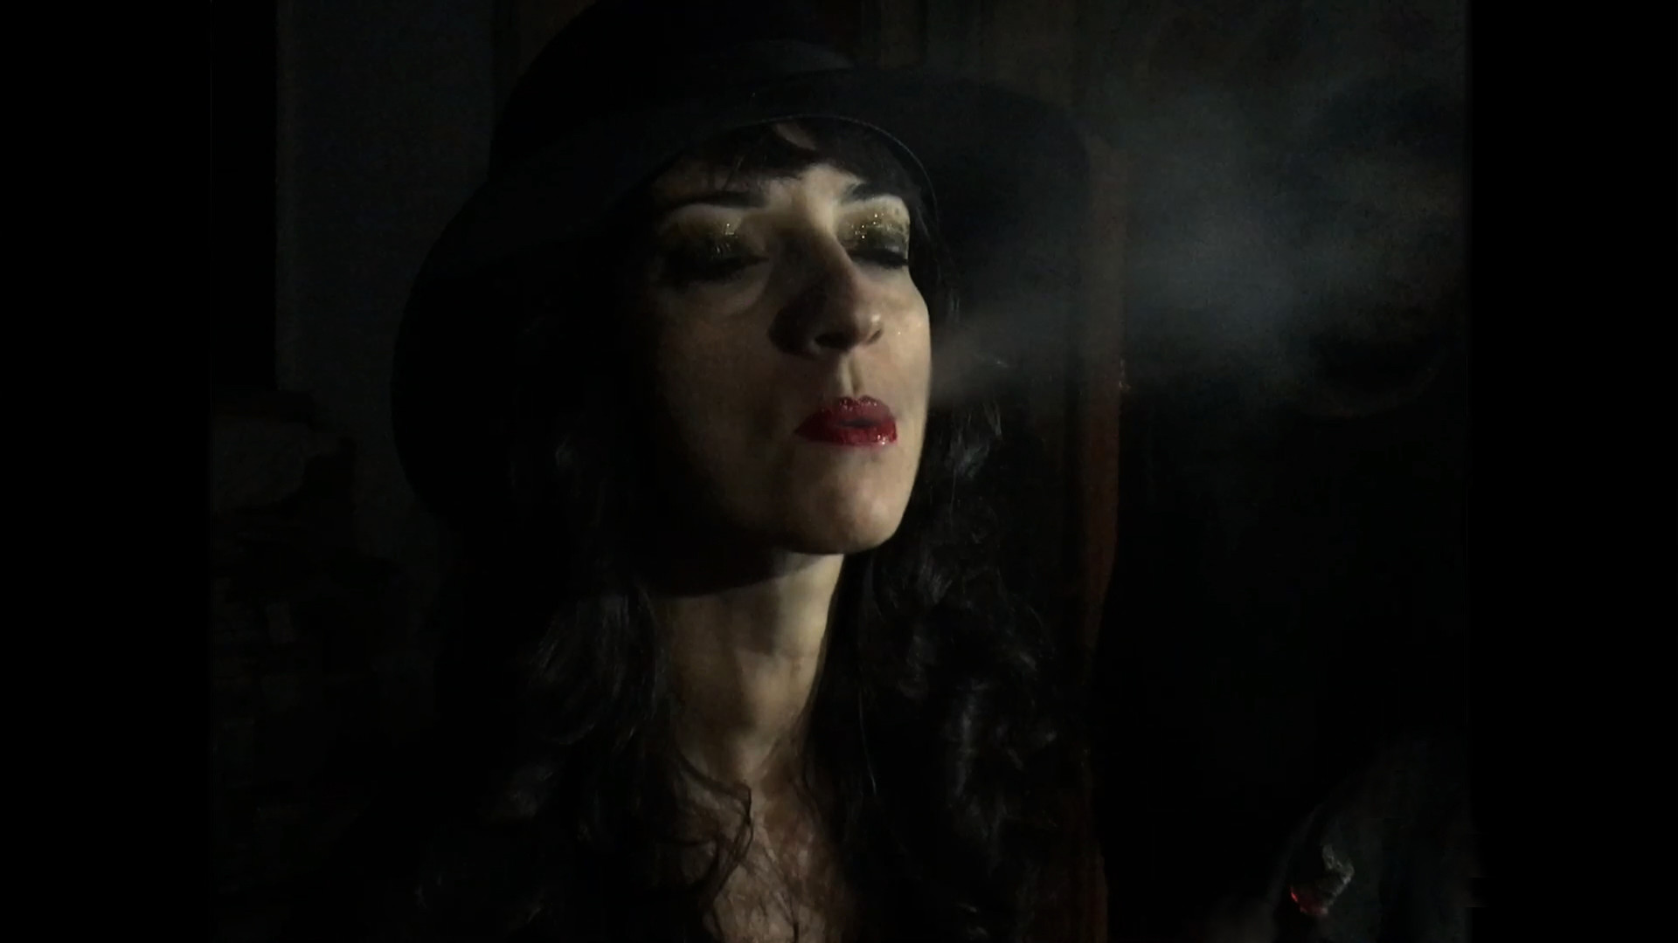
Film set in the neighborhood of Copacabana, elaborated through a collage of current and archive images (Super 8 and digital). An experimental work narrated by the significant speech of the poet Fausto Fawcett, and sonorized by the musician Arnaldo Brandão.

Last Days in Moers
Eddie Bolger / Germany / 00:19:49
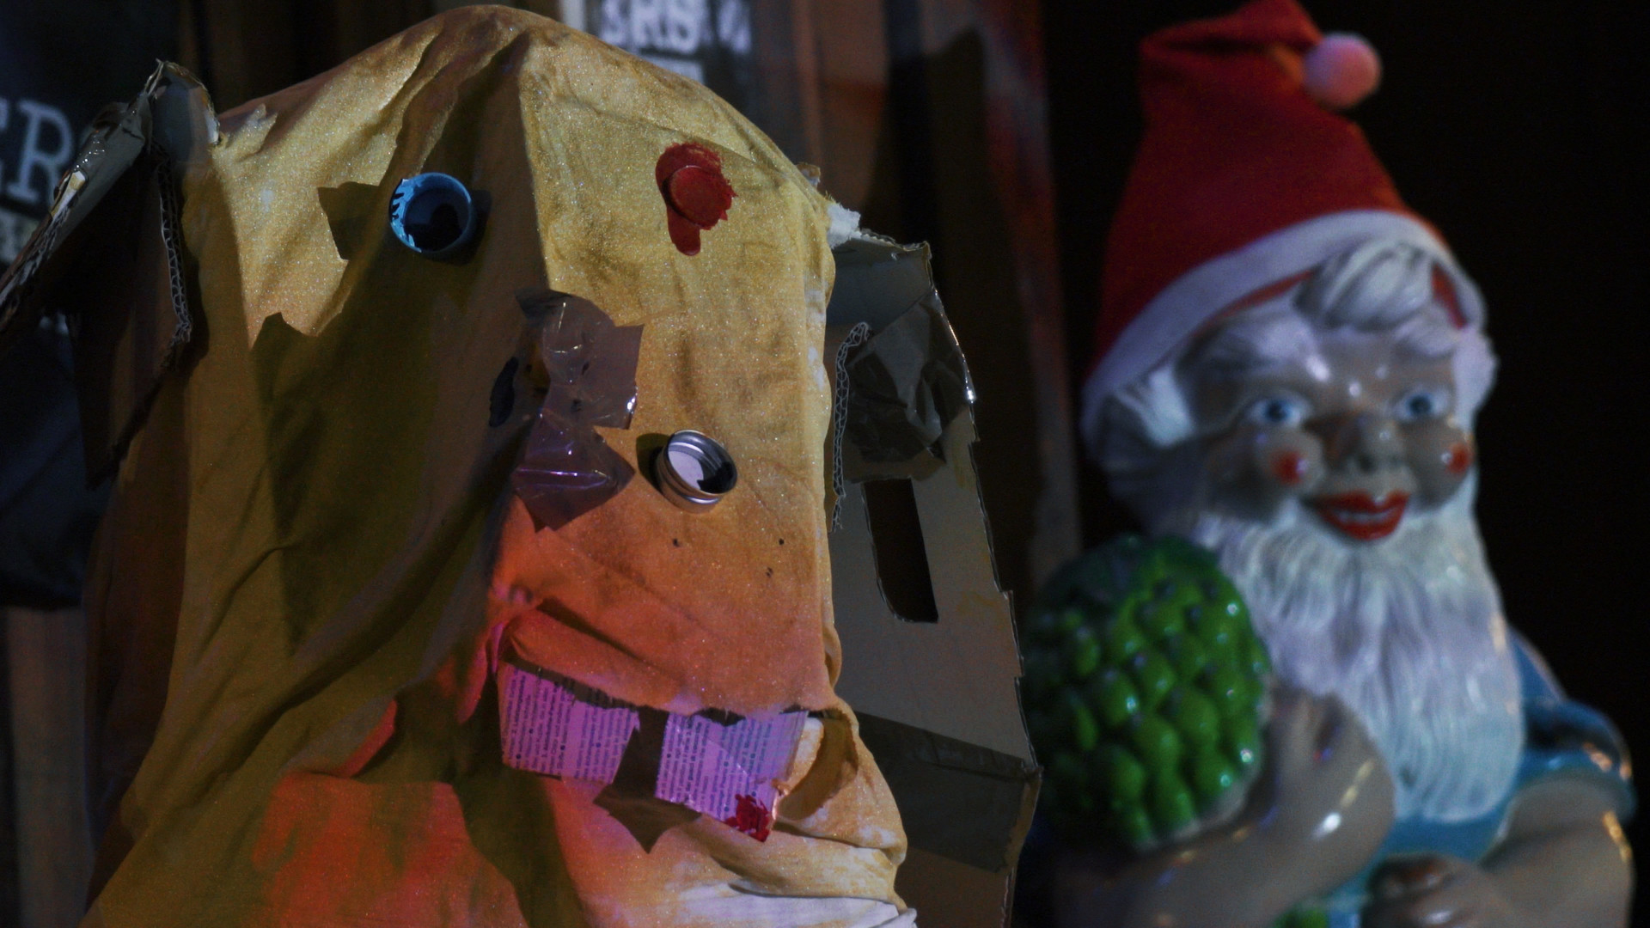
Matt Mottel and Kevin Shea, two free jazz musicians from New York, spent 2021 (and the series of lockdowns it entailed) in Moers, a small city on the lower Rhine in Germany. As the city’s official "Improvisers in Residence", they lived together in a house on the market square where they honed their craft, collaborated with other improvisers from the region, and integrated themselves into the Moers community… well… they did their best under the circumstances… LAST DAYS IN MOERS follows the duo as their year in Germany comes to a close, and they attempt to pull off one last concert in Moers as a thank you to their host-city.

London Heathrow to Sydney Kingsford Smith
Sophie Jackson / Australia, Japan, United Kingdom / 00:13:24

I shot this film on my phone on my 13th flight “home” from London to Sydney. 32 hours in this strangely suspended state, the trip always feels liminal but this trip is mid pandemic, only the people who have to travel are. The airports and plane cabins are virtually empty, heighten a sense of a void that arriving this time would bringing. A personal meditation on home and loss.

Lost and Hungry in the Amazon: a Yanomami Story
Cliff Orloff, Rafael Hernandez / Venezuela, Bolivarian Republic of / 00:54:40
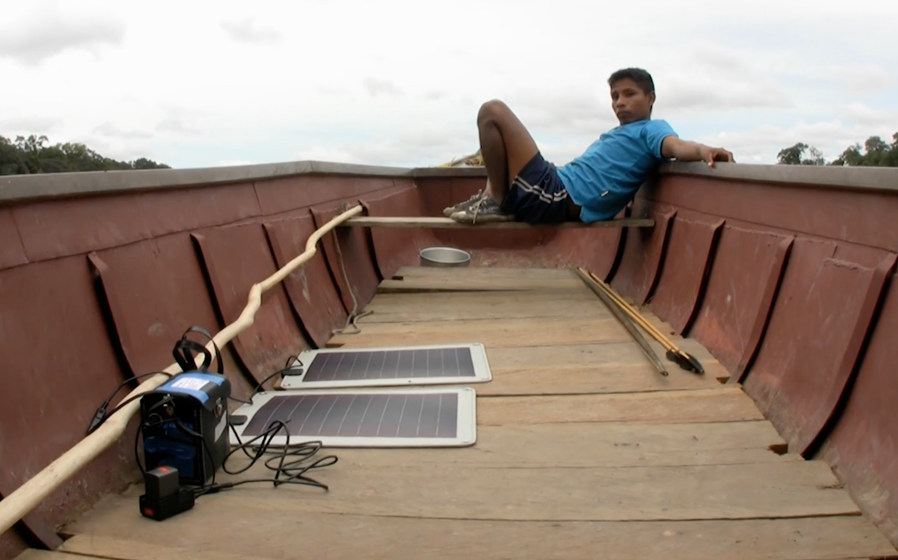
Ten thousand years ago we were all hunter-gatherers. Now, the Yanomami Indians are the last large group of semi-nomadic hunter gathers remaining on earth. What happened when Hugo Chavez decided to bring remote Yanomami Indians from the Amazon into modern Venezuelan society? The filmmakers have been documenting the path of one Yanomami village in the Venezuelan Amazon, from November, 2000 to December, 2020.

Luso-Fornia
David Grabias / United States / 01:22:20

LUSO-FORNIA is an immersive dreamscape of California’s dairylands, where amidst industrial agriculture and drought a Portuguese immigrant community turns to a series of rituals worshipping the Virgin Mary to find meaning and power – culminating with a “bloodless” bullfight, where men subdue a bull with their bare hands.

Mandatory Training
Patrick Tarrant / United Kingdom / 00:10:15
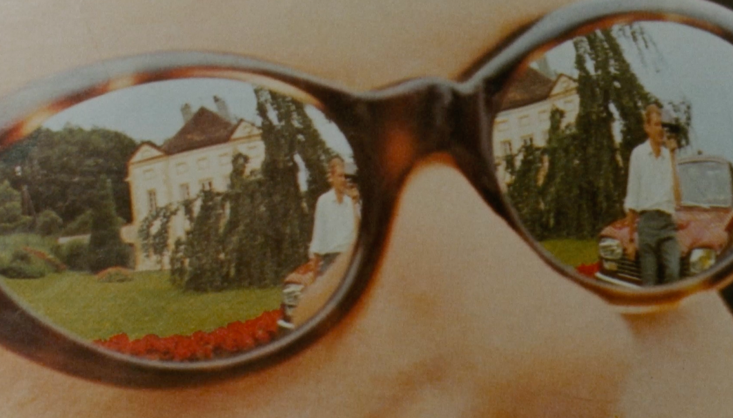
The whiteness and gender normativity of Bolex promotional brochures and magazines from decades past is brought face to face with audio taken from contemporary mandatory training modules on Equality, Diversity & Inclusion and Health & Safety such that the two become fused in a glitch-strewn perversion. If the former medium is a record of unconscious bias and the latter seeks to redress this bias, nonetheless when jammed together one gets the distinct sense that they are more complexly imbricated than we might like to think.

Maybe The Foot Does
Pawel Nazaruk / Norway / 00:14:32
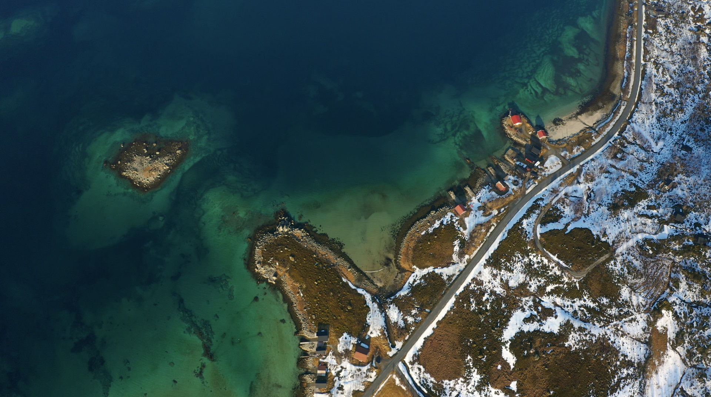
Ánde Somby, a Sami Yorker and law professor from Tromso, Norway, has for all of his life been fighting for the right to express his "Saminess" despite the state's oppressive policy of Norwegianization.

Millennials leave in peace
Louise Marie Beauchamp / Canada / 00:05:42
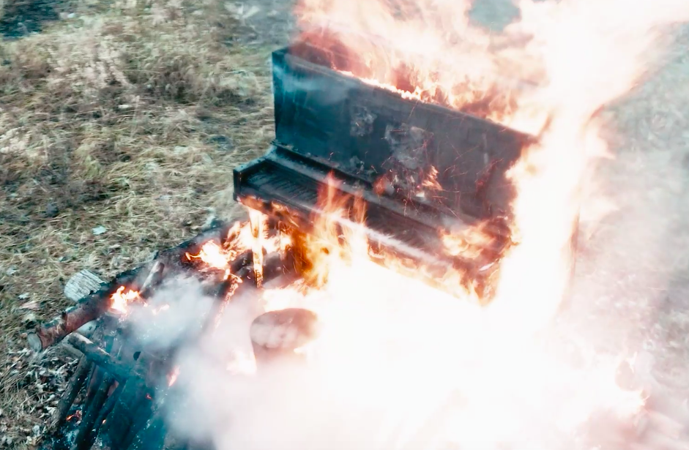
Using a burning piano to symbolize the state of the planet, this documentary poetically illustrates soil degradation, and proposes the implementation of a planetary ecological service as a possible solution.

My Rembetika Blues - A film about love, life and Greek music
M.Zournazi / Australia, Greece, United States / 01:23:00
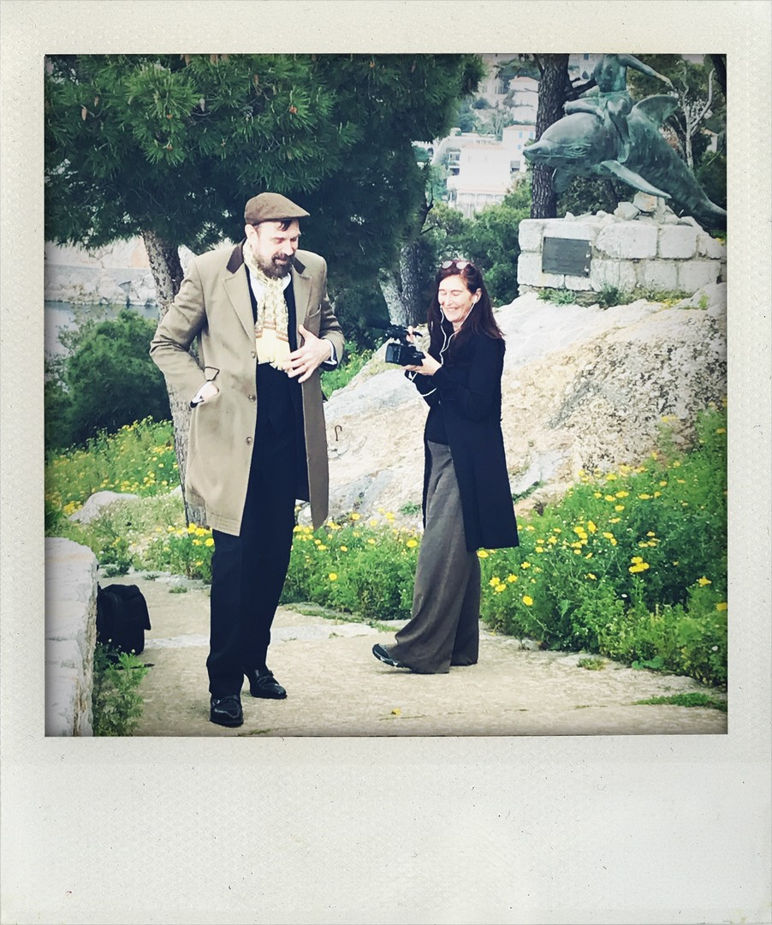
Rembetika music or the Greek blues is a music born of exile and the streets. Developing its roots from the mass migration of people in the early twentieth century, filmmaker M. Zournazi traces the journey of her forebears from Smyrna in Turkey to Sydney Australia but discovers more than family history, she finds out how music connects people during times of struggle and crises.

Nosh-up
Mafalda Salgueiro / Portugal / 00:12:00
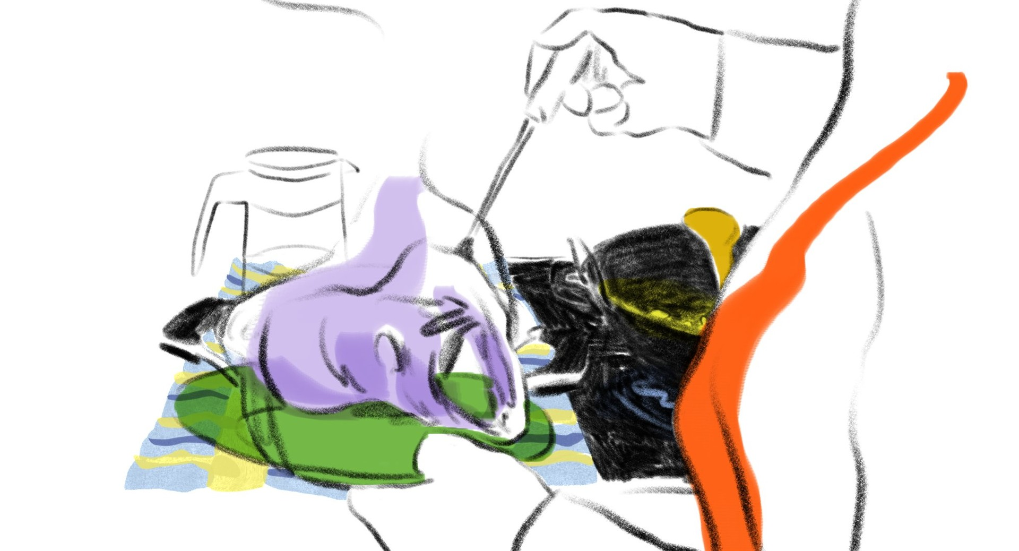
“Cooking is caring” says my mother while she enthusiastically juggles pots and pans preparing a family meal. Using food and passed down recipes, personal history is interwoven with gestures of affection and familial unity. A visual ode to the unsung heroes who repeatedly feed and care for us without asking for anything in return.

One Earth Everything is Connected
Francesco De Augustinis / Brazil, China, Greece, Italy, Netherlands, United Kingdom, United States / 01:32:23
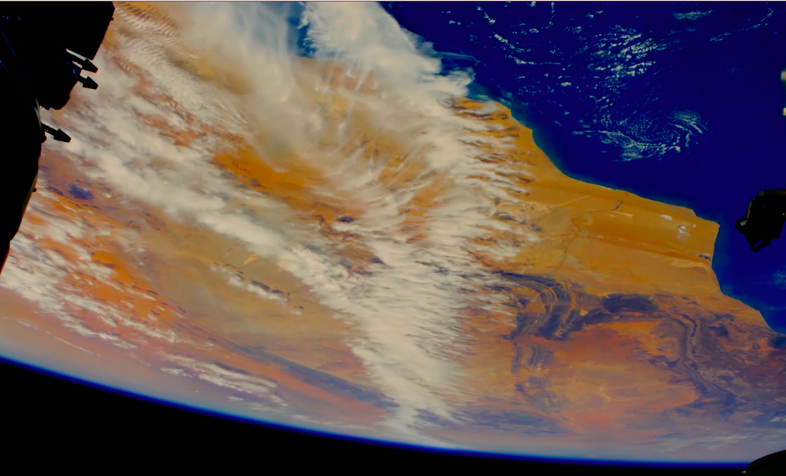
Seen from the outside, they don't even look like farms: they are blocks of concrete, several floors high, hidden in an earth quarry, in the center of a mountain in the remote heart of China. Within them, a hyper-intensive production of pigs, destined to supply the increasing Chinese demand for pork. Around this hyper-technological farm that is a symbol of human progress, a story unfolds, touching the four corners of the planet. It shows how the global food system is irreversibly compromising the fragile balance of the planet and contributing to the current global crises such as climate change, and epidemics.

One of us Now
Maya Steinberg / Israel / 00:30:00
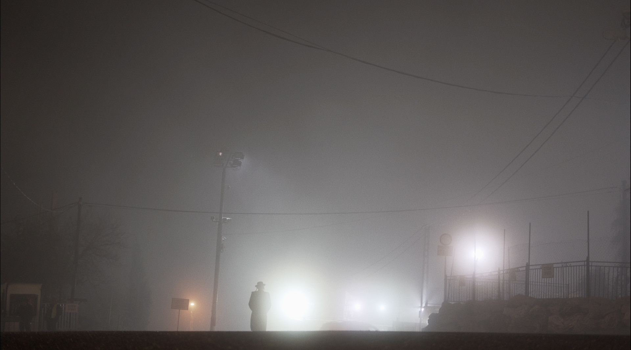
Maya Steinberg is a secular Israeli. Her father, however, had a late religious awakening. He will not appear in her film. Instead, the young director approaches his faith and her lack of understanding for it through a visit to the gravesite of rabbi Shimon bar Yochai in Galilee, where she spends a few weeks, observing believers, Orthodox and ultra-Orthodox, and wondering: Is there a place here for women? And can there be a place for queer women? Marie Kloos, Dok Leipzig Programming

Our way
Laura Fontaine, Yasmine Fontaine / Canada / 00:05:30
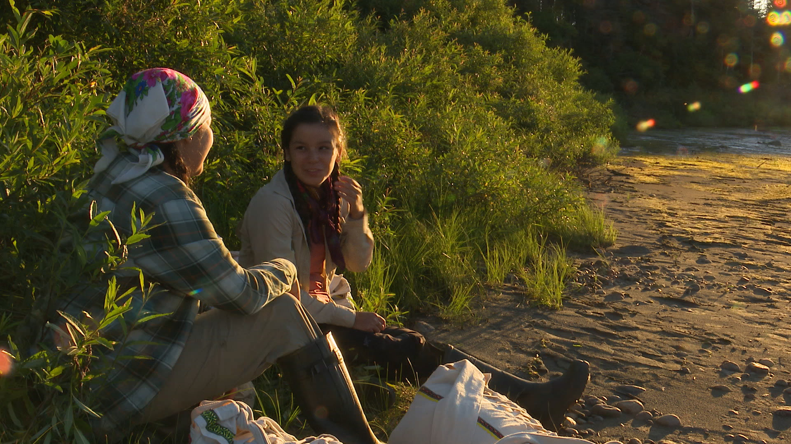
Two young Innu women take up the old roads of the past to revive the identity of their Nation; a tribute to the Elders, the territory and the Innu people.

Patcho Star & Munganga
Esteban Calderón / Germany / 00:30:00
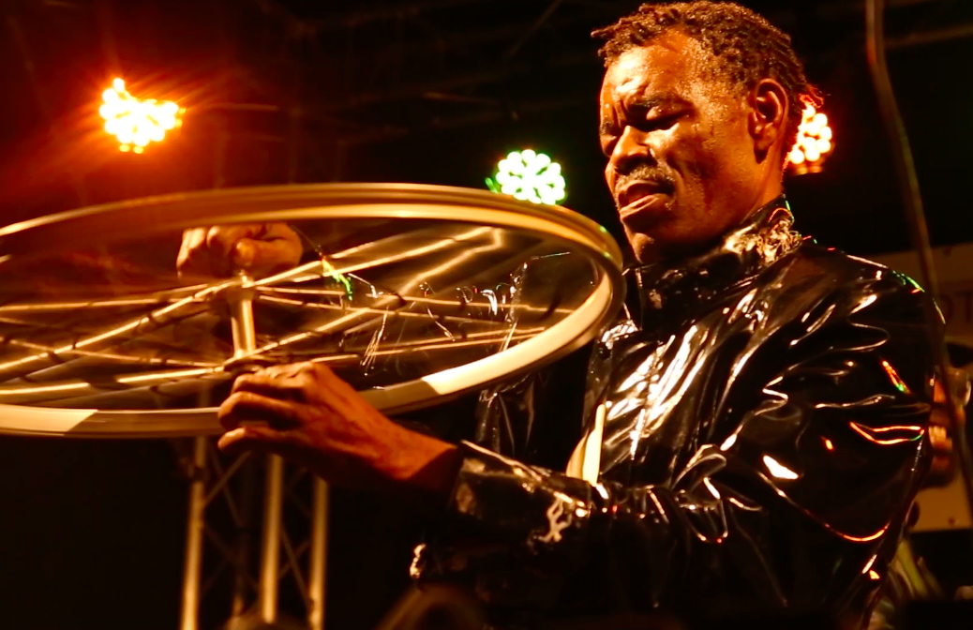
The story revolves around a musician from the Democratic Republic of Congo named Patcho Star, who is a well-known representative of the influential Congolese musical style Soukous. He fled the Congo 25 years ago and has since then been living in the German city of Münster, where he continues his music career in a special way. He has founded a band with German musicians and is now planning to play a series of concerts with this band in the DR Congo. The film Patcho Star & Munganga portrays Patcho's biography and the preparation of his German band for the concerts in Congo.

Paying Tribute to the History of Steel?
Tony Buba / United States / 00:04:20
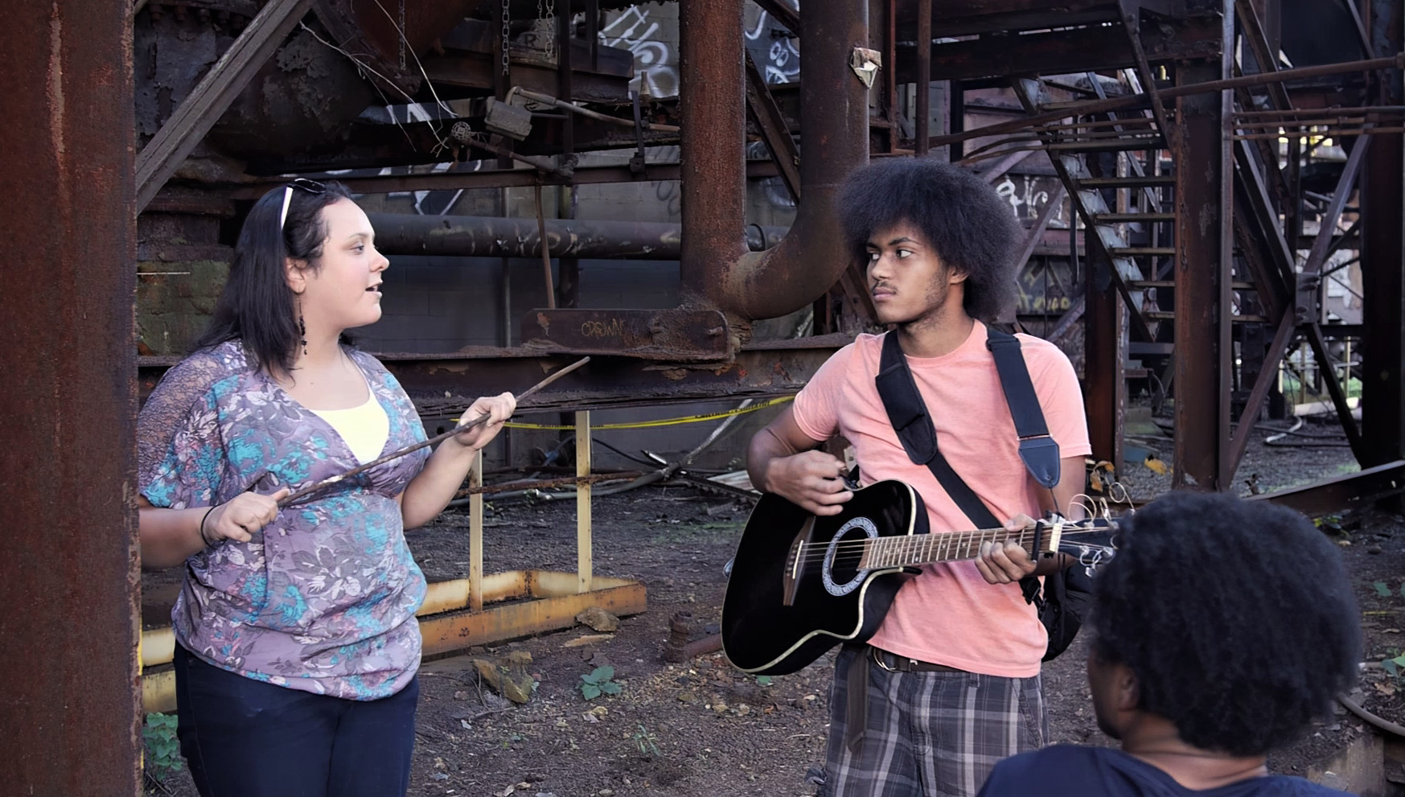
Twenty-four years ago, the Carrie Funace site was dedicated to honor steel workers who lost their jobs and their legacy as workers.

Plus
Bohdan Romanko / Ukraine / 00:09:00
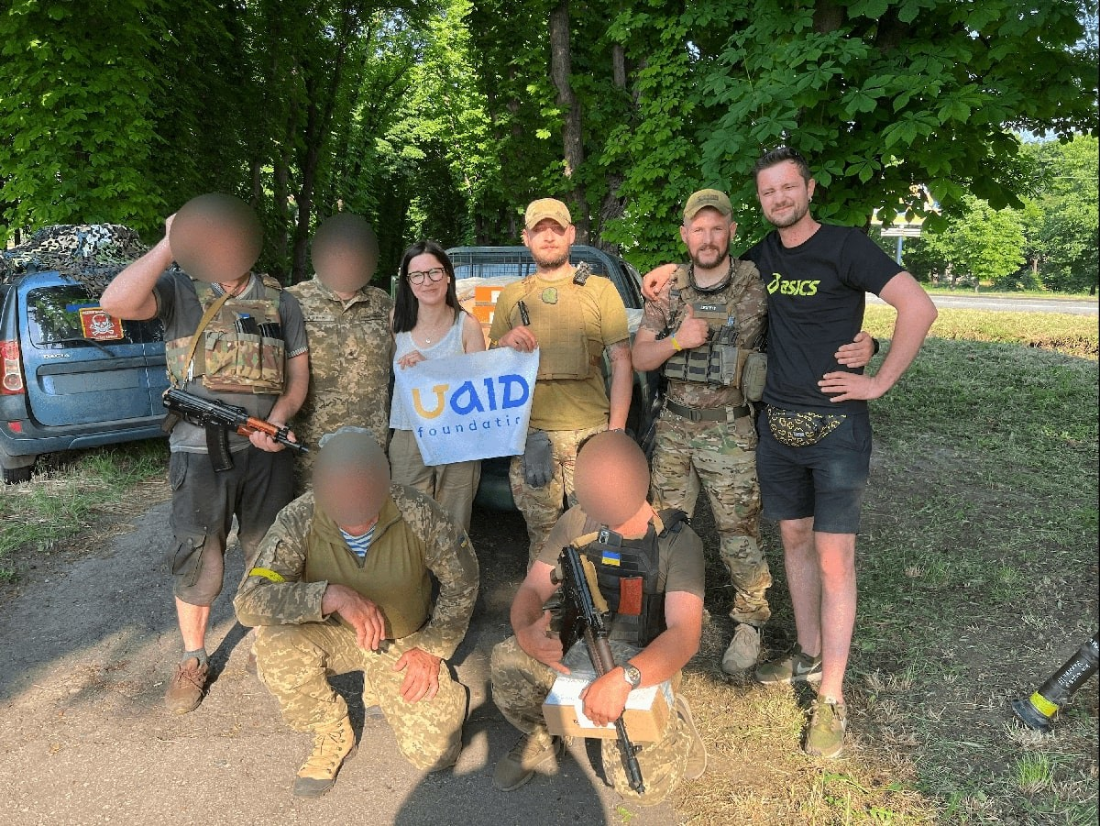
This Ukrainian short - created using state-of-the-art technology - follows a heart-breaking chat between an ordinary Ukrainian man, compelled to join the defense forces on the front-line of the 2022 Russian War, and his emerging girlfriend who anxiously follows his journey as war rages all around him doing what she can to help.

Rez Metal
Ashkan Soltani Stone / Denmark, United States / 01:15:09
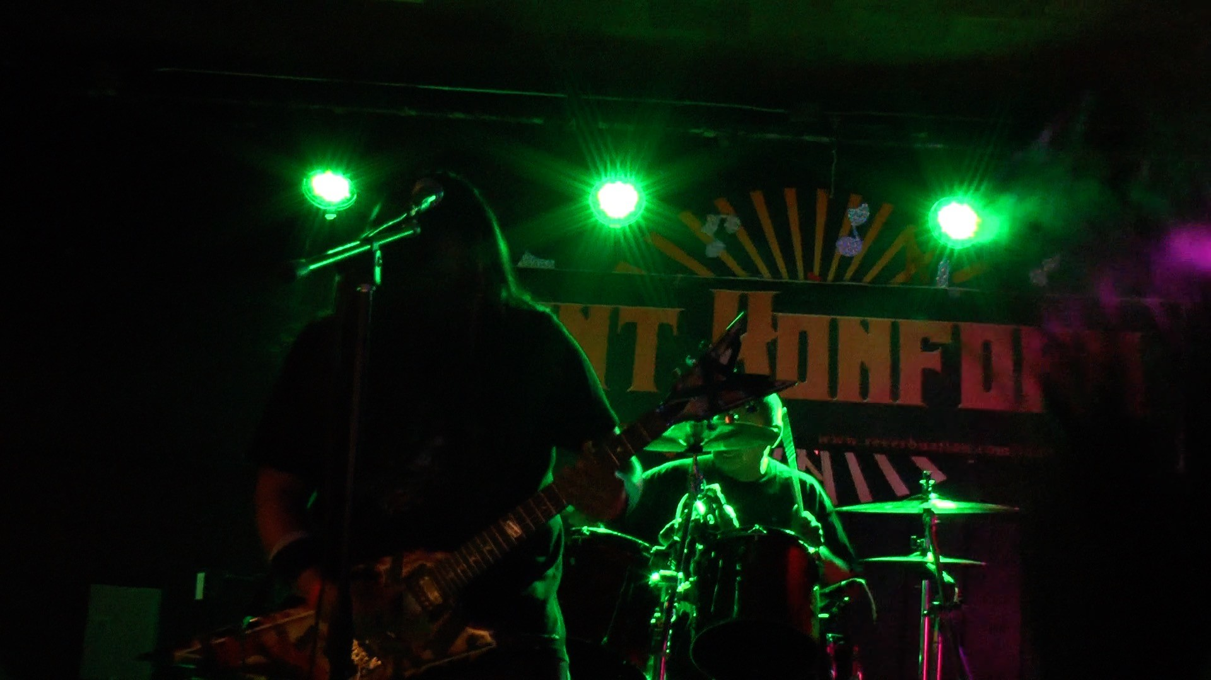
When Kyle Felter, the lead singer of I Don't Konform sent out a demo album to Flemming Rasmussen, the Grammy Award-winner producer of Metallica, they never imagined themselves a few months later rehearsing with Rasmussen inside a hot hogan on a Navajo reservation before recording their debut album at the iconic Sweet Silence Studio in Denmark. While following I Don't Konform's fairy tale journey, our documentary REZ METAL, tells the larger compelling story of the heavy metal scene on Navajo reservations where many youths have grown disaffected as a result of endemic poverty and high rate of suicides.

Rooted Musicians from Klenovec
Petr Nuska / Slovakia / 00:16:26
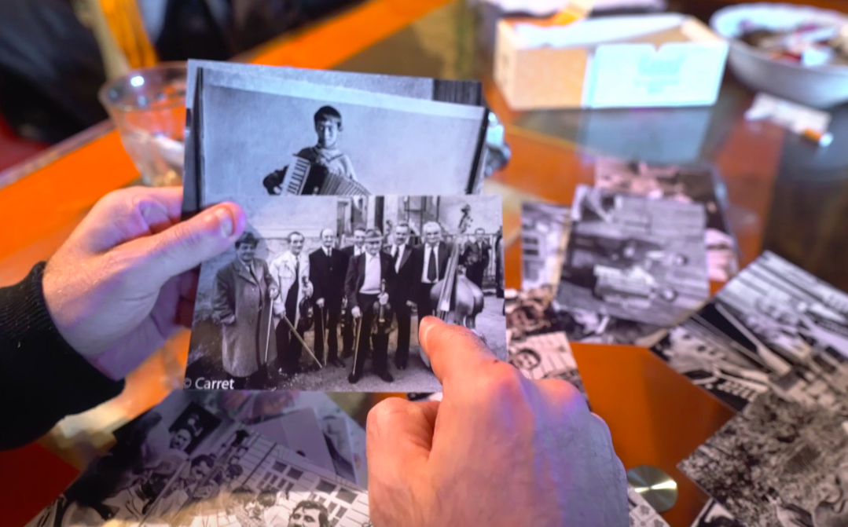
French photographers Claude and Marie-José Carret first came to Klenovec in 1984. They were immediately fascinated by the life of the local musicians and have returned every year since, capturing generations of the town’s famous musicians. Their work reveals the depth of Klenovec’s musical roots and how characters from the past live on in the memories and practices of local people. The short film Rooted Musicians from Klenovec: Life in Photographs depicts a joint effort of the French photographers and a Czech anthropologist.

Séance and Islam
Adham Ashirov, Seika Wazaki / Uzbekistan / 00:37:00
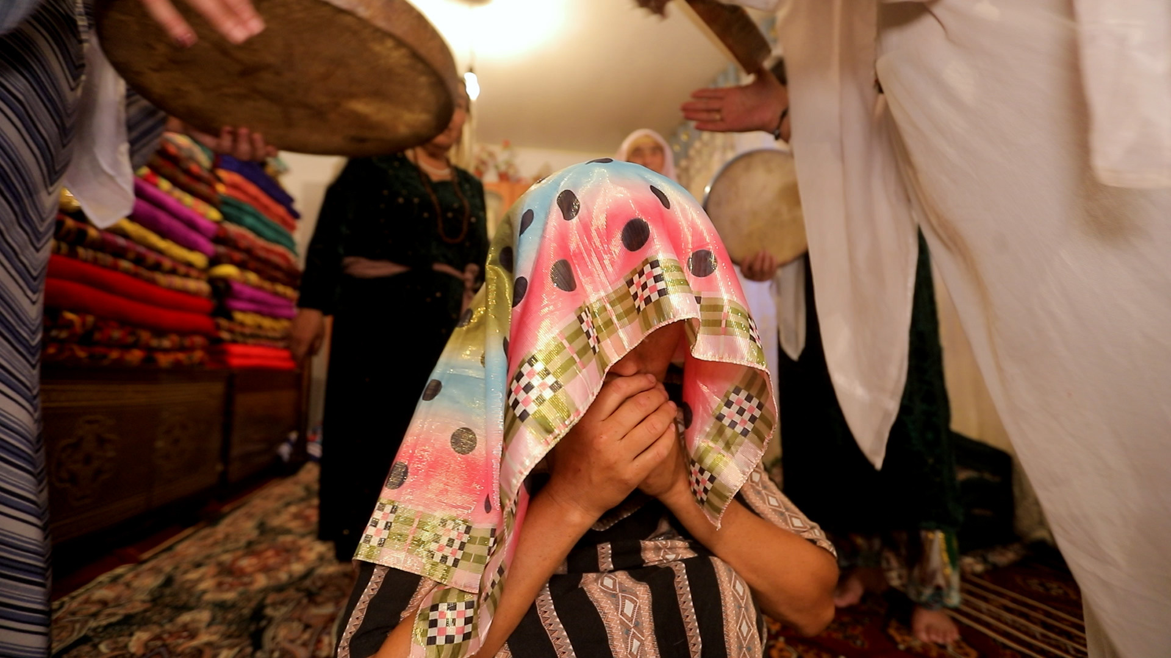
In Central Eurasia, nomadic Turkic tribes migrated from the northern steppes from the 6th century onwards, and gradually established themselves in various parts of the region while adopting Islam. In some of these settlements of former nomads, séance customs, characterized as ancestral rituals of shamanism in an Islamic guise, continue to be practiced today. This film documents the treatment of illnesses as performed by female spirit mediums called Bakhshis in some of these settlements of former nomads in the rural villages of post-Soviet Uzbekistan, which was filmed in 2019 and 2021.

Shalom Putti
Tamás Wormser / Uganda / 01:30:35

When a little-known Jewish community in rural Uganda comes into contact with a group of Orthodox Israeli rabbis, everyone is destined to be transformed. Director Tamás Wormser documents the extraordinary encounter over seven years, crafting a nuanced and visually arresting documentary reflection on identity, religion and the long shadow of colonialism.

Shepherds of the Earth – Stories from the Cradle of Humankind
Iiris Härmä / Kenya / 01:15:00
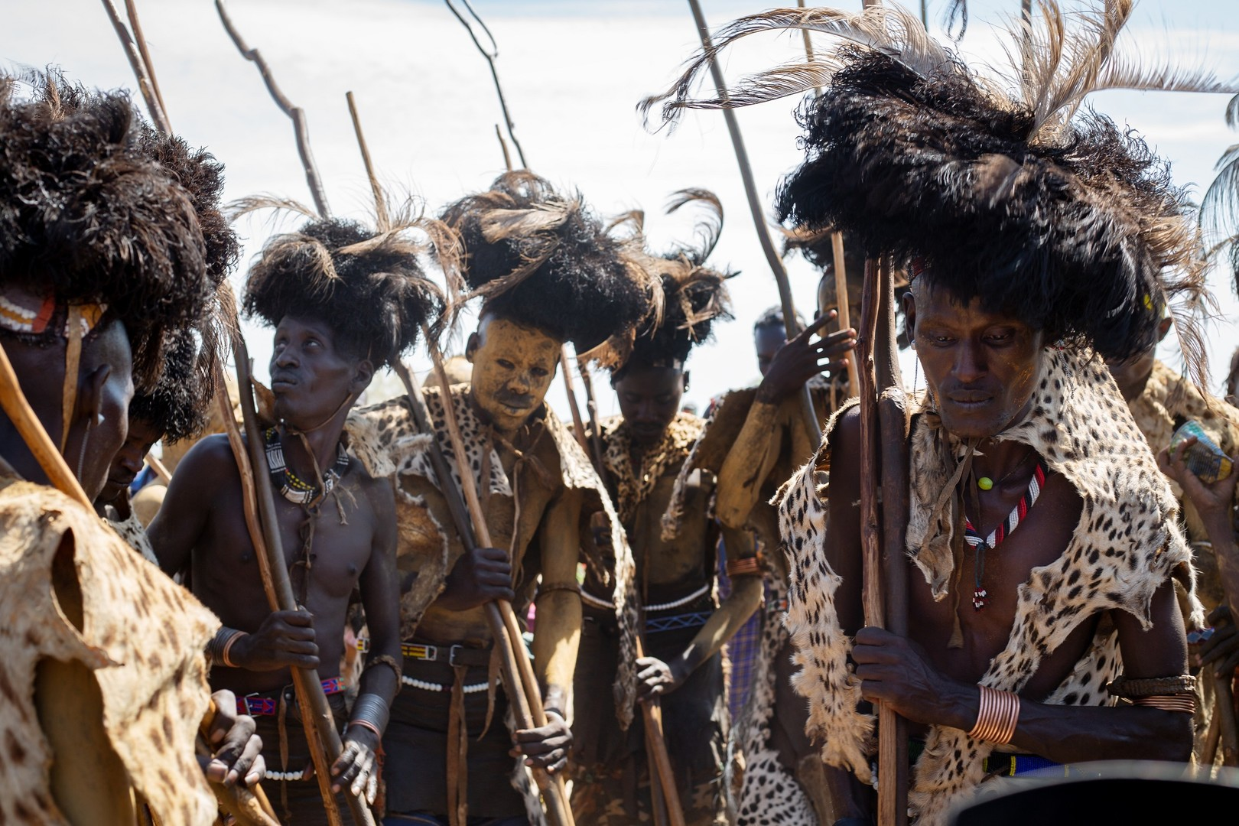
Researchers collect ancient animal stories of the indigenous tribe in Turkana - the Cradle of Humankind. For their disturbance, they find out that the relationship between the indigenous tribe and nature is far from harmonious. "Who are we to say what's right or wrong?".

Soldier
Justin Zimmerman / United States / 00:22:00
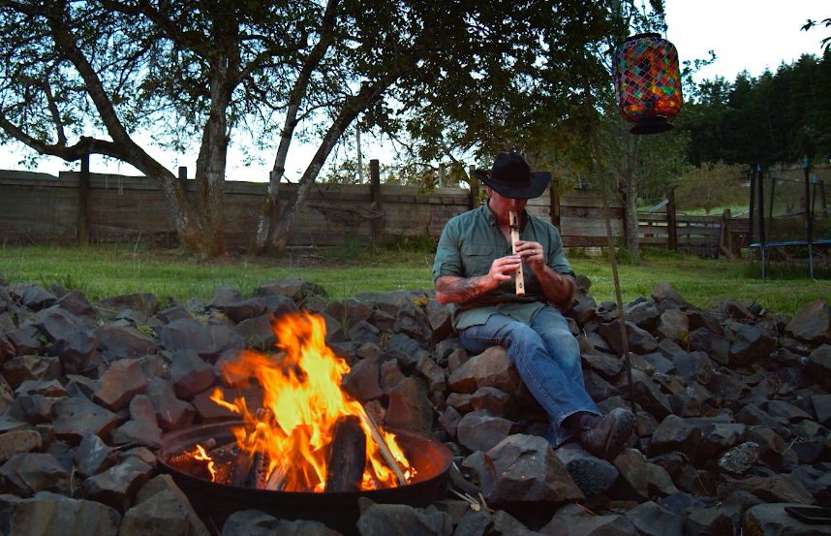
SOLDIER focuses on Daniel Krug: a heroic firefighter, father of five, SWAT trainer and armored combat enthusiast. Daniel is also a former sniper, with ten years of combat, security, rescue and recovery experience in Iraq. And over the past decade, he's lost 11 of his close military friends - and almost lost himself - to PTSD.

Sorombe
Taku Iida / Madagascar / 00:48:19
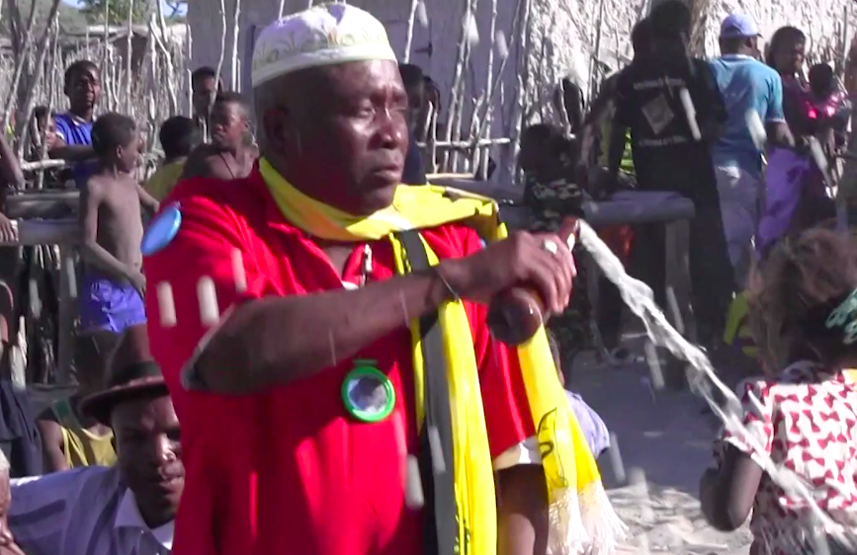
On the southwestern coast of Madagascar, spirits called DOANY listen through human media to complaints and sufferings of people to settle their problems. In July 2017, Jean-Rossy, a spirit medium, held a ceremony called SOROMBE for DOANY spirits. Through communication between spirits and humans, role of the medium, and narratives on spirits’ “customs,” this film demonstrates the world of imagination entangled with everyday lives.

Spółdzielnia / Co-operative
Piotr Goldstein / United Kingdom / 00:26:47
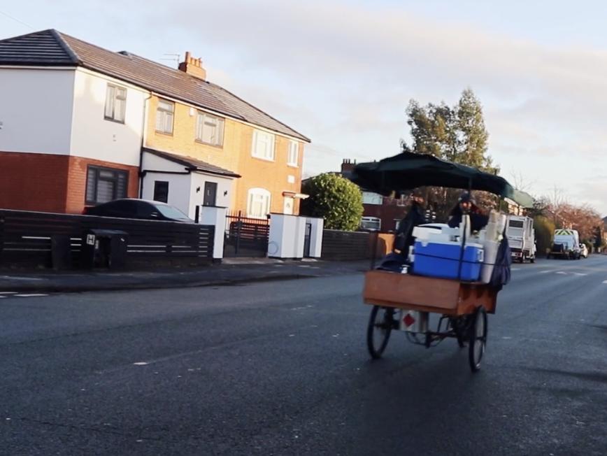
‘Spółdzielnia / Co-operative’ is a visual ethnography filmed across five years, telling the story of a co-operative in Manchester, UK, run mainly by Polish migrants. It is a story about social engagement, migration, and a community that typically escapes media and academic attention. It is, after ‘Active (citizen)’, the second film of the ‘Visualising the Invisible Project’ which looks at the activism of migrants and ethnic minorities outside of their community organisations.

St Cuthbert's This is what I like about my place
Lieza Louw / South Africa / 00:46:00
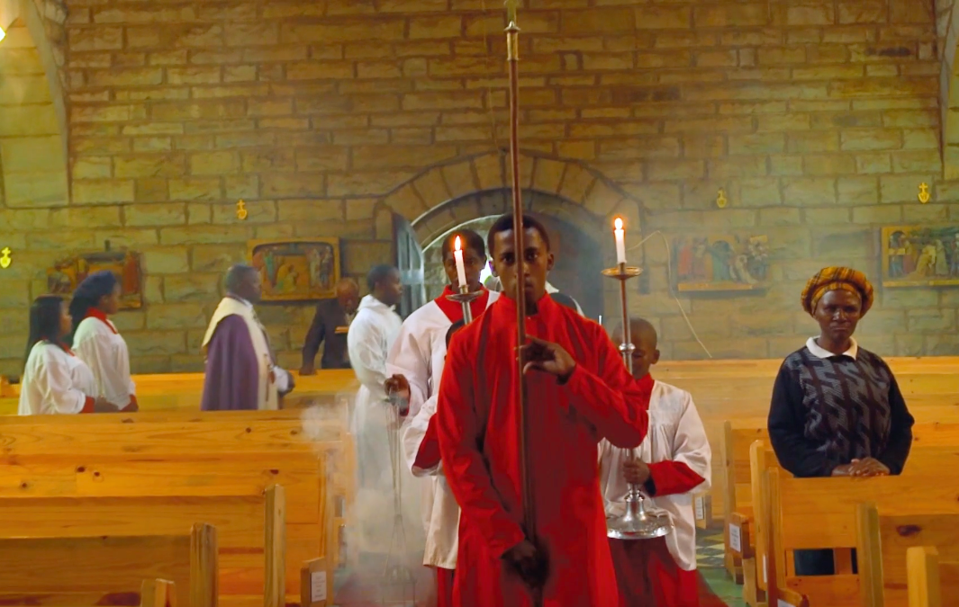
Many films are made in urban areas and of political and social issues; unfortunately, rural histories and living memories are often ignored. This film is a poetic interpretation of a rural community with a complicated yet fascinating history. At the St Cuthbert’s church near Tsolo, the hundred-year old stone church and convent still provides a spiritual home for the community.

Staying Put
Nico Bunnik / Ethiopia / 02:07:00
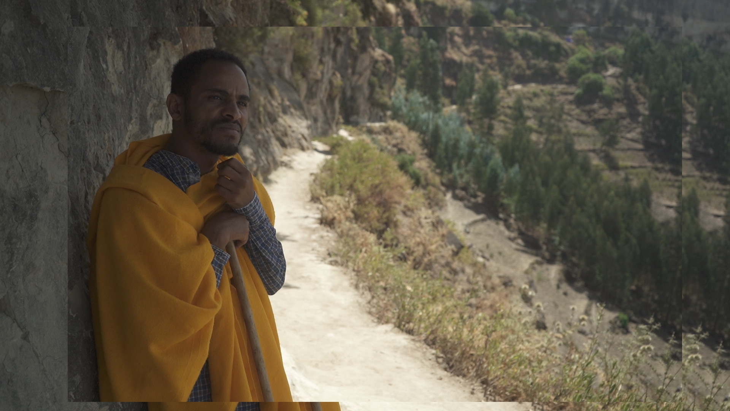
While his friends are dreaming of a modern and better life in Europe, Abebe travels through ancient Ethiopia, trying to find crucial answers and a way towards a meaningful life. In an observational style, we follow the young Abebe in his personal quest. The future is uncertain, his journey erratic. The centuries-old scenery of impressive landscapes, monasteries and rock-hewn churches is undisturbed. The reality of daily life and Abebe’s magical dreams merge into each other. Filmmaker Nico Bunnik shot and developed this film over a period of 5 years together with Abebe and his friends. Close to the bone, from Abebe's perspective we follow him in his thoughts and quest.

Still Here
Álvaro Hernández Blanco / Spain / 00:16:00
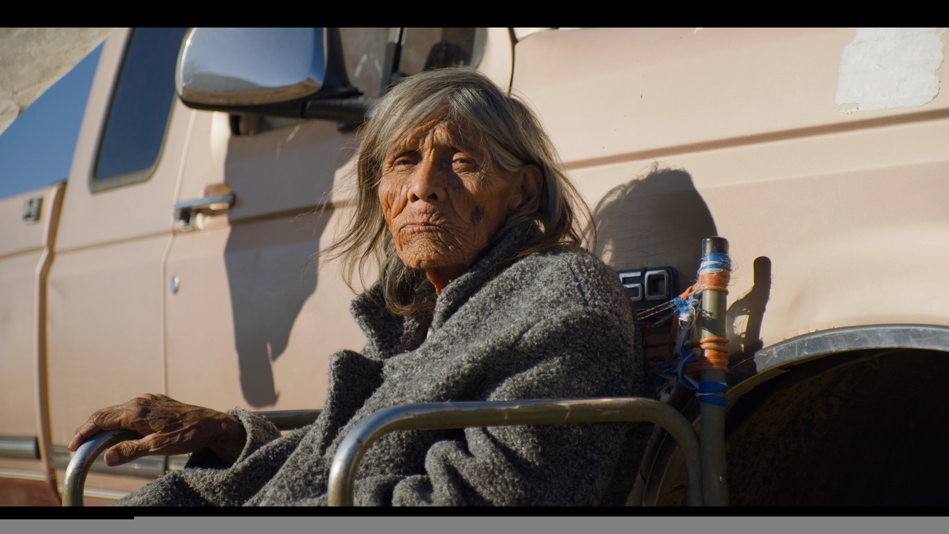
In the deserts of Baja California (México), Daria and Teresa are the last two speakers of the Ku'ahl indigenous language. In their world of oblivion and decrepitude, they lament the imminent extinction of the ku'ahl language and culture as the modern world moves on with indifference. But as long as Daria and Teresa converse together, ku'ahl lives.

Summon Xian
Qiong Wu / China / 03:30:32


Summon Xian is an ancient shaman ritual in northeast China. Some people use this ritual to achieve the purpose of divination and healing. People possessed by Xians also have magic power, and after later learning, they also become shamans. This film recorded the whole process of a 'Summon Xian' ceremony.

Survivors of Wadjemup
Glen Paul Stasiuk / Australia / 00:09:15
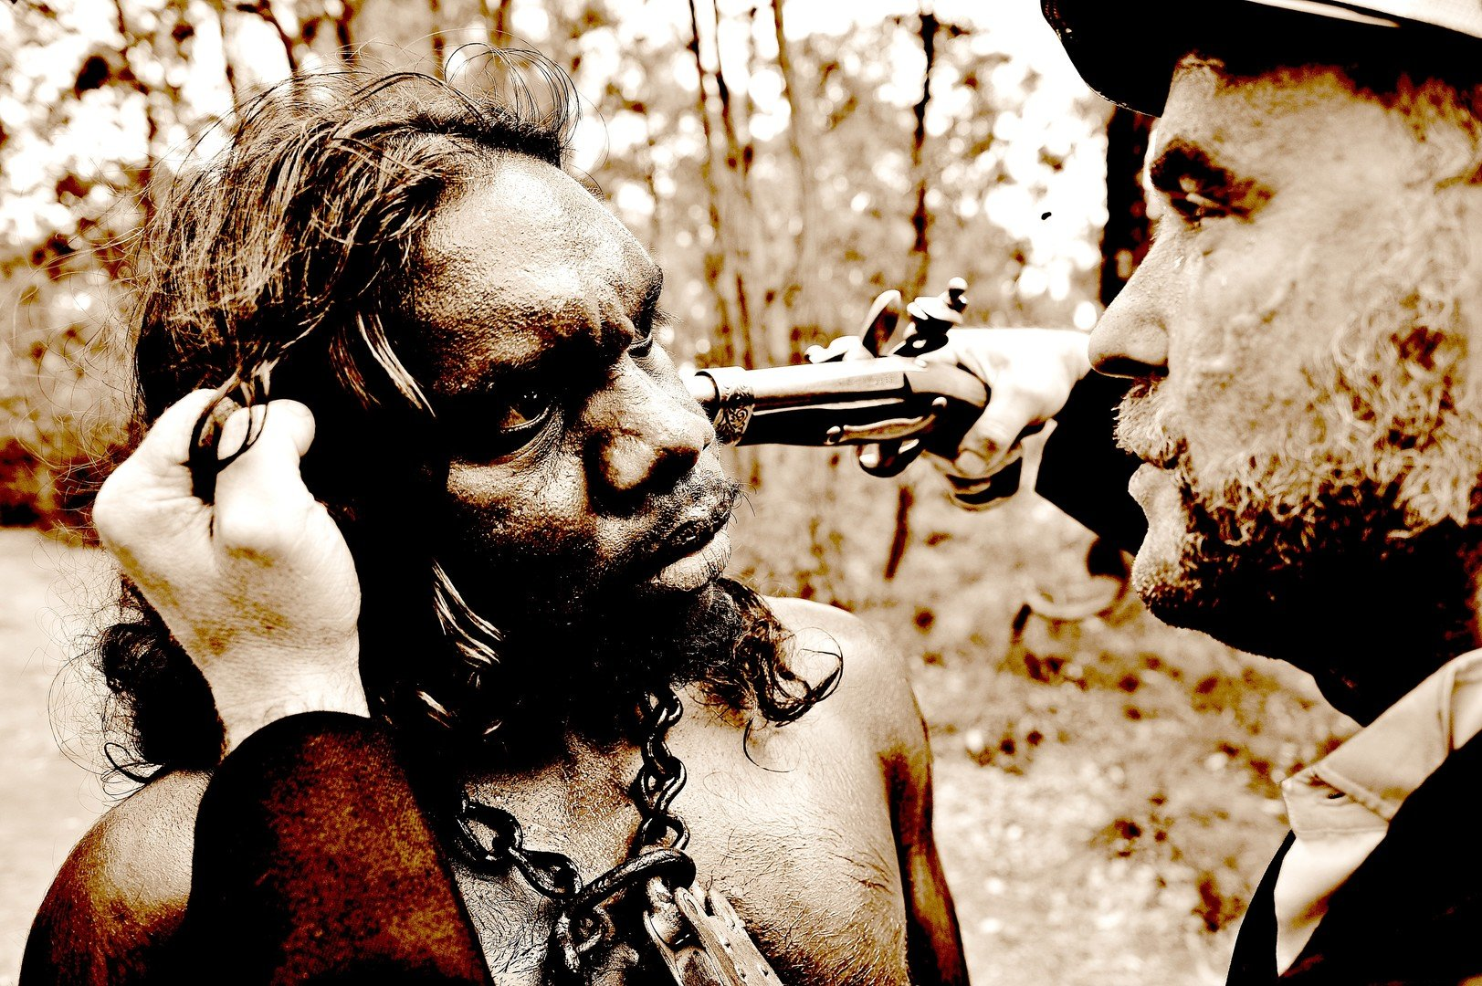
WADJEMUP or ROTTNEST ISLAND is sacred to Aboriginal people For almost 100 years between 1838 and 1931 Wadjemup was a prison for at least 3,670 Aboriginal men and boys More than 370 men never made it off the island and are now buried in unmarked graves on the island They were fathers They were sons They were brothers They were husbands They were never to see their homelands and family again Their spirits are part of this island…and for those that got off the island…their descendants now proudly tell their story…

Tangible Memory
Adolfo Ruiz / Canada / 00:03:55

This short film is based on conversations with (and footage of) a veteran moldmaker/machinist from Spain who reflects on a lifetime of working with metal. Through the sharing of memories and storytelling this brief account sheds light on the intimate, life-long relation between maker and material (and the degree to which the latter has agency). As people shape material, material also shapes people. The circular concept behind this film also embodies a core idea of ontological design, as described by Anne-Marie Willis; namely, "we design our world, while our world acts back on us and designs us." The medium used to capture this footage (using a Bolex 16mm camera in an industrial work environment) further reinforces the significance of tools and tactility in shaping things.

Ten by Ten
Jami L. Bennett / Korea, Republic of / 00:29:16
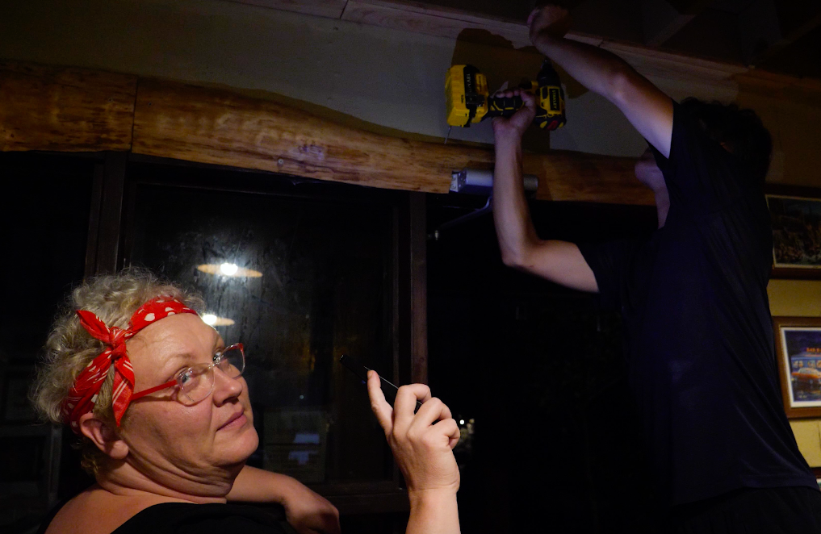
There is no denying the evocative power of food to remind us of who we are and where we come from. And after living in Asia for over fifteen years, Jessica was longing for the burgers and barbecue of her native Tennessee. With the help of her husband Dongseop, Jessica opened an American-style diner out of her home on Jeju Island, South Korea in 2018. But after being featured on one of the country’s most popular television shows, the couple must now adapt to the shock of their newfound TV fame, the crowds of curious new customers it brings, and all this amidst the uncertainty of the COVID-19 pandemic.

The Billboard
Asher Marie Coffield / / 00:06:47
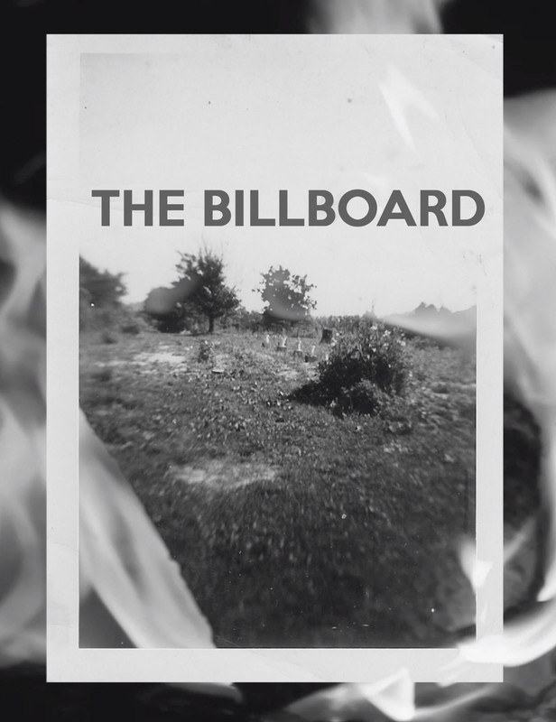
A house fire on December 24th, 1945 in Fayetteville, West Virginia leads to a decades-long family mystery.

The death of a nomad
Dastanbek Borkoshev, Danysh Akylbekov / Kyrgyzstan / 00:12:32
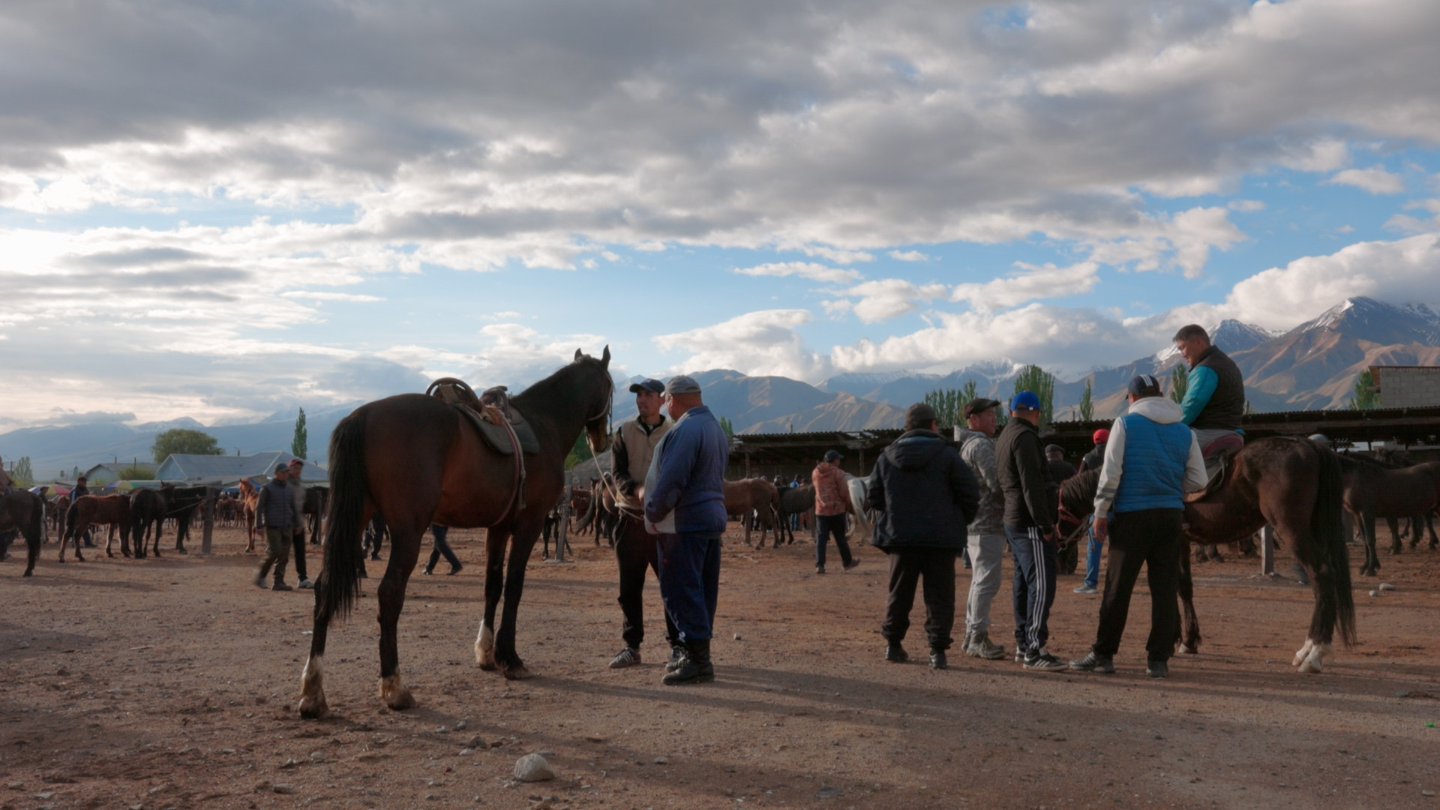
Feature documentary about a resident of a remote village in the Kyrgyz Republic. The main character is a real captain of the national team of 'kok boru' nomad games. He watches daily broadcasts of these national games with his family before selling his own racehorse in order to buy a bus ticket and go to the city in search for a paying job.

The Disease Detective Looks at Friedreich's Ataxia
Laura P. Valtorta / / 00:15:40
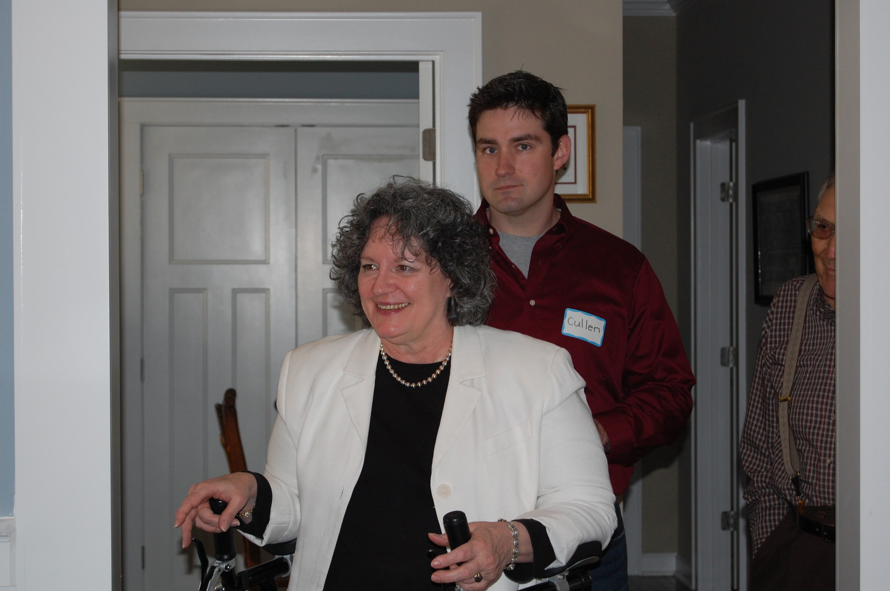
Ginny Padgett lives a full life and re-learns how to drive despite suffering from this chronic neurological disease.

The Eye Begins in The Hand
Yehuda Sharim / United States / 00:15:31
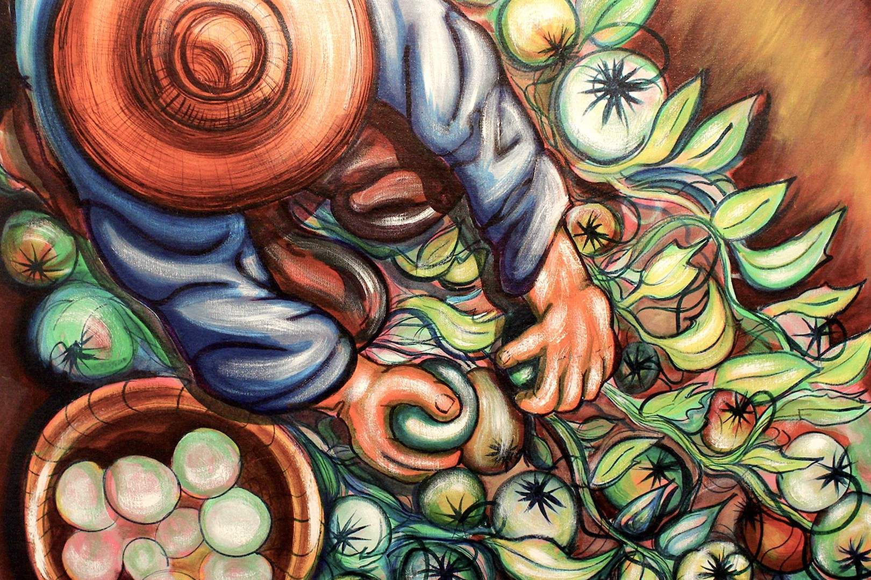
El Ojo Comienza En La Mano is a tribute to campesino histories in rural CA through the artwork of an artist largely absent from critical conversations on Chicanx art, Ruben A. Sanchez, as well as an unsentimental reckoning with the fate of many cultural workers that struggle between paying rent and/or creative endeavors.

The Land of Whispering Stars
Ayaal Adamov / Russian Federation / 00:15:00
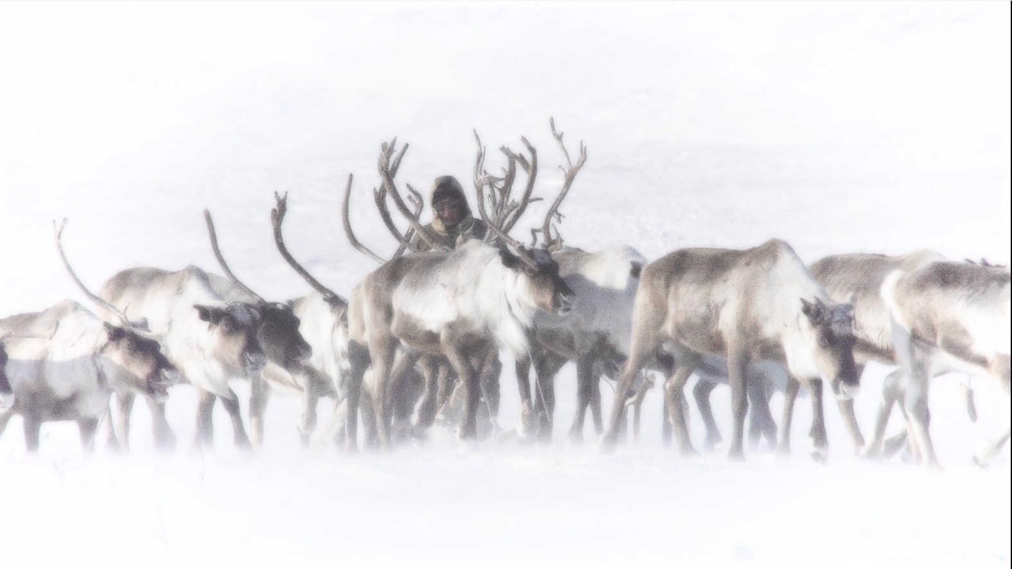
The coast of the Laptev Sea, around one tundra and nothing but the small Even village of Naiba. What are they doing there? And where do they roam on reindeer?

(The Lost Found) Boy Man Bunny
Daniel Ifans / United Kingdom / 00:24:59
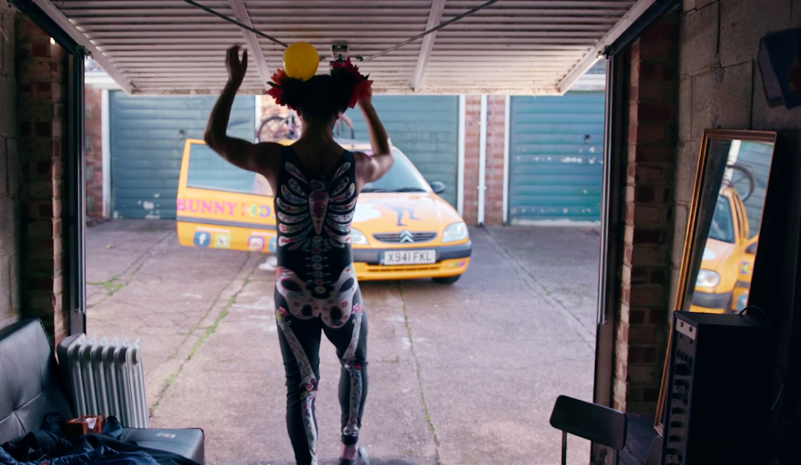
"You look to the sky and you see a plane. The plane is like the claw. It comes down and takes a child - maybe your best friend - never to be seen again. Where did they go? I don't understand...But I want to go on the plane". What happens when you take an abandoned Brazilian street kid from the favelas of Salvador, and drop him into privileged English society? Three decades later, Pablo is still trying to figure things out.

The Lost Shoes
Tomaso Aramini, Rafiqfuad Yarahmadi / Italy, United Kingdom / 01:44:00
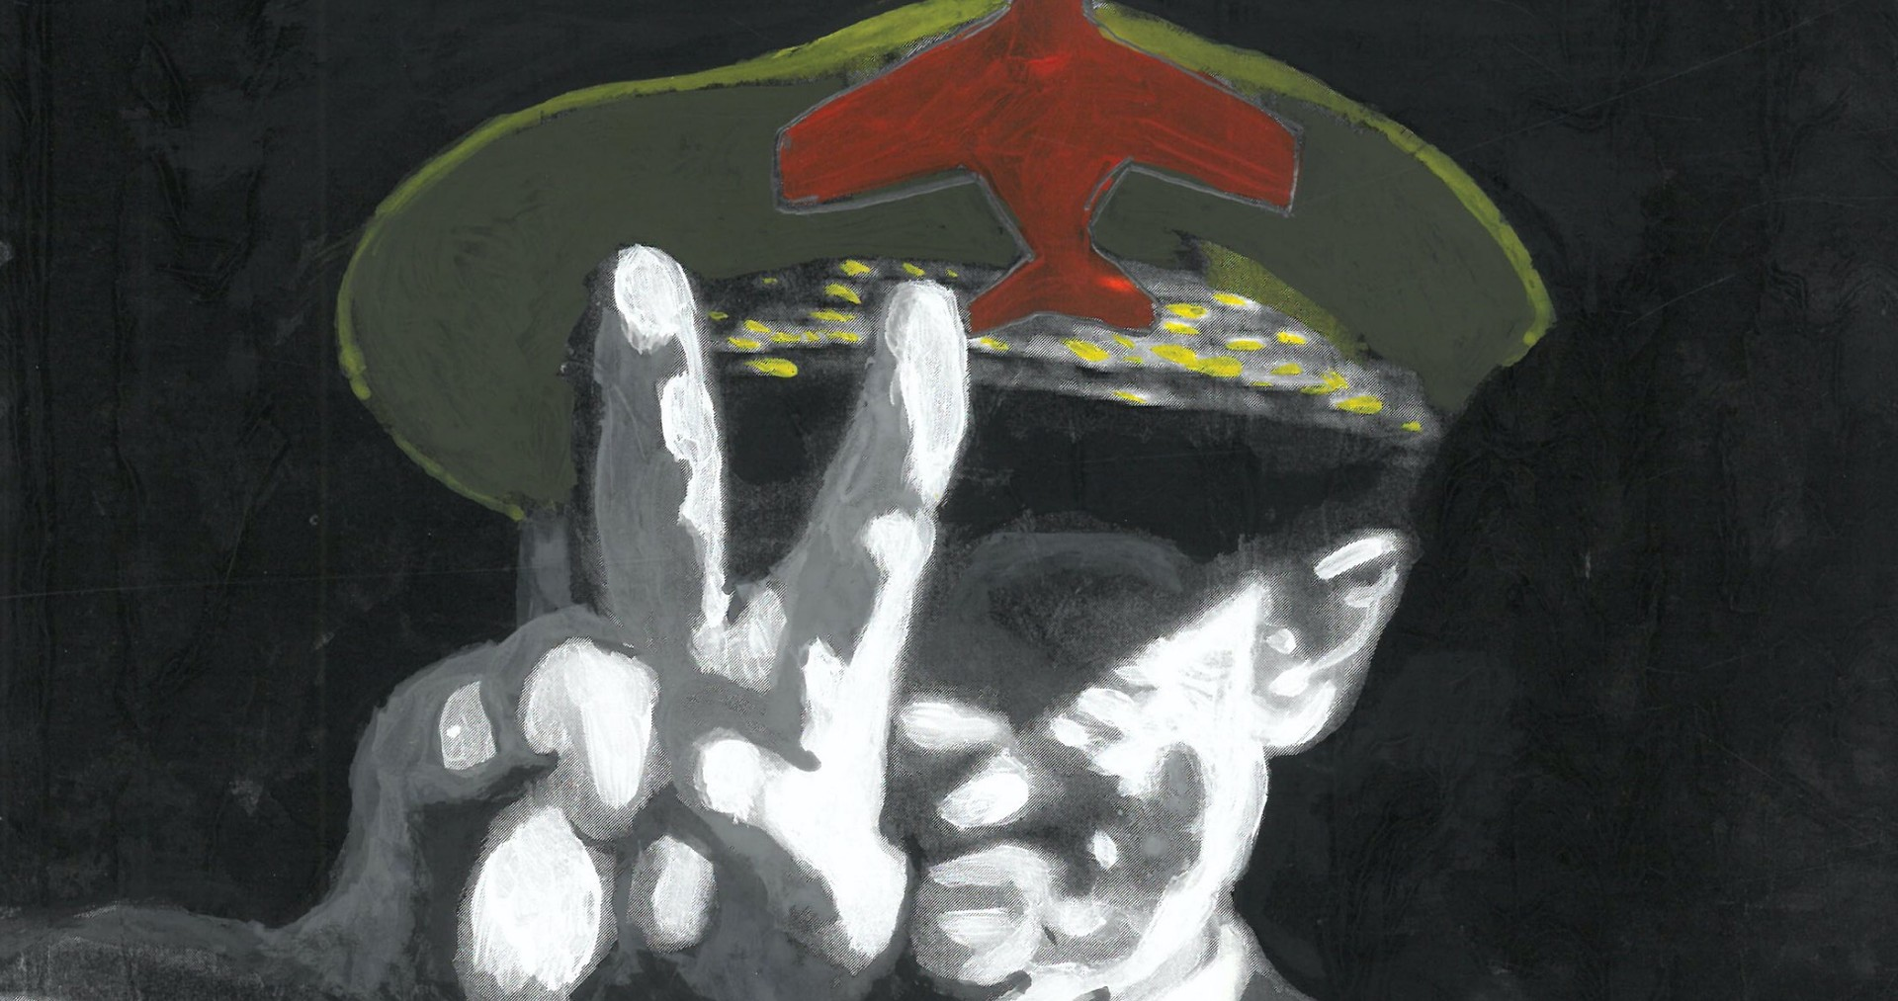
The story of a man from the Verona countryside who devoted his life and political experience to his communist ideals, culminating in the kidnapping of a NATO general. Along with him thousands of other people who tried to radically change Italy and the world during the 70s.

The Music of the Wiwa People
Michael Brims, Jaime Bofill / Colombia / 00:11:25
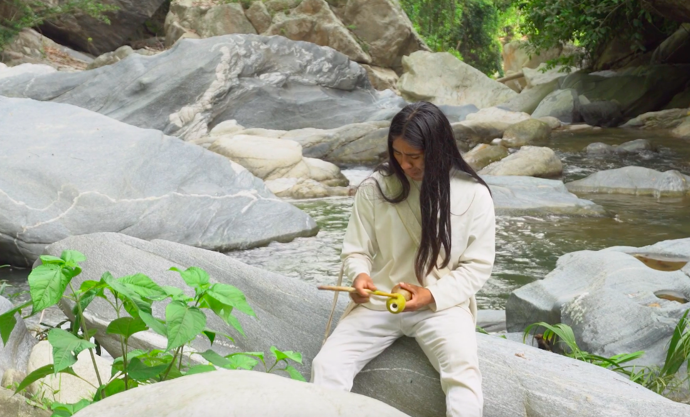
The Wiwa is an indigenous people living in the Sierra Nevada de Santa Marta, Colombia. This short film explores the musical practices of the Wiwa Community of Gotsezhy. Wiwa music is directly related nature, spirituality and healing. According to Wiwa mythology, their ancestral musical practices ensure harmony and well-being among all living beings by restoring order in the universe. The Wiwa live in remote villages of the Sierra Nevada de Santa Marta with limited influence from the outside world, holding on to their cultural and religious traditions.

The Rhythm of My Land
Mohammed Hashim Didari / Afghanistan / 00:06:04
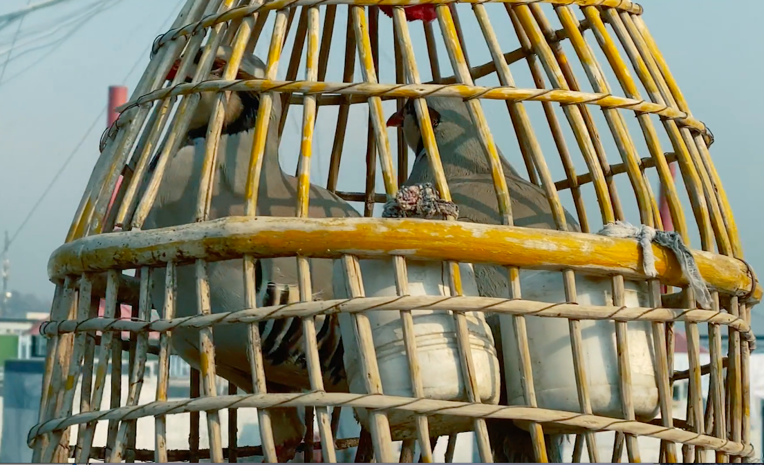
The Rhythm of My Land is a fast-paced sequence of images from present-day Kabul, a vivid collage capturing the prevailing mood in Afghanistan after the Taliban invaded the capital and President Ashraf Ghani fled the country on 15 August 2021, abandoning his people to the terrorist regime. It is a film about anxiety spreading from one person to the next, about despair over lost opportunities, about the moment you are robbed of your future. It shows people stranded in a black hole of history, gasping for air like a fish on dry land, writhing in agony like a snake held in the grip of a devil that has declared itself the master.

The Sacred Goats
Birgitte Glavind Sperber, Yasir Khan Kalash / Pakistan / 00:45:00
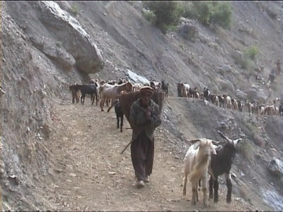
The 4000 Kalasha are a Non-Muslim minority living in the Hindukush Mountains in NW-Pakistan. It is the last remains of the shamanistic goat cultures that dominated in the big Central-Asian mountain area “Peristan” till the advent of Islam. Among the Kalasha, still goats are a most important part of the religion, the social life and the material subsistence. During long stays every year for 25 years the filmmaker Birgitte Glavind Sperber has lived among the Kalash, for the last years shooting with a little camcorder. Being an “impure” woman it is impossible for her to attend the religious ceremonies at the sacred places.

The Ungemach experiment, a eugenics history
Vincent Gaullier, Jean-Jacques Lonni / France / 00:52:32
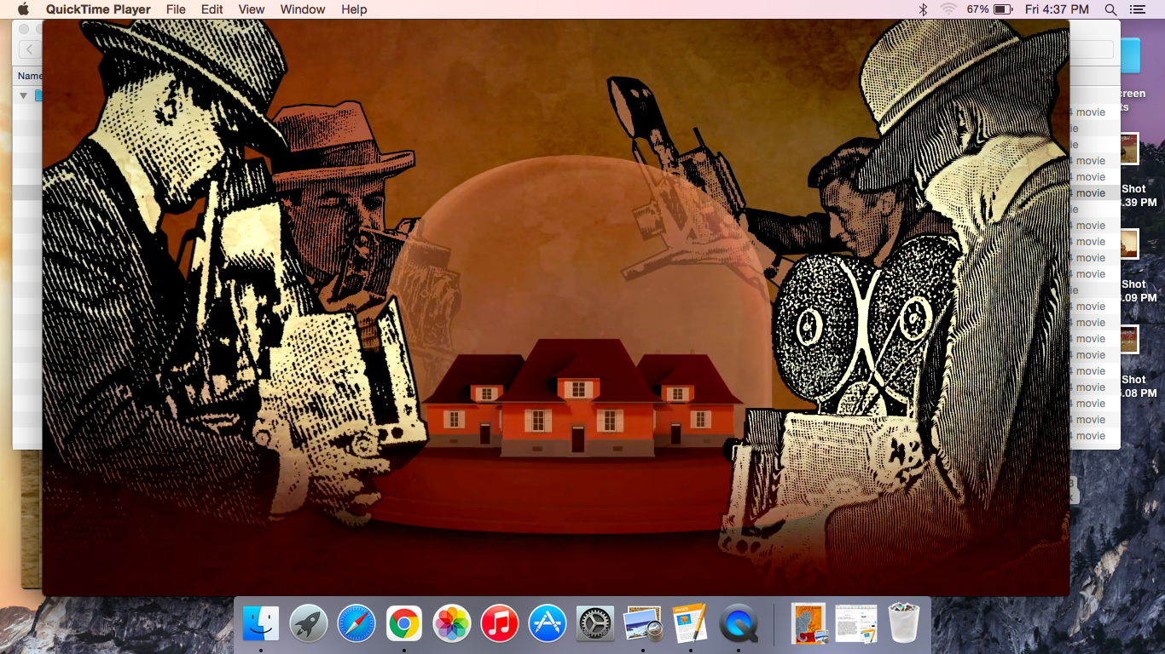
In 1924, an idyllic house and garden complex known as “Ungemach” is inaugurated in Strasbourg. It welcomes couples whose lifelong project was to found a large family. What the tenants does not know is that they are participating in a great eugenics experiment: only "healthy and fertile strain" are selected. This experiment was a subject of fascination the world over. It received the approval of the authorities – at once national and local, political and scientific. Armed with this legitimacy, the system of selection was to last up until the late 1980s!

The village of Kenou
Niek Nicolaes / Benin / 01:07:50
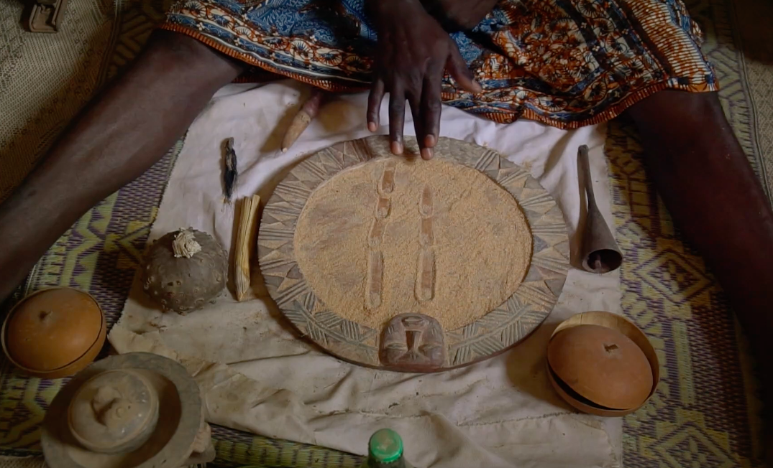
LOGLINE The village of Kenou is a portrait of a traditional village community in Benin, a small country in West Africa, where the old animist Vodou culture is still leading. SYNOPSIS Tassi is the oldest inhabitant of the village. She is the priestess that maintains contact with the ancestors on behalf of the community. Tassi teaches us how to look at her world, where ancestors and Vodou are naturally present and where they must always be consulted through the oracle before important decisions are made. We meet Sylvine, the village chief, who was chosen by the spirit of the deceased Martha to take her as his second wife.

There She Is
Tracey Anarella / United States / 01:09:52

The film asks the question 'why' women make the choice to compete in beauty pageants. There is coverage of the culture behind pageants by examining a diverse group of themes, age groups and cultures. "There She Is" handles the sensitive area of the intersection of pageants with the #METOO movement.

This Is Not A Protest
Claire Reardon / United States / 00:07:14
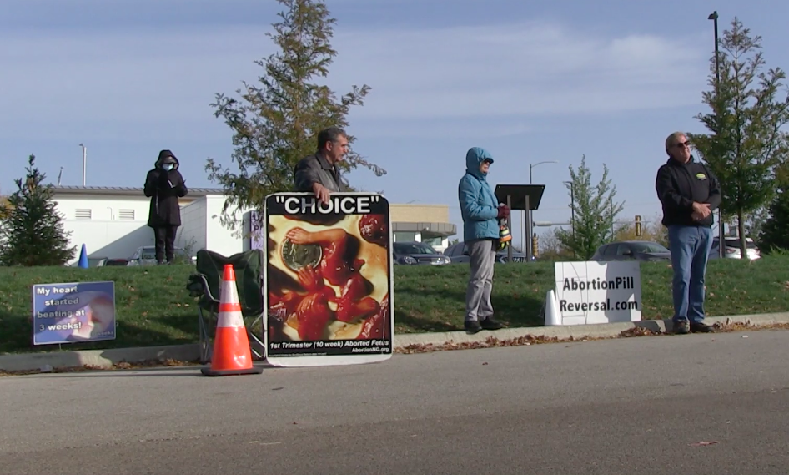
“This Is Not A Protest” follows a group of protesters who frequent the Planned Parenthood in Aurora Illinois. The film begins with the diligent set-up process of the protesters, capturing their promptness that coincides with the clinic’s surgery hours. Protesters are seen engaging in various actions that involve praying, sign holding, and sidewalk counseling. All three roles are distinct and rarely overlap, however, the group deems the same importance to each towards their overall goal. Protesters insist that what they are doing is not protesting, however, the group displays widely accepted acts of protesting.

3 Conversations in April
Susan Hamovitch / United States / 00:11:12
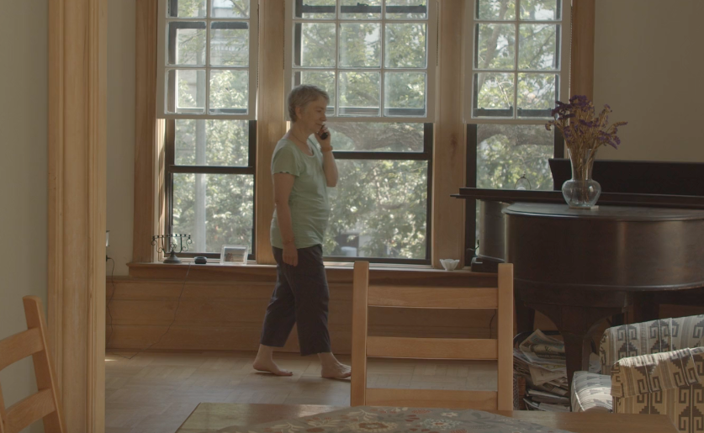
When you’re trying to communicate with a loved one who doesn’t use words to communicate, who lives in a group home miles away, and who has been placed in isolation, diagnosed Covid positive, what do you say? What do you do? How do you feel? 3 Conversations in April is the filmmaker’s recordings of the first calls she’s ever made to her brother - an older man with autism - by phone. as she attempts to find ways to provide something familiar in her brother's upended life.

Thrown
John Bright Mann / / 00:04:24
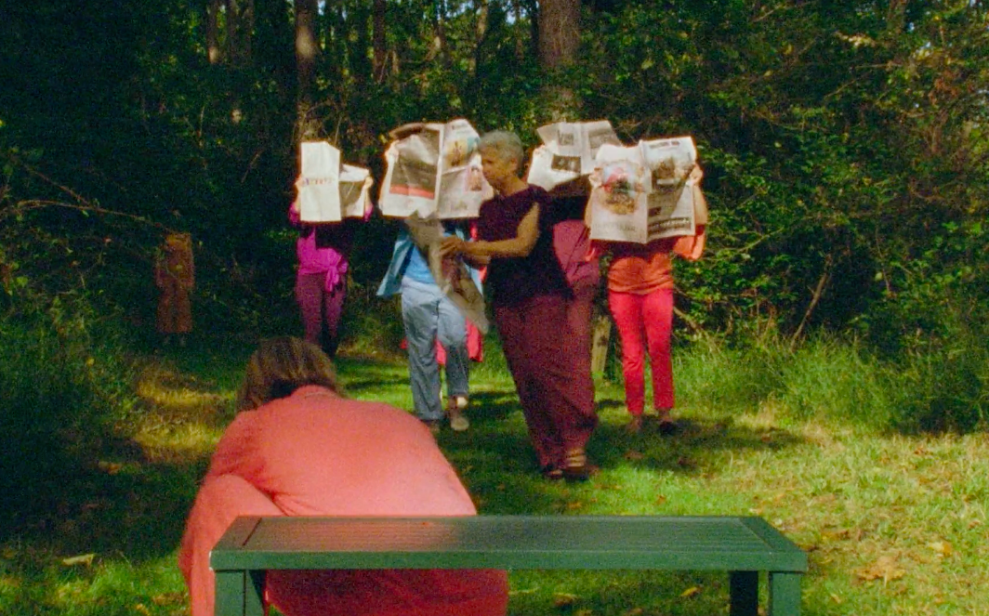
Suddenly, her familiar world vanishes. She no longer belongs-thrown into The New World of deceit and accusation-without hope. "Thrown" is a short dance for the camera project shot on S16mm film.

Time Washes Over Us
Joshua Reiman / Canada, Iceland / 00:21:19
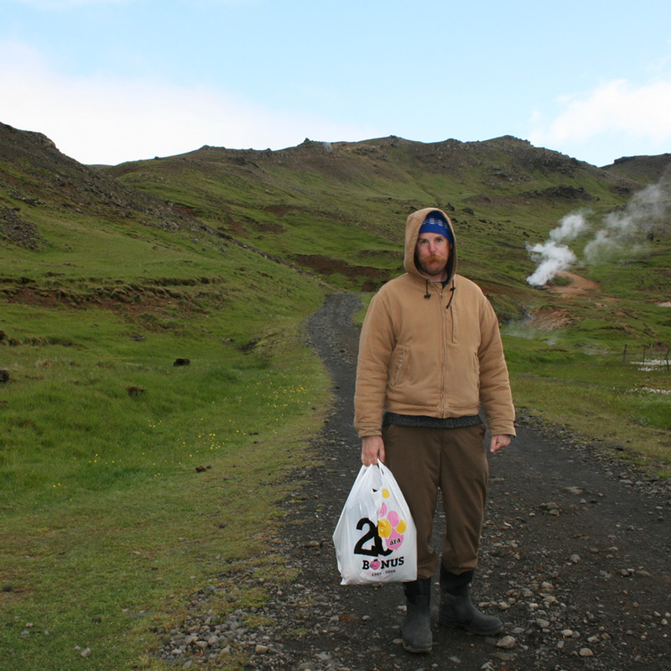
Time Washes Over Us considers mortality through marine life and poetic observational storytelling. Years in the making, he worked with divers and scientists to identify a few of the longest living animal species in the oceans of the world. Mortality as a concept is expressed through an extended voiceover of that was constructed after each encounter with multi-decadal oceanic animals. The film focuses on the Icelandic Clam (Arctica islandica) in Eyjafjörður, in Northern Iceland; the Red Sea Urchin (Mesocentrotus franciscanus) in Vancouver Island, British Columbia; and the Greenland Shark (Somniosus microcephalus) in Baffin Island Canada.

To Save a Language
Liivo Niglas / Estonia, United States / 01:14:20
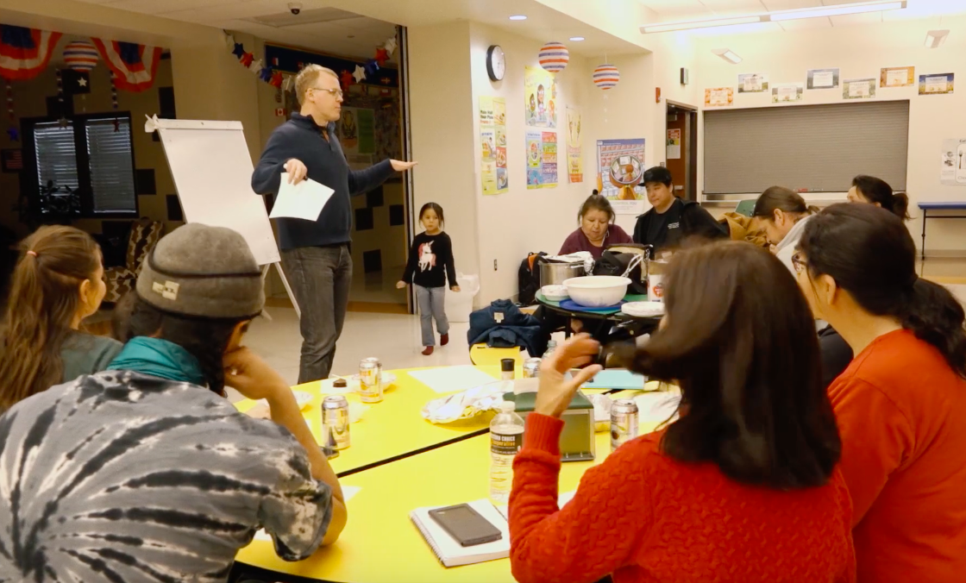
“To Save a Language” tells the story of the endeavour to save an endangered Plains Indian language with the help of a language programme led by an Estonian linguist. The film follows the protagonist in his efforts to revive the language, including the difficult decisions he has to make along the way. It also highlights the role of language in shaping one’s identity.

Toang
Rizky Maulana / Indonesia / 00:36:40
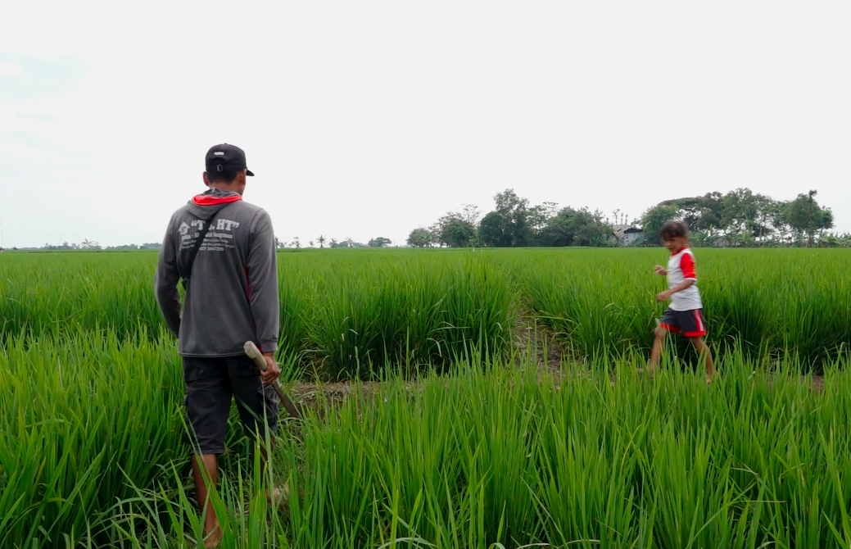
Toang is an intimate portrait of a rice paddy farmer (Edi Sutaryadi) and his family in Indramayu, Indonesia, who were in a precarious situation due to the cycle of indebtment and environmental degradation that the Green Revolution brought to Indonesia.

Together
Ning Tong Wang / China / 01:06:00

Old age, illness and death are writ large in all our fates. Many moments of farewell await. Sometimes sudden ones. How can you be ready for those, and can you avoid having too many regrets? This documentary follows anthropologist Luo Hongguang at his 102-year-old mother's side, as well as "Together"'s director Wang Ningtong (Nina) as she witnesses her cancer-stricken father's last few months. They focus an unsparing lens on each other as they approach issues like old-age support in the home and end-of-life care. As they explore each other's boundary looking into themselves and each other, the wall starts to break down between observer and subject.

Tracking Alewives for the Passamaquoddy
Kurt Lancaster / United States / 00:04:15

2.6 million alewives used to spawn in the St. Croix River, but was blocked by the state of Maine in 1995, forcing the alewife population to drop to 900 by 2002, impacting the traditional foodways of the Passamaquoddy Tribe. On May 1, 2013, the state opened the Grand Falls fishway, allowing for the passage of alewife migration--and the hopes of the Passamaquoddy.

Tributary
James Davoll / Iceland, United Kingdom / 00:12:40
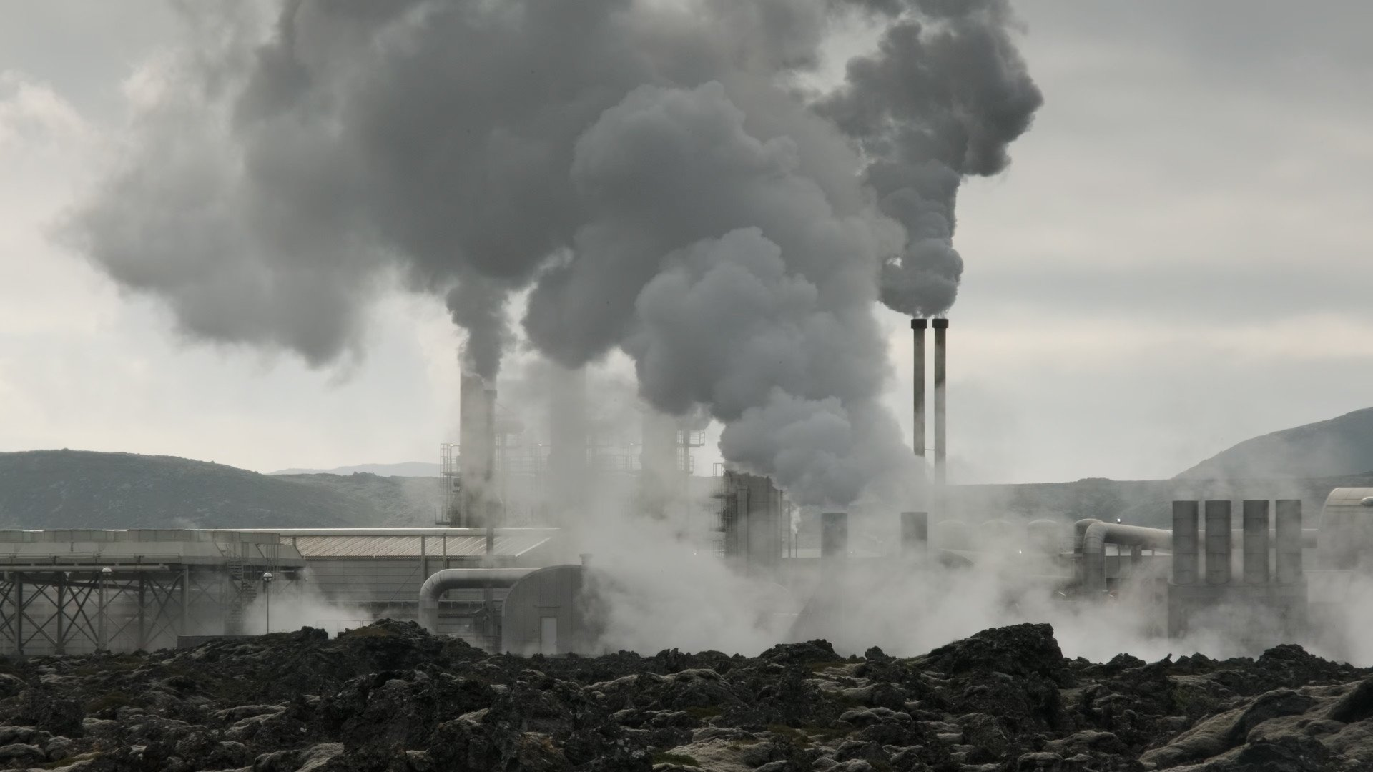
A short experimental ethnographic film that traces the movement of natural resources through the Icelandic landscape against the visual and sonic sites of data centers and power plants. The film explores the covert, 'black-boxed' data centers (remote and highly secure sites, obscured from maps and incredibly difficult to gain access to) against the power stations of the Icelandic landscape. These data centers are the physical locations of intensive computational processing that prop up the digital infrastructure of contemporary life.

Tukdam - Between Worlds
Donagh Coleman / / 01:31:18
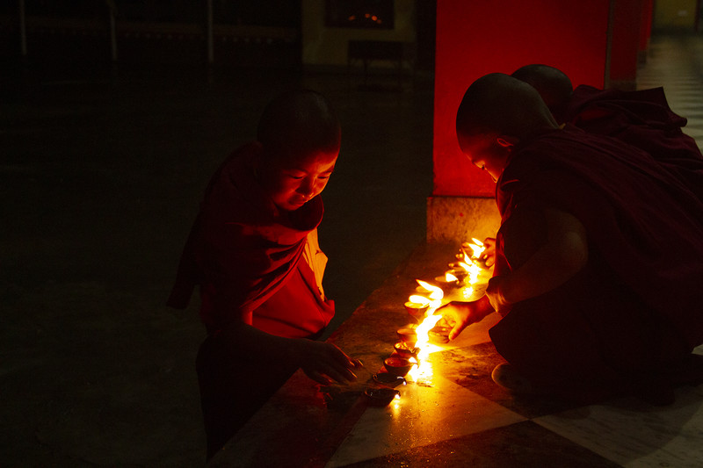
Most of us think of death as something clear-cut, and that medical science has it neatly figured out. This feature documentary explodes such assumptions through its exploration of a phenomenon that blurs life and death to an unprecedented degree. In what Tibetan Buddhists call tukdam, advanced meditators die in a consciously controlled manner. Though dead according to our biomedical standards, they often stay sitting upright in meditation; remarkably, their bodies remain fresh and lifelike, without signs of decay for days, sometimes weeks after clinical death. Following ground-breaking scientific research into tukdam and taking us into intimate death stories of Tibetan meditators, the film juxtaposes scientific and Tibetan perspectives as it tries to unravel the mystery of tukdam.

Two as One
Carlo Stoppa / India / 00:44:48
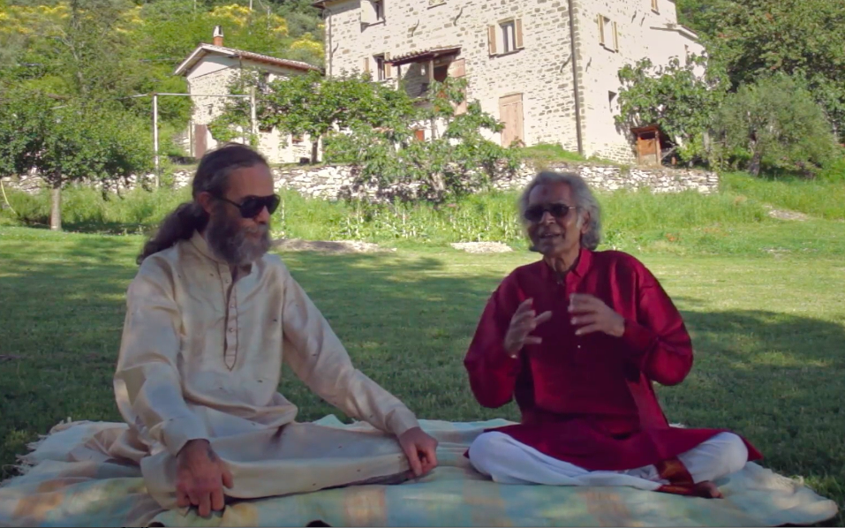
A documentary on the essence of Indian classical music, filmed in the city of Varanasi in India. In addition to revealing its spiritual connotation, the documentary investigates its teaching system, what is transmitted through the relationship between guru and disciple.

Under the Shadow of the Wall
Taylor Genovese / Mexico, United States / 00:09:29
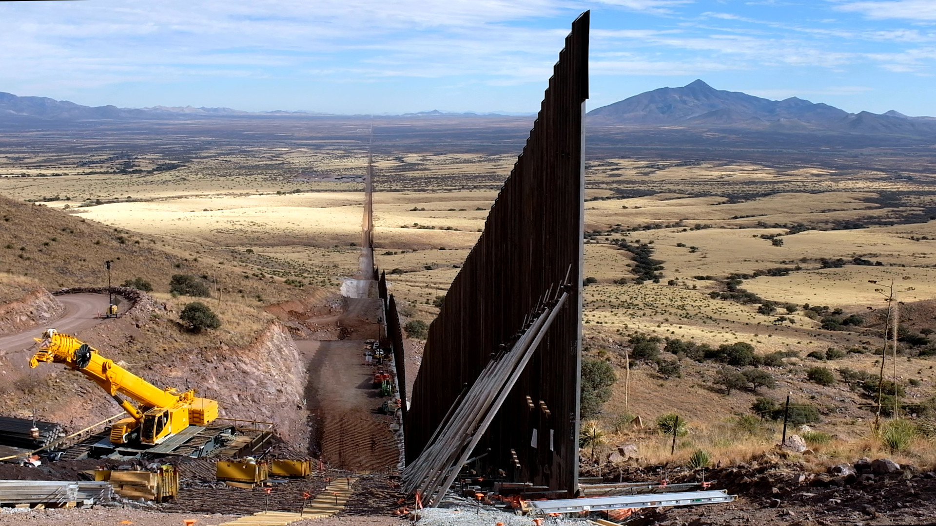
This video essay focuses on the landscapes of the Sonoran Desert—and the project of a border wall between the U.S. and Mexico—as a way of investigating the manner in which something as seemingly generic as a wall can take on particular political and affective forms. This short provocation explores the ways that violent and distasteful objects create, and subsequently come to characterize, malevolent spectacles.

Uniquely Blessed
Kiril Kirkov / United States / 00:29:49
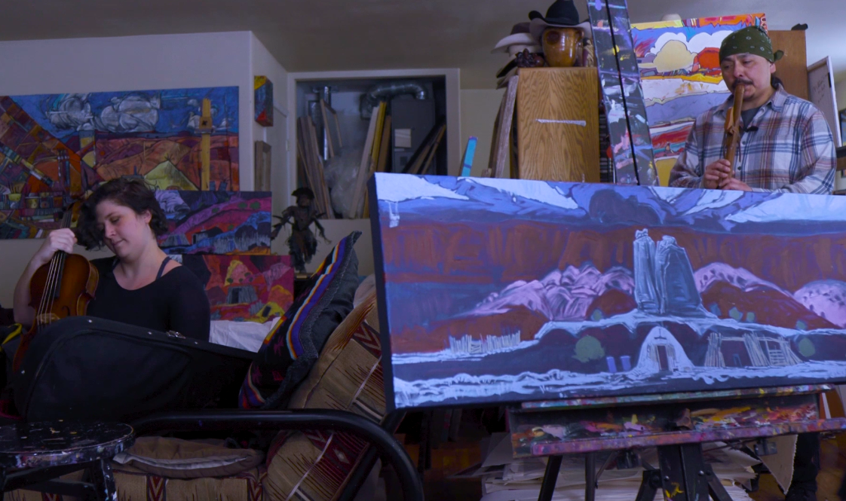
In this experimental and participatory art documentary, a collective of indigenous artists collaborates with classic viola and Navajo flute musicians, demonstrating live-painting and music improvisations. While developing their art ideas before the camera, the hearts of the film share stories about religion, philosophy, and way of life.

Unknown Melbourne
Julian O’Shea / Australia / 00:07:48

Unknown Melbourne is a YouTube documentary series hosted by award-winning educator and designer Julian O’Shea, exploring and explaining the hidden side of the city. Explaining the bridge that keep being hit by trucks, to the pedestrian crossing button that features in a hit song - these unknown stories give an insight into the design, history and fascinating stories of the city of Melbourne.

Venice Elsewhere
Elia Romanelli / Croatia, Germany, Italy, Romania, Turkey / 01:05:00
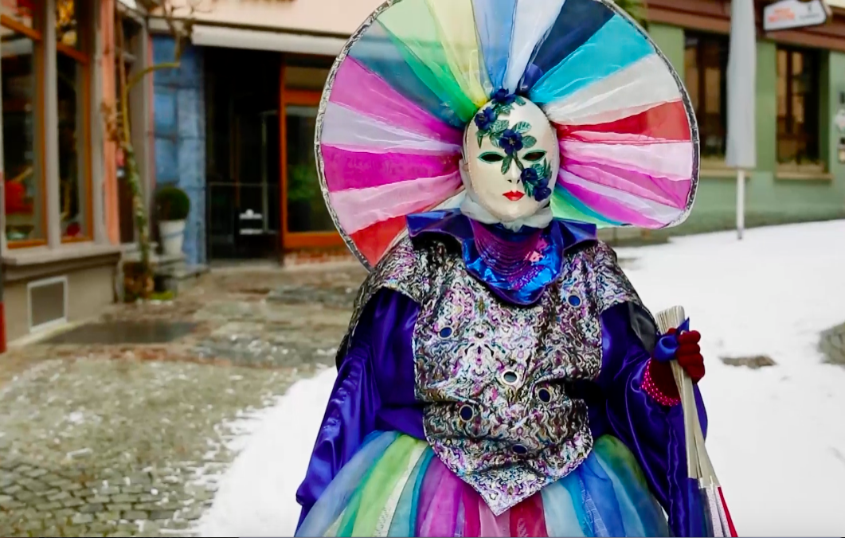
Venice Elsewhere, following a map of private and intimate stories, seeks to understand how it is possible, today, to tell the story of this city. Beyond its lagoon: in a world of television images and artificial sensations that perhaps describe it better than the original.

What We're Hungry For: How Food Pantries Fed Rural Wisconsin During the Pandemic
Jim Winship / United States / 00:43:44

Documenting the response of five local Wisconsin food pantries to the unprecedented needs created by the coronavirus pandemic, this film tells the story of the hard work, ingenuity, and compassion of these organizations while also exploring the complex and longstanding challenges of fighting hunger in rural America.

What will I show you?
Elie-John Joseph / Canada / 00:09:32
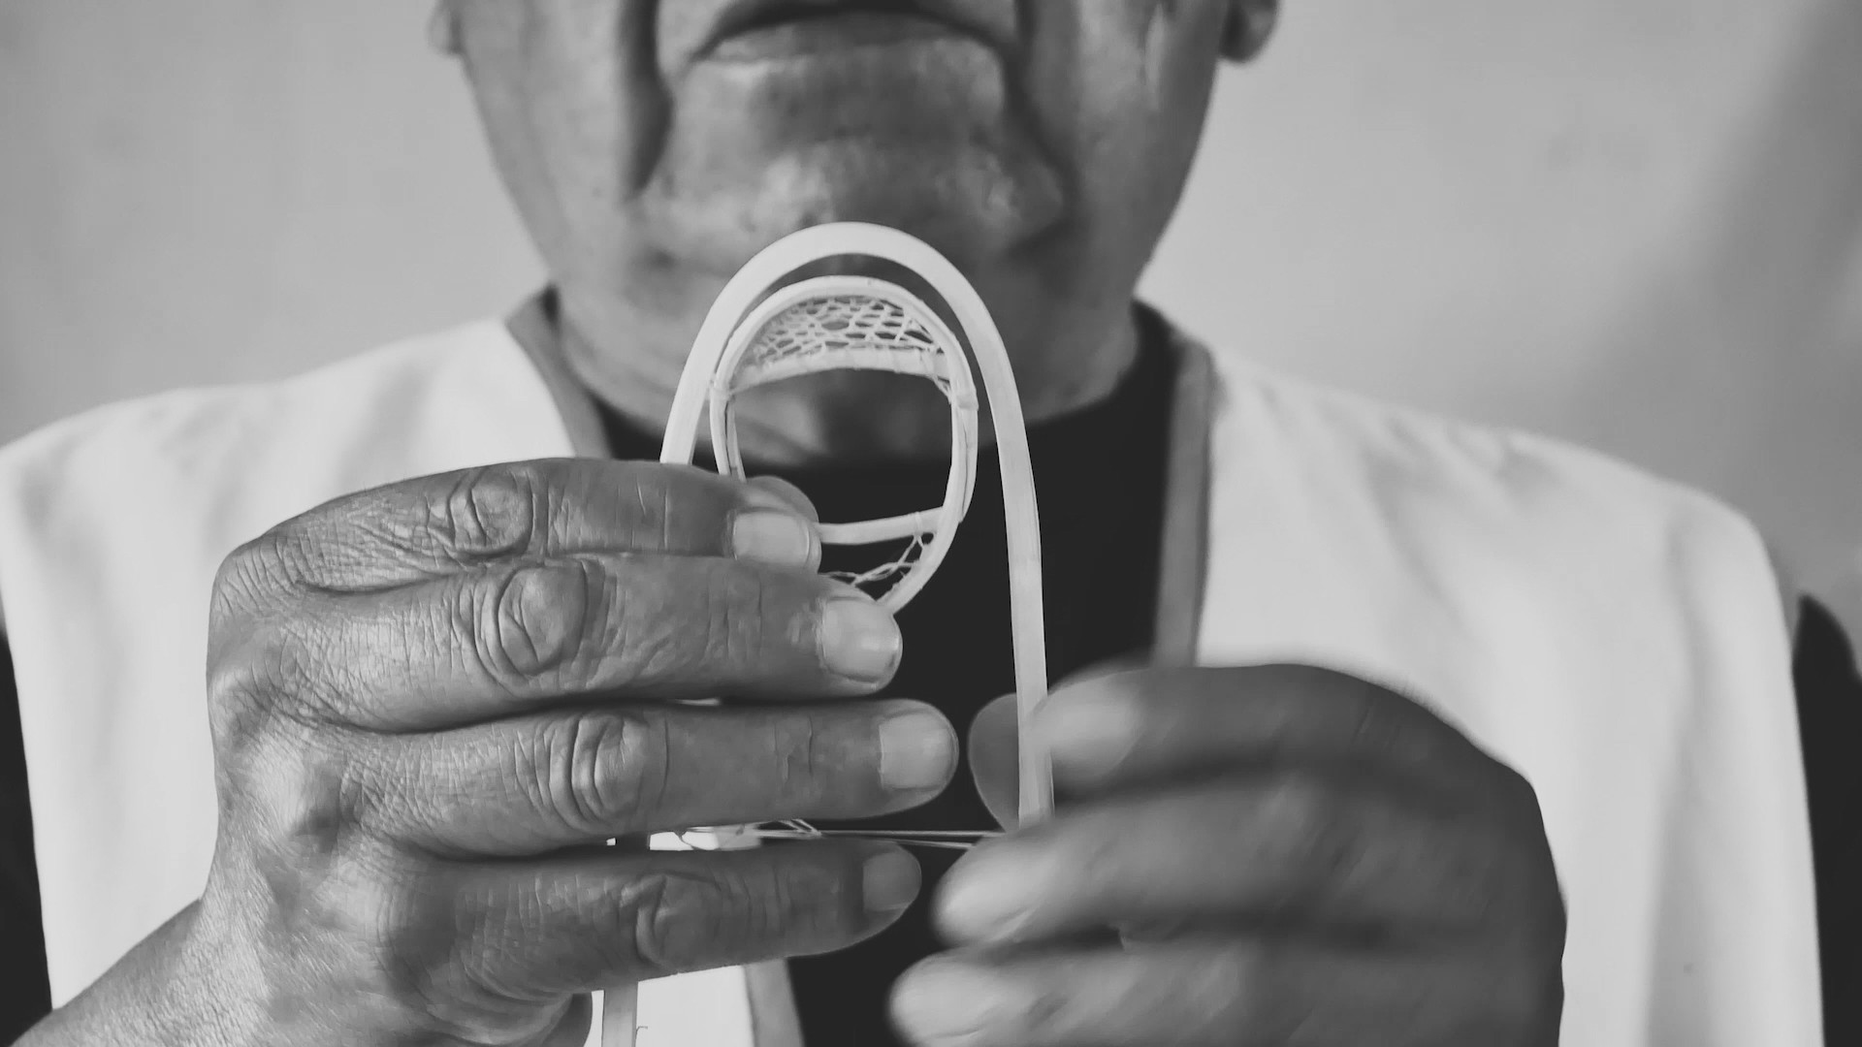
In the tradition of direct cinema, "What Will I Show You" is an intimate documentary in which a grandfather and his grandson discuss the past and future of Innu culture.

When the Devil Lived in the fields
Debski Lukasz / Poland / 00:59:58
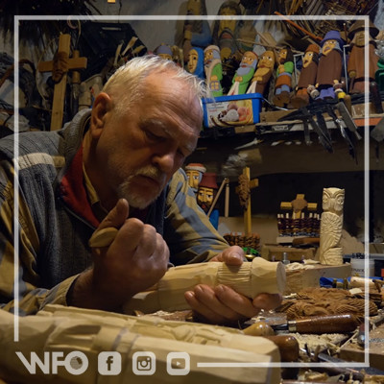
‘When the Devil Lived in the fields’ is a film about a magical perception of the world, traces of which are preserved in the memory of the film's characters. In the past, nature was the world in the countryside. People explained nature as best they could. Devils, ghosts, demons, witches, wraiths, fantastic animals, strange creatures... They inhabited cornfields, roadside bushes and inaccessible swamps, they hid in forest thickets, in riverside reeds, in murky water of ponds. They were everywhere, wherever one believed in them.

When the Dust Clears
Leo Kang, Sam Lam / Afghanistan, China / 00:39:46
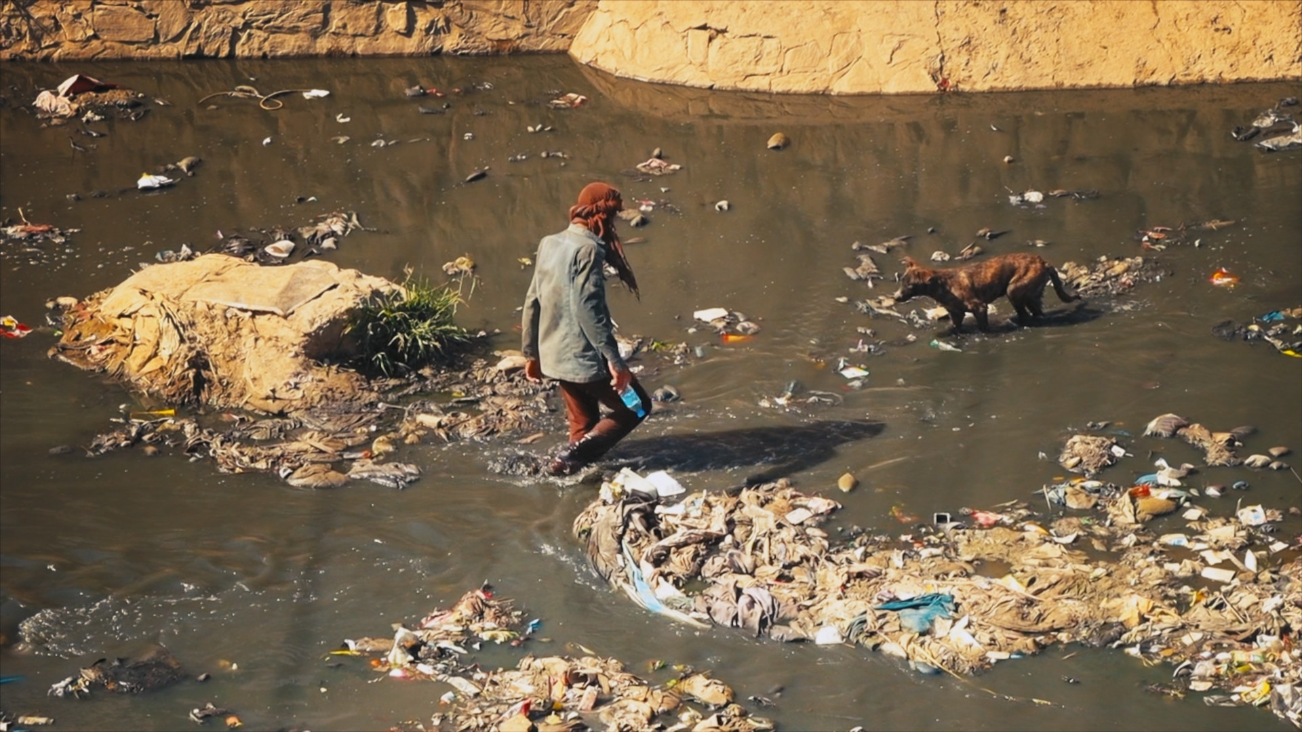
War is like the dust raised by the wheels that crush the pavement. As the dust settles, the pavement reveals its indelible scars. The children born in the cracks in the pavement are growing up with the dangers of war, but they are still trying to grow up in their own way, and it seems that more people need to help them in this effort.

When will the warmth come?
Oleksandra Pletenetska / Ukraine / 00:14:40
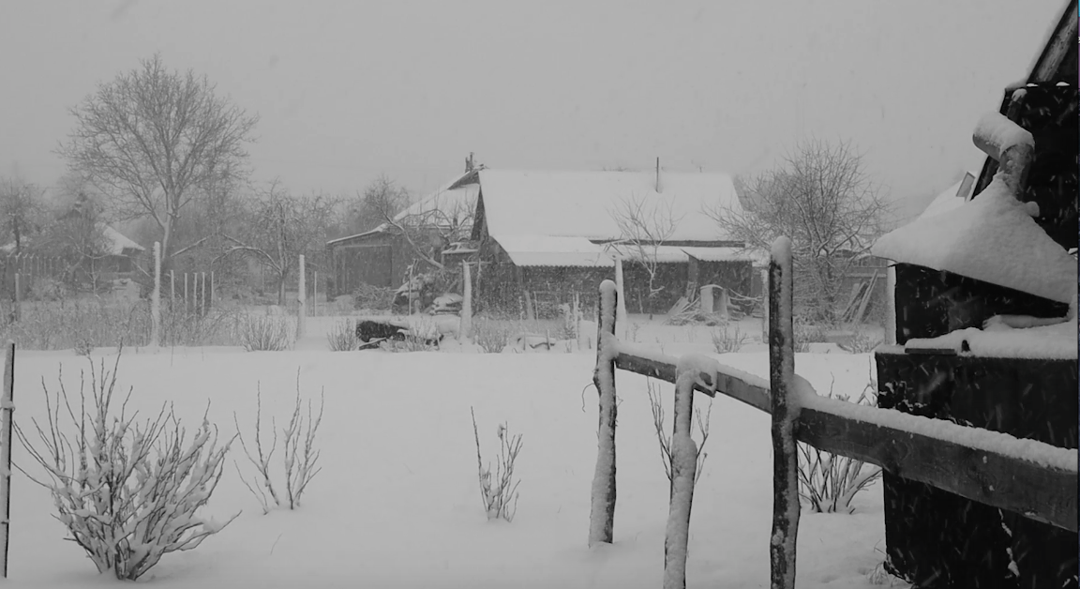
This is a video diary of my feelings, in which I documented my emotional states during the full-scale invasion of my country - Ukraine.

Whetū Mārama- Bright Star
Toby Mills, Aileen O'Sullivan / New Zealand / 01:34:00
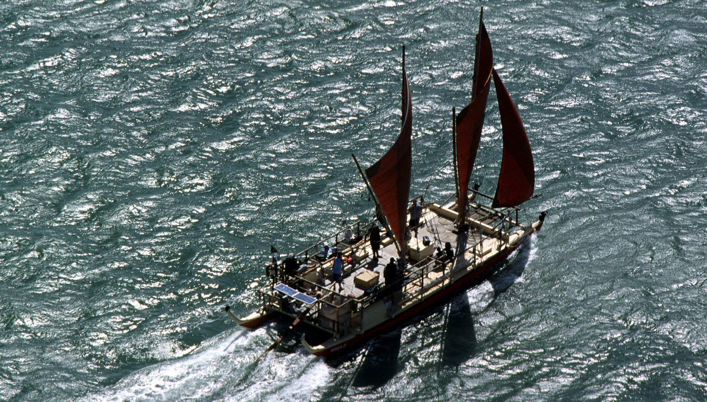
Polynesians were the most adventurous voyagers on earth. We sailed the vast Pacific by the stars. But these ancient arts were lost for 600 years. Then the stars re-aligned and three men from far flung islands met by chance..... Nainoa Thompson from Hawaii, Mau Pialug from Satawal and Hek Busby from Aotearoa / New Zealand. Together they revived our place as the greatest navigators on the planet.

Why the Mountains are Black
Alcaeus Spyrou / Albania / 00:11:41
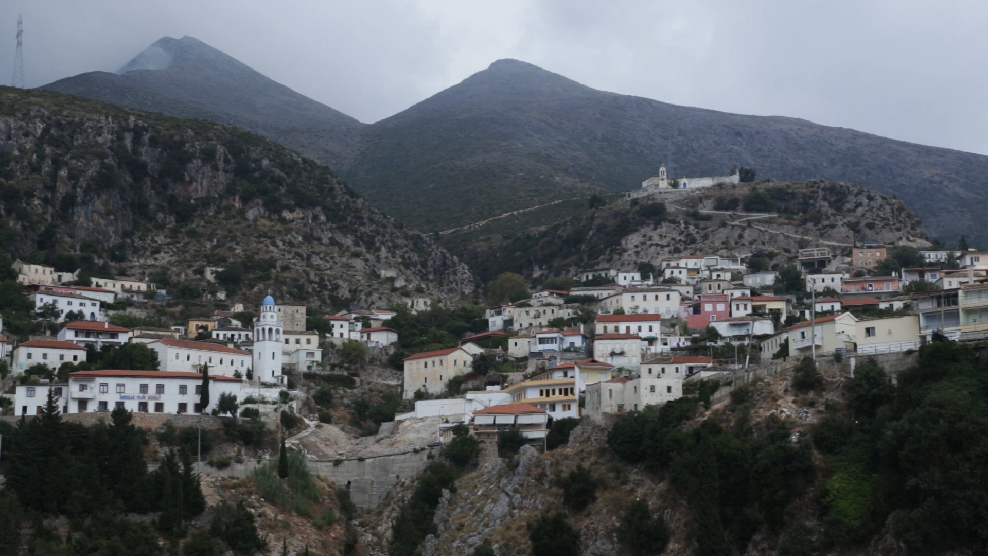
An international team of ethno-linguists meet at the foothills of Mount Çika, in an effort to document the dialect of the Greek-speaking villages in the Himara region. During the Hoxha establishment, the area was subjected to political prosecution and after the fall of Communism in Albania, Himara was marked by waves of migration. Today, its population has been decreased significantly, with the remaining residents being predominantly elderly women.

Winston Fleary and the Big Drum Nation Dance
John -- Melville Bishop / Grenada / 01:08:00
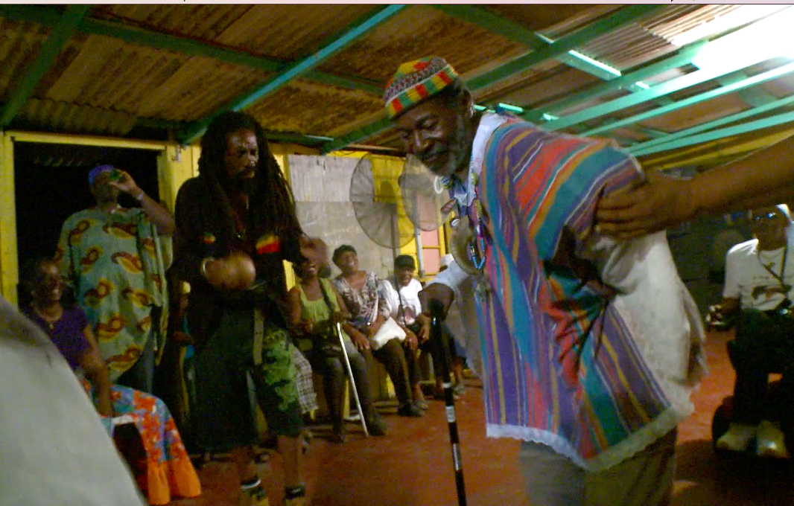

Winter 1984
Tony Buba / United States / 00:14:19
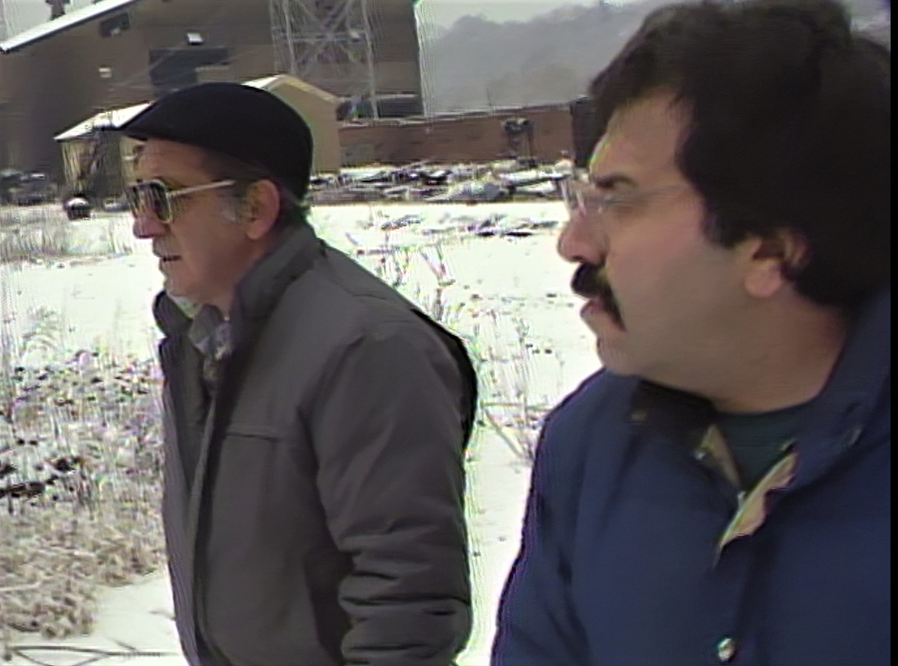
In the winter of 1984, Amedeo "Pee Wee" Vieri gives a tour of the Carrie Furnace site. A steel mill that he worked at for 34 years before losing his job when the mill closed in 1982.

Wrought
Joel Penner, Anna Sigrithur / Canada / 00:19:25

A stunning visual exploration of matter in various states of microbial transformation begs fundamental questions about human cultures’ complicated relationships with other species. Wrought begins with that universal moment of disappointment: despite all best efforts, our food has gone bad! But instead of turning away in disgust, Wrought zooms in, approaching the usually hidden world of decay with curiosity and stunning time lapse photography. As the film title implies, we are all forged out of the relationships that transgress such binaries; we are all, indeed, wrought.

You Can't Stop the Music
Mohammed Hashim Didari / Afghanistan / 00:25:05
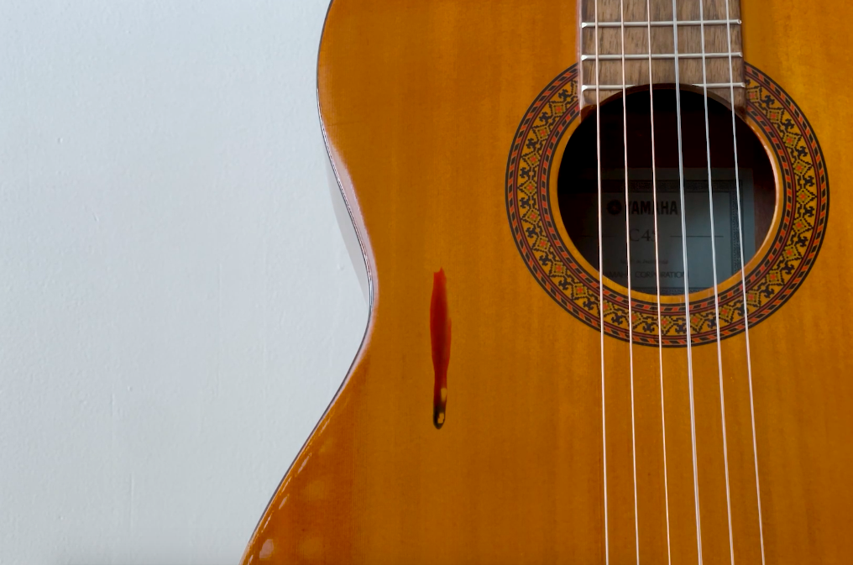
What happens when you can no longer practice the profession that is part of your identity? You Can’t Stop the Music is a portrait from today’s Afghanistan, where life in the shadow of the Taliban can at times seem surreal. Akbar Adeli was a music student at Kabul University when the Taliban took over Afghanistan. For conservative Afghans, music had been suspect even before, but under the Taliban it became a gamble with one’s life – especially so because Akbar plays Western pop music. Fearing the Taliban, Akbar stashed away his guitar, but the pull of music was too great.

Zoya Cherkassky - Soviet Life
Anat Schwartz / / 00:30:00
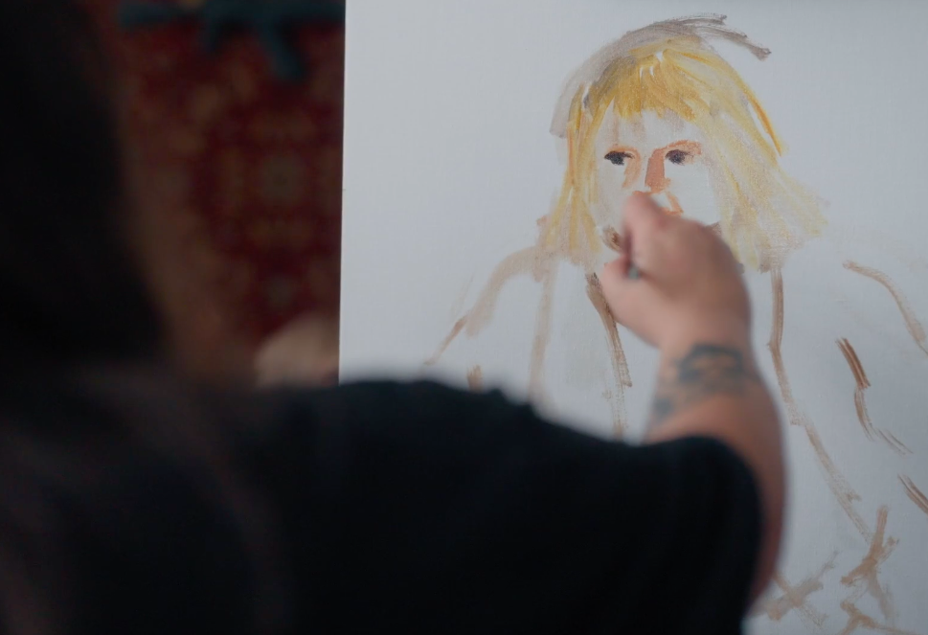
The works of the Ukrainian born artist, Zoya Cherkassky, sell for thousands of dollars, but their bright colors tell a story of immigration, survival, and alienation. We accompany her on an intimate journey from the studio in the immigrant Tel Aviv neighborhood where she has met her Nigerian husband, to her childhood in Kyiv, in search of her lost Ukrainian-Soviet childhood, hoping to find the one place in which she would feel at home.
